“Design and Development of Fruit Preservation System by Using Thermo-Electric Coupler”

Mr. Suraj Manohar Hasabe Mr. Gaurav Anil Ghogare
Mr. Advait Sandeep Kokaje Mr. Suraj Rajaram Gotad

Guide
Mr. D. S. Nakate

Department of Mechanical Engineering
D Y Patil School of Engineering Academy
Ambi

ABSTRACT
Now a days as the aim of international organizations is to phase out the HFC_{S} there is a high need for the development in the arena of refrigeration and cooling. Refrigeration is the most important prerequisite for the storage of vegetables and other perishables. But when we achieve the refrigeration effect by using the conservative approach it just not only energy inefficient but also not environment friendly. So to make refrigeration environment friendly we have to start other alternative development. In our project we are designing a system in such a manner that cooling effect is achieved using the peltier effect. Here only electrical energy is used to achieve the cooling effect. In the project course we are designing the system using CATIA V5 R20 system and calculations are done accordingly for energy transfer. Finally components were selected and manufacturing will be done in second semester.
Keywords: Thermoelectric Cooler, Generator, Peltier Cooling System, Cooling Capacity.
1. INTRODUCTION:

Thermoelectric cooling uses the Peltier effect to create a heat flux at the junction of two different types of materials. A Peltier cooler, heater, or thermoelectric heat pump is a solid-state active heat pump which transfers heat from one side of the device to the other, with consumption of electrical energy, depending on the direction of the current. Such an instrument is also called a Peltier device, Peltier heat pump, solid state refrigerator, or thermoelectric cooler (TEC). It can be used either for heating or for cooling, although in practice the main application is cooling. It can also be used as a temperature controller that either heats or cools. This technology is far less commonly applied to refrigeration than vapor-compression refrigeration is. The primary advantages of a Peltier cooler compared to a vapor-compression refrigerator are its lack of moving parts or circulating liquid, very long life, invulnerability to leaks, small size, and flexible shape. Its main disadvantages are high cost for a given cooling capacity and poor power efficiency. Many researchers and companies are trying to develop Peltier coolers that are cheap and efficient. (See Thermoelectric materials.)
A Peltier cooler can also be used as a thermoelectric generator. When operated as a cooler, a voltage is applied across the device, and as a result, a difference in temperature will build up between the two sides. When operated as a generator, one side of the device is heated to a temperature greater than the other side, and as a result, a difference in voltage will build up between the two sides (the Seebeck effect). However, a well-designed Peltier cooler will be a mediocre thermoelectric generator and vice versa, due to different design and packaging requirements. Thermoelectric coolers operate by the Peltier effect (which also goes by the more general name thermoelectric effect). The device has two sides, and when a DC electric current flows through the device, it brings heat from one side to the other, so that one side gets cooler while the other gets hotter. The "hot" side is attached to a heat sink so that it remains at ambient temperature, while the cool side goes below room temperature. In special applications, multiple coolers can be cascaded together for lower temperature, but overall efficiency drops significantly.
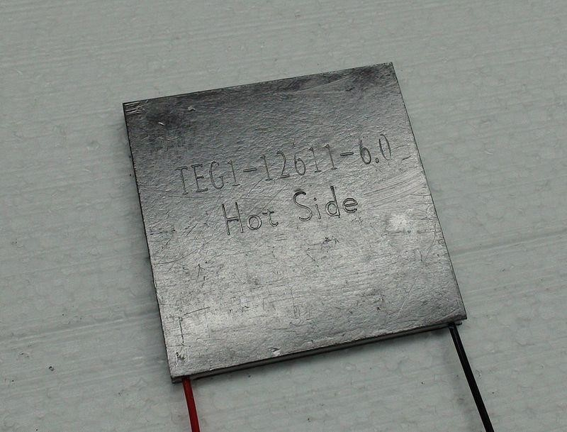

(Fig.1. peltier plate) Advantages of the system-
- It does not use refrigerants in its operation. Prior to their phaseout some early refrigerants, such as chlorofluorocarbons (CFCs), contributed significantly to ozone depletion. Many refrigerants used today also have significant environmental impact with global warming potential.
- TEC systems have no moving parts. This lack of mechanical wear and reduced instances of failure due to fatigue and fracture from mechanical vibration and stress increases the lifespan of the system and lowers the maintenance requirements.
- current-controlled leads to another series of benefits. Because the flow of heat is directly proportional to the applied DC current, heat may be added or removed with accurate control of the direction and amount of electrical current.

Disadvantages of the system-
• Foremost is their limited energy efficiency compared to conventional vapor-compression systems and the constraints on the total heat flux (heat flow) that they are able to generate per unit area.

2. LITERATURE REVIEW:

1.Electric vehicle battery thermal management system with thermoelectric cooling by Y. Lyu, A.R.M. Siddique, S.H. Majid, M. Biglarbegian, S.A. Gadsden, S. Mahmud.

An experimental investigation is performed on an advanced battery thermal management system for emerging electric vehicles. The developed battery thermal management system is a combination of thermoelectric cooling, forced air cooling, and liquid cooling. The liquid coolant has indirect contact with the battery and acts as the medium to remove the heat generated from the battery during operation. Forced air assisted heat removal is performed from the condenser side of the thermoelectric liquid casing. Detailed experiments are carried out on a simulated electric vehicle battery system. Experimental results reveal a promising cooling effect with a reasonable amount of power dissipation. Moreover, the experimental test shows that the battery surface temperature drops around 43 oC (from 55 oC to 12 oC) using TEC-based water cooling system for a single cell with copper holder when 40 V is supplied to the heater and 12 V to the TEC module.
A new design based on the combination of forced air cooling, liquid cooling, and TEC is investigated here. The battery is placed vertically in the center of the coolant container. Flowing liquid takes away a considerable amount of heat generated by the battery during operation. A water pump is used to drive liquid circulation. The TEC is used to manage the temperature of the coolant afterward. Lastly, the hot end of the TEC will be cooled by the heat sink and fan attached to it. The battery thermal behavior by natural air cooling at different voltage supplies was investigated first. The temperature rises in volume and the rate of change increases significantly as the voltage supply increases. When the heater voltage changed from 30 V to a 60 V, the steady temperature almost doubled. Next, a study was carried out for a proposed liquid cooling and hybrid TEC-liquid–air cooling system. At a 40 V voltage supply baseline for the heater, the hybrid system showed an improved cooling effect compared to the liquid cooling; which

is more desirable than natural air. A copper casing was added to mitigate rust on the battery and reduce corrosion issues brought by the coolant in real applications.

2. Sensible Air Cool-Warm Fan with Thermoelectric Module Systems Development by S. Wiriyasart, P. Naphon, C. Hommalee.

An experimental investigation on the application of thermoelectric modules for cooling and heating supply air of the conventional fan system is performed. The thermoelectric cooling module is comprised of six thermoelectric plates, two cold water boxes and a hot water box. While the thermoelectric heating module is comprised of three thermoelectric plate, a cold and hot water boxes. The obtained results from the heating capacity of the sensible air cool-warm fan system are presented and compared with those from the conventional fan system (without thermoelectric module). It can be found that the minimum and maximum water temperature obtained from the thermoelectric module are 12oC and 70oC, respectively. For on-off modes every 5 minutes, average cool air obtained from the fan system with thermoelectric module is 2.0oC lower than that without thermoelectric module while average warm air temperature is 2.5oC higher than that without thermoelectric module. The obtained results are also expected to guideline that will allow designing higher thermal performance.
The thermoelectric module, as a DC voltage is applied through the connected junction of the module, one side is cooled and the other side is also heated. The recent study has been conducted on the application cool and hot sides of thermoelectric to cool down and heat up supply air of the conventional fan which more suitable for summer and winter, respectively. The results obtained from the sensible air cool-warm fan with thermoelectric module system are compared with those from the conventional fan (without thermoelectric module). The obtained results are expected to guideline that will allow continue developing and designing the sensible air cool-warm fan with thermoelectric module with higher thermal performance. In the present study, the temperature variation of air from the sensible air coolwarm fan with thermoelectric module system are

presented. The sensible air cool-warm fan with thermoelectric module system is performed at various fan operating conditions; continuous working fan, on-off working fan every 5 minute. The obtained results are compared those from the conventional fan system (CFS).

Keywords: Sensible air cool-warm fan, thermoelectric module, cooling and heating.

- Effective design, theoretical and experimental assessment of a solar thermoelectric cooling-heating system by Roonak Daghigh, Yavar Khaledian.

This study performed a theoretical and experimental assessment of a solar thermoelectric cooling-heating system using photovoltaic (PV) collector in the weather conditions of Sanandaj, Iran. The thermoelectric cooling system was tested as an auxiliary system from 11:00 to 12:12 to reduce the power consumption of compression cooling system and to increase its coefficient of performance from 12:00 to 18:00. The results were reported for a thermoelectric system tested during the given period. The maximum voltage and current applied to the thermoelectric system were 12 V and 3.043 A, respectively. The coefficient of performance in this maximum input power was calculated to be 1. Total energy consumption of thermoelectric system and energy generation of PV collector from 11:00 to 12:12 were found to be 56.465 and 361.406 kJ, respectively. The minimum temperature of cooling chamber and maximum outlet water temperature of thermoelectric system at maximum input power consumption were 12 and 45 °C, respectively, and temperature of the hot and cold sides of thermoelectric module in this consumption power were 69 and −3 °C, respectively, which were found to be noticeable. The findings showed that the operation time, energy consumption and coefficient of performance of compression cooling system and thermoelectric hybrid cooling system were 16,380 s, 8636.8 kJ and 5.3 and 15,000 s, 7911 kJ and 5.4, respectively, indicating a better performance for the hybrid cooling system.
In heating and cooling systems, the most important and effective factors are energy

consumption and environmental factors so that the system is cost-effective both economically and environmentally. In this study, these factors were fully taken into account. Based on the results obtained from compression cooling system by R404A refrigerant, it can be concluded that this refrigerant, due to a good coefficient of performance, needs less piping; therefore, it can be a good substitute for R134, R12 and R22 refrigerants because it is more economical and most importantly more environment-friendly. The less operation time and energy consumption (7911 kJ) of the hybrid cooling system with thermoelectric device than the cooling system without thermoelectric device (8636.8 kJ) reveal the positive effect of thermoelectric cooling system as an auxiliary system. Hence, it can be concluded that solar thermoelectric cooling systems can be used to reduce the energy consumption and to increase the coefficient of performance.

- Thermal performance of a cylindrical battery module impregnated with PCM composite based on thermoelectric cooling by Le Jiang, Hengyun Zhang, Junwei Li, Peng Xia.

In this paper, the thermal performance of thermoelectric cooler (TEC) in thermal management of a cylindrical battery module is investigated. The battery module consisted of 18650 test batteries in 3 _ 5 array embedded in the copper foam impregnated with organic phase change material (PCM) for heat transfer enhancement. In the experimental test, the transient and steady-state thermal performances were examined base on the thermoelectric cooling in comparison with the natural convection and liquid cooling conditions. The characteristic PCM melting stages were identified to correlate with the maximum temperature and temperature difference in the battery module. In comparison, the thermoelectric cooling reduced the battery temperature and prolonged the working time significantly. The optimal current was experimentally obtained to be about 6.0e6.5 Further analysis shows that the optimal current is affected markedly by the hot-side thermal resistance, but little by the cold-side thermal resistance. Increasing the number of TEC thermoelectric arms by reducing the spacing has a favorable effect in improving the coefficient of performance (COP) of the TEC module.

In this paper, the battery maximum temperature evolution and the battery module maximum temperature difference were obtained base on thermoelectric cooling at different battery heating power, which were compared with natural convection and liquid cooling counterparts. The characteristic point D is identified to represent the discrepancy in the melting stages and maximum temperature difference of the battery module. Both the battery temperature level and working time t50 for the battery maximum temperature to reach 50 _C were examined. In comparison with natural convection and liquid cooling, the thermoelectric cooling significantly reduced the battery temperature under all the battery heating power, effectively prolonged the working time and had salient advantages on temperature control, which manifests itself a promising technology for the battery thermal management. At the battery heating power of 6W, the working time for the battery maximum temperature to reach 50 _C was 5335s for the thermoelectric cooling, which was much longer than 1275s for the liquid cooling and 930s for the natural convection. Moreover, the optimal current was studied by varying the TEC currents, which were experimentally obtained to be about 6.0e6.5 A in both the steady-state regime with Tbmax below 50 _C and transient regime with Tbmax exceeding 50 _C at the battery heating power of 6e7W.

- Thermoelectric cooling technology applied in the field of electronic devices by Updated review on the parametric investigations and model developments by Yang Cai, Yu Wang, Di Liud, Fu-Yun Zhao.

In recent years, thermoelectric cooling technology (TECT) has emerged as one of high efficiency and low energy consumption methodologies for electronic cooling. This paper presented a comprehensive survey of TECT to show a complete foundation on the thermoelectric applications in electronic cooling. Thermoelectric physical parameters, consisting of See beck coefficient S, thermal conductivity K, and electric resistance R, are highly dependent on temperatures of thermoelectric heating and cooling sides and they have been simplified into constants when the thermoelectric cooling model was theoretically established. Furthermore, two systematical solution methodologies were

proposed, i.e., the thermal resistance network and the effectiveness-number of transfer units, to describe the coefficient of performance (COP). Effects of cooling load, air temperature and all thermal conductance in heating side on the cooling performance have been attempted, regarding surface temperature of electronic devices and COP as evaluation indexes. Our analysis reveals that thermal control for electronics of high heat flux could be achieved by enhancing heat transfer in the hot side of thermoelectric system and increasing the numbers of thermoelectric coolers. Overall, governing parameters and modeling for practical applications have been presented, and the cooling potential of thermoelectric technology for electronic devices could be enhanced further.
The thermoelectric physical parameters could be extracted from constant material properties based on sheet data or temperature dependent formula based on material properties. Average error could be controlled below 7.83% as the errors have been taken into the simplified formula. In the practical applications, suitable extraction of physical parameters (See beck coefficient S, thermal conductivity K and thermal resistance R) can be obtained from vendor datasheets.
3. OBJECTIVES :

  - To develop a system where we can obtain cooling without utilization of HFCs.
  - To study the Peltier effect and Seebeck effect and produce a Peltier module used for cooling.
  - To study the amount of heat transferred during the process.

4. METHODOLOGY

- We have started working with finding and studying of research papers from different portals like science direct.
- Then we collected all the topic related data from these research papers and studied them in detailed manner along with the standard reference books and academic books.
- Then we finalized the working methodology of our prototype and used CATIA to design the model.
- After finalization of prototype functioning, we have done the calculations and accordingly detailed force analysis is done, where which type of material is used for prototype is finalized.
- After the final analysis and material selection we go out in the market to purchase the required components with required specifications.
- In this purchasing process we approximately estimated the cost required to purchase the components and for machining.
- Finally, our product will be manufactured in second semester and results and testing will be carried out.

5. DESIGN OF THE SYSTEM-
Computer-aided design (CAD) is the use of computers to aid in the creation, modification, analysis, or optimization of a design. CAD software is used to increase the productivity of the designer, improve the quality of design, improve communications through documentation, and to create a database for manufacturing. CAD output is often in the form of electronic files for print, machining, or other manufacturing operations.
CAD is used as follows:
- To produce detailed engineering designs through 3-D and 2-D drawings of the physical components of manufactured products.
- To create conceptual design, product layout, strength and dynamic analysis of assembly and the manufacturing processes themselves.
- To prepare environmental impact reports, in which computer-aided designs are used in photographs to produce a rendering of the appearance when the new structures are built.
CAD systems exist today for all of the major computer platforms, including Windows, Linux, Unix and Mac OS X. The user interface generally centers around a computer mouse, but a pen and digitizing graphic tablet can also be used. View manipulation can be accomplished with a space mouse (or space ball). Some systems allow stereoscopic glasses for viewing 3-D models. In our olden days, engineers, designers and draughts men were struggling to produce and submit engineering drawings in their scheduled times. It was mainly due to tremendous efforts they had taken to produce both new drawings or edited/updated drawings. Every lines, shapes, measurements, scaling of the drawings - all made them headache to the design / drafting field. All these difficulties and pressures over-ridden by Computer Aided Design Drafting (CAD
Drafting) technology.

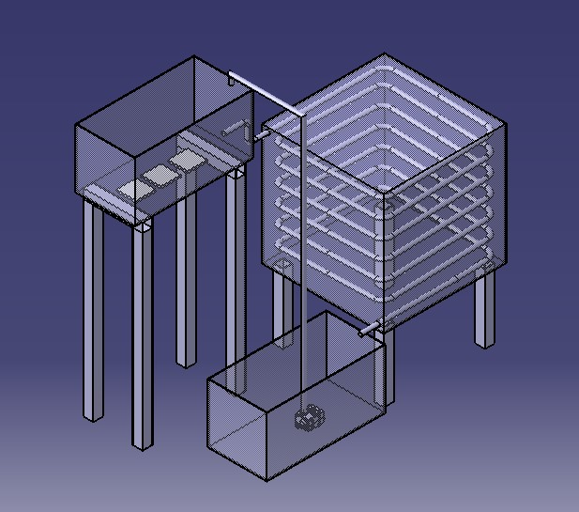
(Fig.2.Important components of the system)
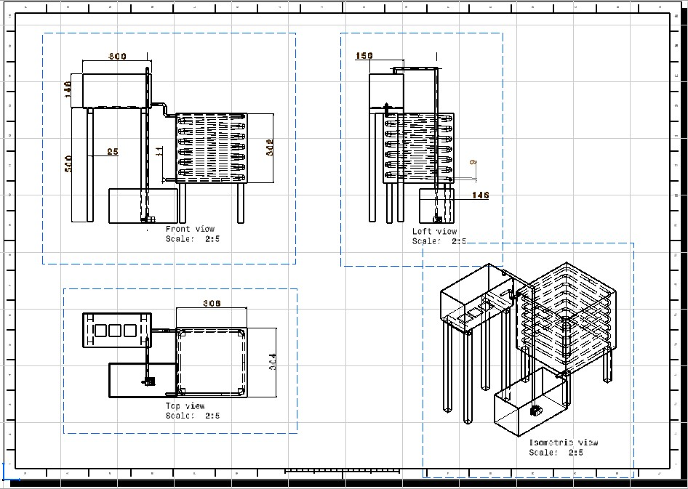
(Fig.3..Drafting of the system)

6. WORKING OF THE SYSTEM-
The proposed system is based on the working of Peltier Effect where one side of the Peltier module is gets cooled and one side is gets warm when we supply electric current to it. Here in the system a Peltier module is used for the absorbance of heat. As we know that the heat is transferred from high temperature to low temperature, in the water tank water is gets cooled as it transfers its temperature to the Peltier module. Due to conduction when the temperature of the stored water reduces up to a desired value, a valve is made open so that low temperature water is flows through the copper pope. Copper has the high heat transfer coefficient. The copper coils are coiled around the box in such a manner that when cold water flows through it, the flowing water will absorb the heat inside the box reducing its temperature. When the water comes out of the coil its temperature will be again increased. The water will move around the box due to the head difference. To achieve this head difference storage water tank is made to present at a height the water is again collected into the below tank and submersible pump is used to again pump the water in to the above tank. This process continues for a time period so that finally we get the desired temperature inside the box.
When the cooling at the one side goes on, the other side of Peltier module becomes warm. We have to harness that amount of energy too. So accordingly, water is made to come in contact with the warmer side heat is added into it due to conduction. That warm water can be further used for any desired purpose. Hence heat is added at one side and heat is removed from one side by using the Peltier effect.

7. BASIC DESIGN CALCULATIONS-
1.Temperature of the water pouring into the tank=26 C=T1
2.Temperature of the water moving out of the tank due to Peltier effect=22 C=T2
3.Temperature of the water flowing through copper pipe and coming in contact with the room where refrigeration is required=22 C=T3
4.Temperature of the water again collected in the bottom tank=26 C=T4
5.Volume of the working fluid=30 Ltrs.
6.Dimensions of single peltier module=(20*20*2)mm3

When we supply the electric current to the Peltier plates one of their sides give us reduction in temperature and one of its other side give us increase in temperature. We have to harness this cooling effect to cool the small-scale fruit storage tank, and the heat released at the other side is again used to increase the temperature of water.

In the first case when water is in contact with the peltier module conduction occurs, so accordingly the calculations were done.
1.Heat transfer due to conduction,
Q_{c}=KA(dt/dx)
=K*A*(T1-T2)/L
Where,
K=Thermal conductivity of peltier module=0.303 W/mK.
A=Surface area of the peltier module=(0.304*0.304)=0.0924 m2
T1=26 and T2=22
L=Thickness of peltier module=0.002m
Hence,
Q_{c}=K*A*(T2-T1)/L
= (0.303) *(0.0924) *(22-26)/0.002 Q_{c}= 55.99 Watts.
As, we are using two peltier modules,
Qc= -111.98 Watts
Now in the second case the temperature of the water moving out of the tank=22 C due to peltier effect. This temperatured water is moving around the box through the coil.
T3=T2=22 C
As this water is going to reduce the temperature of the box, so its temperature will be increased and temperature of the box reduced. This moving water is again collected in the tank its temperature is given as,
T4=26 C
Now,
Q=mC_{p}(T3-T4) m=Mass flow rate of fluid.
C_{p}=Specific heat capacity of working fluid(Water)=4182 J/KgC
Now we are using a copper pipe with diameter D=20mm=0.02m
Area of the pipe=(3.14/4)*(D)2
A=3.141*10^-4 m2
As the water is moving under gravitational head and the angle at which copper pipe is inclined to the box is very low, so that maximum heat transfer can be found out. Velocity of the moving water,
V=0.025 m/s
Hence the discharge
Q_{d}=A*V
=(3.141*10^-4)*(0.025) Q_{d} =7.85*10^-6 m3/s
Now we know that mass flow rate of fluid(m)=Density of fluid*Discharge
m=997*7.85*10^-6 m=7.82*10^3 kg/sec.
Now the amount of heat transfer is calculated as,
Q=mC_{p}(T3-T4)
=(7.82*10^3)*( 4182)*(22-26)
Q₂= 130.92 Watts
Now the net Q is given as,

Q=Q_{c}+Q₂= (-111.98)+(-130.92) = 242.9 Watts.
On the other hand when cooling is going on water coming in contact with the warmer side will gain the temperature.
T1=Temperature of the surrounding water=26 C
T2=Temperature of the surrounding water=30 C

Again heat transfer due to conduction is given as,
Q_{c}=K*A*(T2-T1)/L
= (0.303) *(0.0924) *(30-26)/0.002 Q_{c}= 55.99 Watts.
For two Peltier modules, Qc=111.98 Watts.

8. IMPORTANT COMPONENTS-

8.1.Peltier Module-
Peltier modules contain two external ceramic plates separated by semiconductor pellets. One of the plates absorbs heat (becomes cooler) and the other plate dissipates heat (becomes hotter) when a current is passed through the semiconductor pellets. Thermoelectric coolers operate according to the Peltier effect. The effect creates a temperature difference by transferring heat between two electrical junctions. A voltage is applied across joined conductors to create an electric current. The main application of the Peltier effect is cooling. Peltier modules are made of 2 dissimilar material, most of the time semi-conductors. They are placed thermally in parallel and electrically in series and they are joined by thermal plates to allow heat or to flow from one side to the another .when a emf is applied to it , the cold side pumps the heat and transfer it to the hot side ( that the reason you need a heat sink on the hot side to transfer all the heat out the hot side to keep it efficient). Peltier devices are designed to move a given amount of heat when the hot side of the device is at a given temperatures and the cold side is at a given temperature.
The cold side for the refrigerator will be around 2.7C for perishables.

(Fig.4. Peltier Plate)
8.2.Copper coils for heat transfer-
An HVAC system cools the air by replacing heated air with cool air through a heat exchanger coil. This coil transfers the heat between the fluids, such as water or intermediate fluid (Freon) present in your HVAC system. Why are cooling coils at the back of refrigerators are made up of copper? Copper has very high conductivity of heat and copper does not get rusted very easily. So, the copper is ideal for making cooling coil of refrigerator. Copper heat exchangers are important in solar thermal heating and cooling systems because of copper's high thermal conductivity, resistance to atmospheric and water corrosion, sealing and joining by soldering, and mechanical strength. Aluminum has the ability to absorb heat faster than copper, and when removed from the heat source, will cool faster because it is less dense than copper. But in a system with steady heat input, like a computer cpu, copper is better at keeping heat going into and out of the metal, much as it is with electricity. A heat sink is usually made out of copper or aluminum. Copper is used because it has many desirable properties for thermally efficient and durable heat exchangers. First and foremost, copper is an excellent conductor of heat. This means that copper's high thermal conductivity allows heat to pass through it quickly.
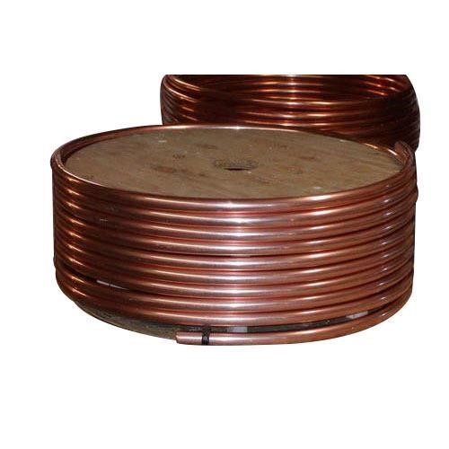

(Fig.5. Copper pipe)

8.3.Submersible Pump-
A submersible pump pushes water to the surface by converting rotary energy into kinetic energy into pressure energy. This is done by the water being pulled into the pump: first in the intake, where the rotation of the impeller pushes the water through the diffuser. From there, it goes to the surface. Submersible pumps, which are located in the well last 8 to 10 years before they need to be replaced, however, many well pumps that service homes with moderate water usage can last up to 15 years. Dry running of the pump can damage the mechanical seal and the motor. For this reason, the float switches should be arranged so that the fill level in the shaft does not fall below the minimum level required to operate the pump. A submersible pump (or sub pump, electric submersible pump (ESP)) is a device which has a hermetically sealed motor close-coupled to the pump body. The whole assembly is submerged in the fluid to be pumped. The main advantage of this type of pump is that it prevents pump cavitation, a problem associated with a high elevation difference between pump and the fluid surface. Submersible pumps push fluid to the surface as opposed to jet pumps which create a vacuum and rely upon atmospheric pressure. Submersibles are more efficient than jet pumps. Hydraulic submersible pumps (HSP's) use pressurized fluid from the surface to drive a hydraulic motor downhole, rather than an electric motor, and are used in heavy oil applications with heated water as the motive fluid.
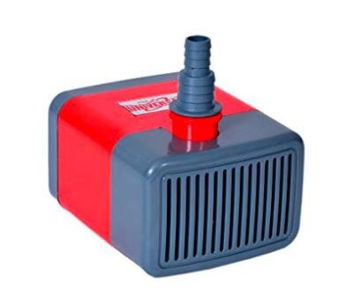

(Fig.6. Submersible Pump)

9. COST ESTIMATION-
Cost estimation may be defined as the process of forecasting the expenses that must be incurred to manufacture a product. These expenses take into a consideration all expenditure involved in a design and manufacturing with all related services facilities such as pattern making, tool, making as well as a portion of the general administrative and selling costs.

9.1. PURPOSE OF COST ESTIMATION:
- To determine the selling price of a product for a quotation or contract so as to ensure a reasonable profit to the company.
- Check the quotation supplied by vendors.
- Determine the most economical process or material to manufacture the product.
- To determine standards of production performance that may be used to control the cost.

9.2. TYPES OF COST ESTIMATION:
- Material cost
- Machining cost

9.2.1 Material Cost Estimation
Material cost estimation gives the total amount required to collect the raw material which has to be processed or fabricated to desired size and functioning of the components.These materials are divided into two categories.
- Material for fabrication:
In this the material in obtained in raw condition and is manufactured or processed to finished size for proper functioning of the component.
- Standard purchased parts:
This includes the parts which was readily available in the market like allen screws etc. A list is forecast by the estimation stating the quality, size and standard parts, the weight of raw material and cost per kg. For the fabricated parts.

9.2.2 Machining Cost Estimation
This cost estimation is an attempt to forecast the total expenses that may include manufacturing apart from material cost. Cost estimation of manufactured parts can be considered as judgment on and after careful consideration which includes labor, material and factory services required to produce the required part.
Procedure for calculation of cost:
The general procedure for calculation of material cost estimation is after designing a project,
1. A bill of material is prepared which is divided into two categories.
- Fabricated components
- Standard purchased components
- The rates of all standard items are taken and added up.
- Cost of raw material purchased taken and added up.

SR.NO. | COMPONENTS | COST
1. | M.S. Material | 3000
2. | Peltier Module | 1500
3. | Copper Coils | 1000
4. | Submersible Pump | 3000
5. | Insulating Material | 500

( Material cost table)

Total Cost = Cost of Components + Machining Cost = 10000/-

10. PROCESS SHEET:

Following operations were while fabricate the project

Cutting: -
This operation is performed to cut the material as our required size. The machine used for this operation is power chop saw. A power chop saw, also known as a drop saw, is a power tool used to make a quick, accurate crosscut in a workpiece at a selected angle. Common uses include framing operations and the cutting of molding. Most chop saws are relatively small and portable, with common blade sizes ranging from eight to twelve inches.

Finishing: -
This operation is performed to finish the edges with grinder using grinding wheel. The machine used for this operation is hand grinder. An angle grinder, also known as a side grinder or disc grinder, is a handheld power tool used for cutting, grinding and polishing. Angle grinders can be powered by an electric motor, petrol engine or compressed air. The motor drives a geared head at a right-angle on which is mounted an abrasive disc or a thinner cut-off disc, either of which can be replaced when worn.

Welding: -
This method is used to weld square pipes of different lengths to make frame. The machine used for this operation is electric arc welding. Electrical arc welding is the procedure used to join two metal parts, taking advantage of the heat developed by the electric arc that forms between an electrode (metal filler) and the material to be welded. The welding arc may be powered by an alternating current generator machine (welder). This welding machine is basically a single-phase static transformer Suitable for melting RUTILE (sliding) acid electrodes. Alkaline electrodes may also be melted by alternating current if the secondary open-circuit voltage is greater than 70 V.

Polishing: -
This operation is performed to polish the welded joints with hand grinder using grinding wheel. The machine used for this operation is hand grinder. With refinement, grinding becomes polishing, either in preparing metal surfaces for subsequent buffing or in the

actual preparation of a surface finish, such as a No. 4 polish in which the grit lines are clearly visible. Generally speaking, those operations which serve mainly to remove metal rapidly are considered as grinding, while those in which the emphasis is centered on attaining smoothness are classified as polishing.

Safety Precautions:
The following points should be considered for the safe operation of machine and to avoid accidents: -
- All the parts of the machine should be checked to be in perfect alignment.
- All the nuts and bolts should be perfectly tightened.
- The operating switch should be located at convenient distance from the operator so as to control the machine easily.
- The inspection and maintenance of the machine should be done from time to time.

 | Sr.  No | Activity/month | July  16 | Aug | Sept | Oct | Nov | Dec | Jan  17 | Feb | March
 | 1 | Search of topic
 | 2 | Selection of topic and  research papers
 | 3 | Finalising of sponsored project
 | 4 | Literature review
 | 5 | Basic diagram and study of components
 | 6 | Cad diagram and starting the calculation of components
 | 7 | Calculations
 | 8 | Finalizing the calculations and preparing the final cad diagram with dimensions
 | 9 | Starting manufacturing

 | 10 | Buying the  standard components from market
 | 11 | Testing of model
 | 12 | Rough draft of  report
 | 13 | Final report

12. CONCLUSION

In this semester we have successfully designed and done the material selection for a cooling system based on Peltier effect. For that purpose, we have used the CATIA V5 R20 software. In the system we can generate cooling effect without the utilisation of HFCs.

13. FUTURE SCOPE

In future scope, this Portable Fruit Preservation System can be used in cooling operation, This system achieves minimum temperature 16oC and maximum around 40oC and maximum voltage occur in about 30 minutes. For future development, this system can be used as a replacement for conventional refrigeration system that using coolant that can be harmless for human in long term.

14. PROBLEAM STEATMENT

Now a days global warming is the most prominent effect of human development done in the last century. Ozone layer depletion over the Antarctic Continent is also a big issue facing by the mother earth. These two are happening due to the CFCs an HFCs. Though CFCs are completely banned HFCs are still used to achieve the refrigeration effect. So, there is a need to develop a system where we can generate refrigeration effect without using these harmful HFCs.

15. REFERENCES

- Margaret Antonik, Brendan T. O’Connor, Scott Ferguson, “Thermodynamic modelling and analysis of thermoelectric cooling system,” International Conference on Energy Efficient Technologies for Sustainability, pp.685-693,2016.

- Matthew R. Pearson, Charles E. Lents “One-dimensional modeling of TE devices considering temperature-dependent parameters using SPICE,” 2007 13th International Workshop on Thermal Investigation of ICs and Systems THERMINIC, pp, 202-207,2007.

- J. Zhao, J. A. Salcedo, J. Hajjar, “On-Chip Protection in Precision Integrated Circuits
Operating at High Voltage and High Temperature,” IEEE International Reliability Physics Symposium IRPS, pp. EL-4-1 - EL-4-3, 2016.

- Jianglan Li, Yunbo Shi, Pengfei Zhao,etc. Temperature control design of TEC high precision semiconductor laser [J]. Infrared and laser engineering, 2014, 43(06):1745-1749.
- Songrong Lu, Xiangmei Xue. The Semiconductor Refrigeration Technique and Application in Domestic Appliance [J]. Refrigeration, 2004, 23(1):83-85.

- Shuping Ai. Research on control mode and algorithm of constant temperature control unit of semiconductor laser [D]. Northeast Normal University, 2005.

- Yanchang Cao, Jijun Xiong, Qingzhi Hou. Design of temperature control system for semiconductor laser based on MAX1978 [J]. Microcomputer and Application, 2014(18):70-72.
- Alfi Tranggono Agus Salim1, Yuli Prasetyo2, Yoga Akhdiat Fakhrudin3 1, 2,
3Department of Engineering, “Politeknik Negeri Madiun, Indonesia, Study of Effect Comparison Thermoelectric Characteristics of TEC and TEG by Considering the Difference in Temperature and Variable Resistant”
- H. Rafika, “Kaji Eksperimental Pembangkit Listrik Berbasis Thermoelectric Generator (TEG) Dengan Pendinginan Menggunakan Udara,” Jurnal Sains dan Teknologi, vol. 15, issue 1, pp. 7-11, 2016.
- M. Khalid, M. Syukri, and M. Gapy, “Pemanfaatan Energi Panas Sebagai Pembangkit
Listrik Alternatif Berskala Kecil Dengan Menggunakan Termoelektrik,” Jurnal Online
Teknik Elektro, vol. 1, issue 3, pp. 57-62, 2016
- K. Prashantha and Sonam Wango “Smart power generation from waste heat by thermo electric generator,” International Journal of Mechanical and Production Engineering, Special Issue, pp. 45-49, 2016.
- A. Roekettini, Perancangan Awal dan Manufaktur Thermoelectric Generator
Menggunakan 12 Modul Thermoelectric untuk Kendaraan Hybrid,” Tugas Akhir Teknik Mesin FT-UI: Jakarta, Indonesia, 2008.
- A. T. Agus Salim and Bahtera Indarto, “Studi Eksperimental Karakteristik Elemen Termoelektrik Tipe TEC,” Journal of Electrical, Electronics, Control, and Automotive Engineering, vol. 3, issue 1, pp. 179-182, 2018.
- Intan D. N. Ramdini, “Termoelektrik generator,” Indonesian Jurnal of Material
Science, vol. 47, issue 120, pp. 7-11, 2014

