**Design of Microgrid with Solar and Wind Systems using Artificial Neural Networks**

**1Chappa Vinodh, 2M. Sai Ganesh**

*1PG Scholar, Department of EEE, BITS, Visakhapatnam, Andhra Pradesh, India*

*2Assistant Professor, Department of EEE, BITS, Visakhapatnam, Andhra Pradesh, India*

---------------------------------------------------------------------***---------------------------------------------------------------------

**Abstract -** According to the suggested system, there are many power transfer techniques for a grid-connected hybrid generating system with flexible power transmission. This hybrid method maximizes energy efficiency by making the most use of freely accessible sustainable energy sources such as wind and solar energy. For such a system, an adaptive MPPT algorithm will be employed in conjunction with the traditional perturb and observe technique. Depending on the accessibility of the power sources, this architecture allows the client sources to supply the load individually or concurrently. In the case of wind energy, the rotor speed of the turbine is a key determinant, but the production of solar energy is heavily controlled by the voltage of the solar cells. A wind farm and a Permanent Magnet Synchronous Generator must be utilized in tandem to convert renewable energy. The inverter converts unconventional energy into AC power, which then converts the DC output into useable AC power for the corresponding load. This hybrid system operates normally under usual conditions, assuming standard room temperature for solar and standard wind speed in a flat site for renewable electricity. Harmonic ripples can be reduced by utilizing an ANN-based PWM system. The modelling and experimental findings were used to show the working principle, practicability, and reliability of the proposed system.

***Key Words*:** Wind, Solar, Battery, PWM, Artificial Neural Networks.

**1.INTRODUCTION**

Climate change and depletion of conventional fuel supplies have prompted many to search for renewable energy alternatives in order to protect the world for future generations. Climate change and depletion of conventional fuel supplies have prompted many to search for renewable energy alternatives in order to protect the world for future generations. Wind and solar energy have the best potential to satisfy our energy needs, except from hydro. The sun also emits energy during the day, but its strength and shadows created by storms, birds, trees, etc. cause the irradiance levels to change. Unreliability is a typical disadvantage of wind and solar systems due to their alternative power. It's possible to greatly enhance the system's energy transfer quality and effectiveness by merging these two inconsistent sources of power and integrating MPPT algorithms. One of newest developments in energy technologies is the combination of alternative energy sources with energy storage devices. Because of the rising group of alternative energy sources and dispersed generators, new techniques for their management are needed in order to maintain or maintain the efficiency and quality of the power source. As opposed to a common ac type, the use of numerous energy sources via a dc bus of a voltage regulator has become more popular because of the ease of integrated management and surveillance and uniformity in the architecture of the controllers. Analysis of the dynamic response of a wind and solar energy system A wind farm plant model was created and matched to a genuine system. The simulation was found to be accurate. A variety of approaches to optimal architecture or unit sizing are available. On walk systems, the major control objective is to match loads in a given area. Several grid-connected technologies view the grid as either a back-up option when renewable energy sources are inadequate. With a risk of power outage of a specified time, they were initially developed to fulfil local peak load. When it comes to hybrid systems, which are primarily concerned with supplying electricity to their loads, they don't give a hoot about quality or adaptability. For utilities, nevertheless, it is preferable to have a hybrid model with a less erratic real power or the capacity to regulate its energy. As a result, users will choose a system that offers a variety of alternatives for power transmission, as it will make system administration and maintenance easier and more convenient. As a hybrid model, the control techniques must differ than those of traditional systems.

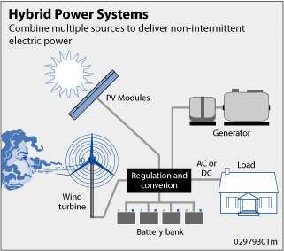

Fig 1.1: General Hybrid System

# II. SOLAR AND WIND

When solar energy is converted into dc electricity utilizing materials that show the photoelectric cells, it is known as photovoltaic (PV). Solar panels incorporating photovoltaic cells are used in photovoltaic systems. Monocrystalline silicon, cadmium telluride, polycrystalline silicon, amorphous silicon and copper indium selenide/sulfide are some of the materials now utilized in photovoltaics [1]. Recent advances in the production of photovoltaic arrays and solar cells are due to the rising need for sustainable power.

The solar pv power industry has grown to more than 100 countries, putting it the world's biggest power generating technology, despite the fact that it only accounts for a small proportion of the nation's population 4800 GW electricity producing capacity.

Since 2004, grid-connected Photovoltaic capacity has grown at an average yearly rate of 60 percent, reaching 21 GW in 2009. Building Combined Photovoltaics, or BIPV, is a type of surface photovoltaic system that is occasionally integrated with farming and livestock. An extra 3–4 GW is attributed to off-grid photovoltaics.

During exposure to light, a substance generates voltage (or an electric current). Photovoltaics and Photo electrics are closely linked, yet they are distinct and should be differentiated. On doses of radiation of adequate power, particles are expelled from a material's surface. Because of this, electrons produced in a solar panel go from one spectrum of the semiconductor to another (i.e. valence to conductive band), leading in a voltage between two terminals. Almost all photovoltaic technologies use radiation from the sun, which is why these devices are called solar cells. An electricity generator by the depleting area of a p-n junction solar cell when the material is illuminated. It wasn't until 1839 that Alexandre-Edmond Becquerel noticed the photovoltaic effect for the first time.



Fig 2.1: PV effect converts the photon energy into voltage across the pn junction

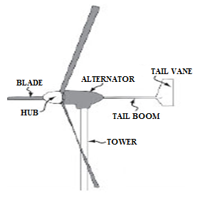

Fig 2.2: Wind turbine

# III. BATTERY STORAGE

When it comes to applications, electricity is more adaptable than other kinds of power since it is a highly organized form of energy that can easily transformed. So, it may be transformed into rotational motion with a near 100% effectiveness or into temperature with 100% effectiveness, for example. That's because heat energy is a disorganized type of energy in the atoms, and it can't be transformed very efficiently into electricity. Therefore, conventional fossil power plants have a superior heat power density of less than 50%.

Electricity has the disadvantage of being difficult to store on a big scale. Most of the electricity utilized today is used at the same time as it's being produced. When it comes to traditional power plants, where the fuel consumption varies continually with the load need, this is not a problem. It is impossible for intermittent sources of energy, such as wind and solar panels (PVs), to fulfil the demand for power at all times, 24 hours per day and 365 days in a year.

*A. Battery control*

The battery converter's primary job is to alter the dc-bus voltage, as implied by its name. The battery load current changes rapidly while the grid inverter is operated in dispatching or averaging mode. Controlling the common dc-bus voltage is necessary to maintain a constant voltage regardless of battery current fluctuations. We use a modified hysteresis-control method to achieve this. Hysteresis bands can be used to alter the DC voltage of a shared circuit. A charger/discharger is regulated in such a way that it does not overshoot or undershoot, as shown in figure, the upper and lower limits of the DC bus voltage. It is decided whether to charge or discharge the battery depending on the level of the standard DC-bus voltage. The batteries buck-booster operates as per the following way:

If  > , then charging →  = 

If  < , then discharging →  = 

If  ≤  ≤  then no control (rest)



Fig. 3.1. Battery-mode control block

Vdc is set to the higher limit if the dc voltage Vdc exceeds the upper limit. If Vdc falls below the lower limit, the voltage goal is tied to the lower limit, and the converter switches to boost mode to compensate for the voltage drop.

# IV. ARTIFICIAL NEURAL NETWORKS

Numerous advances have been made in developing intelligent systems, some inspired by biological neural networks]. Researchers from many scientific disciplines are designing artificial neural networks to solve a variety of problems in pattern recognition, prediction, optimization, associative memory, and control. Conventional approaches have been proposed for solving these problems. Although successful applications can be found in certain well-constrained environments, none is flexible enough to perform well outside its domain. ANNs provide exciting alternatives, and many applications could benefit from using them. This article is for those readers with little or no knowledge of ANNs to help them understand the other articles in this issue of Computer.

The long course of evolution has given the human brain many desirable characteristics not present Invon Neumann or modern parallel computers. These include massive parallelism, distributed representation and computation, learning ability, Generalization ability.

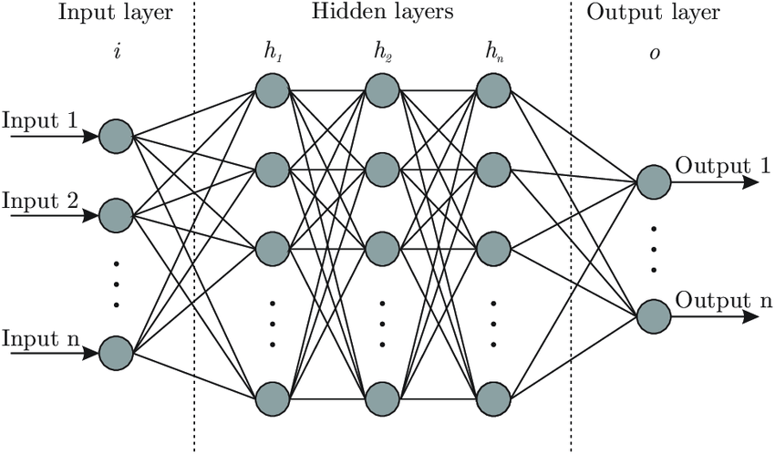

Fig.4.1: Artificial Neural Networks

# V. SIMULATION RESULTS

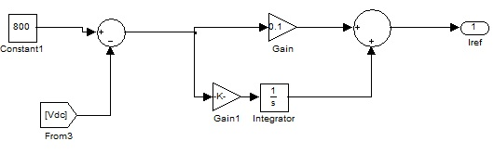

Fig.5.1 MATLAB Simulink model of PI control

Simulink's panels and views allow us to see the program's signals. MATLAB visualization and GUI software applications allow us to create our own unique displays. For comment, we may additionally log the signals that we receive.

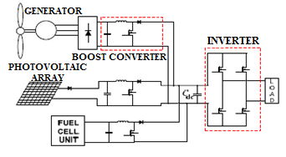

Fig 5.2 Model of Proposed Hybrid Circuit

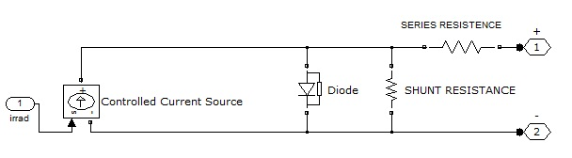

Fig 5.3 Basic Structure Of PV-Cell

Electrical radiation is used to power the fundamental PV cell, which is then fed forward from the help of a diode. Shunt and series resistors have been used to improve the performance of a PV cell.

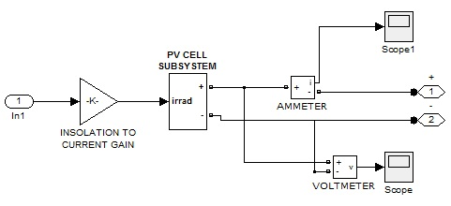

Fig 5.4 Transition of Insolation Into Current Gain

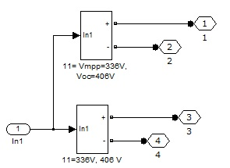

Fig 5.5 Parallel Connection Of Solar Cell

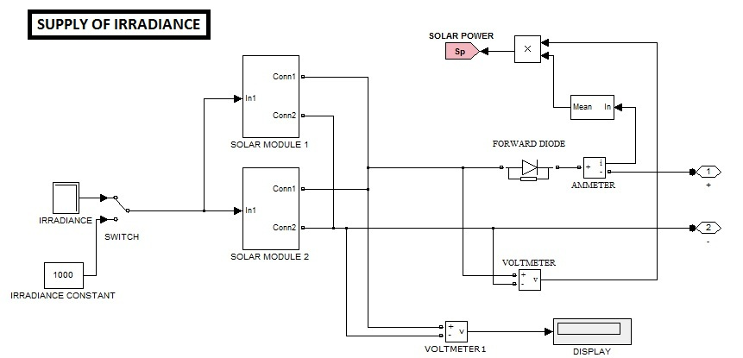

Fig 5.6 Simulation Model Showing the Utilization of Irradiance and Solar Modules

The PV System has different components of PV cells. Each PV panel contains two rows of 11 cells. Simulink's Show block is used to increase the current generated at the parallel combination between the PV panels.

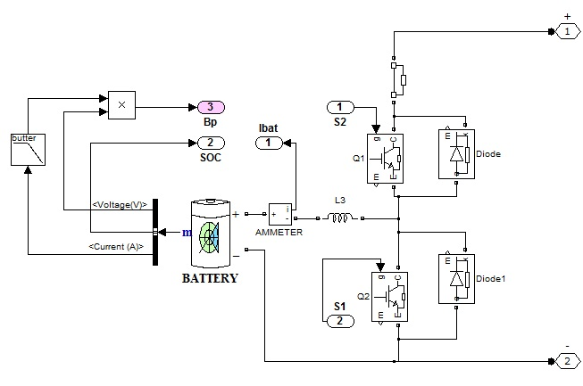

Fig 5.7 Battery Operation features sufficient supply to load

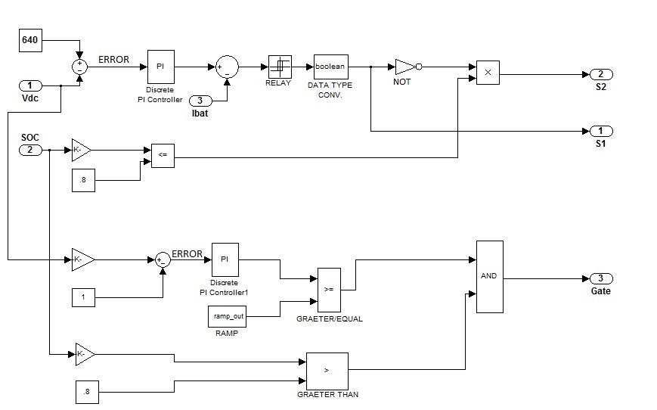

Fig 5.8 Working Logic of Battery Operation

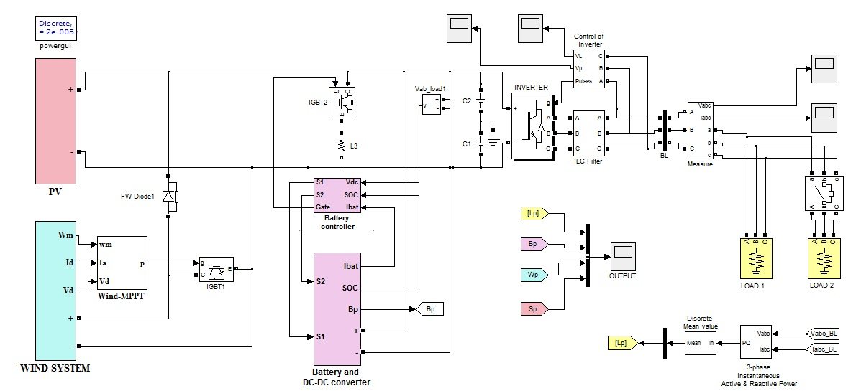

Fig 5.9 Composite Simulation Model of Proposed Hybrid System

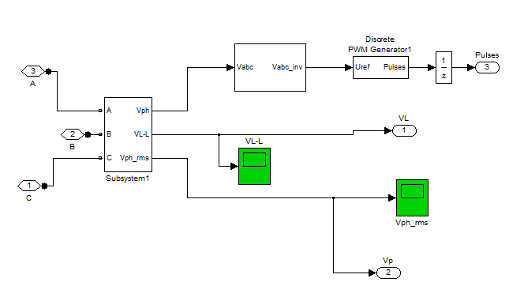

Fig 5.10 Inverter control using PWM

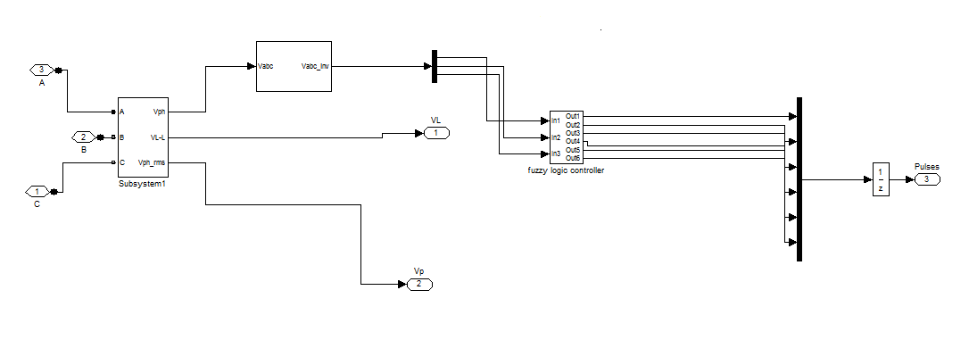

Fig 5.11 ANN based PWM controller

TABLE 5.1 Life Cycle of Hybrid System

|  |  |
| --- | --- |
| **TIME** | **Characyeristics** |
| 0-1s | 1. Solar energy with full irradiance 2. Wind Turbine tends towards base speed of 12ms after 0.5 s 3. Battery gives partial supply to load 4. Load is 10 KW |
| 1-2s | 1. Wind achieves 5.6 KW 2. Battery stores 5 KW |
| 2-3s | 1. Solar Energy Reduced by 15 2. Battery stores 3.5 KW |
| 3-4s | 1. Wind speed decreases by 25 to 9ms 2. Battery gives partial supply to load |
| 4-5s | 1. Load is increased by 40 2. Battery is responsible to overcome 40 load demand |
| 5-6s | Load demand comes to previous point |

*Simulated Graphs:*

* All throughout time scale, the generation capacity is 10 KW, with the exception of 4 to 5 seconds when it jumps to 14 KW.
* Photovoltaic energy's intensity declines from 2 seconds to 15 percent. After 0.5 seconds, a 5m/s wind farm increases to a 12m/s base speed. In this case, the spinning speed has been slowed down to 25% of its rated speed.
* All of these criteria are evident in the graph below.

Approximately 640 V is the maximum voltage of the PV array, according to measurements. As shown in the graph below, changing irradiance is what determines the maximum voltage.

TABLE 5.2 Major Landmarks of Proposed Hybrid System

|  |  |  |  |  |
| --- | --- | --- | --- | --- |
| **TIME** | **SOLAR ENERGY** | **WIND**  **ENERGY** | **BATTERY** | **LOAD** |
| 0-1 |  | Speed Tends Towards Base Speed |  |  |
| 1-2 |  |  | Significant  Charging |  |
| 2-3 | Irradiance Drop | Speed falls |  |  |
| 3-4 |  |  |  |  |
| 4-5 |  |  | Mainstay Load Sharing | Additional Load Attached |
| 5-6 |  |  |  |  |

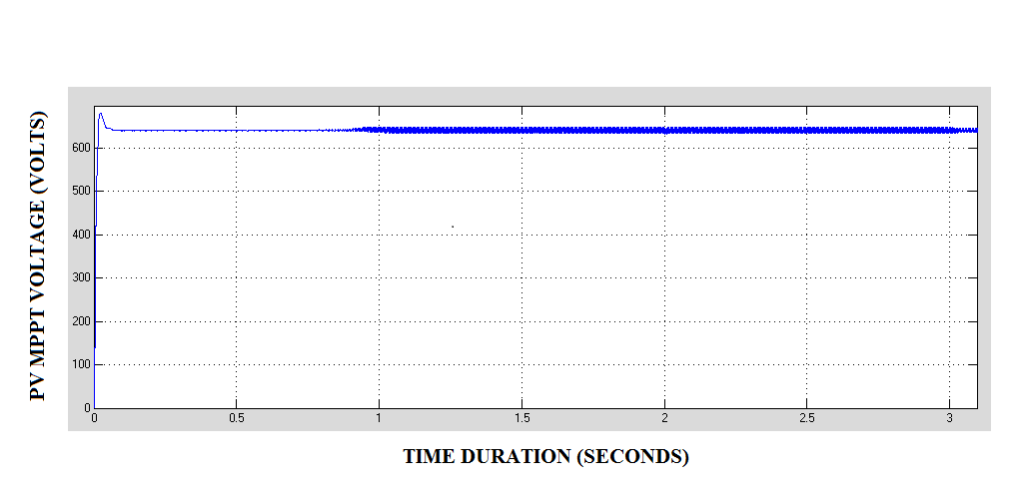

Fig 5.12 Phase Voltage observed at the PV array

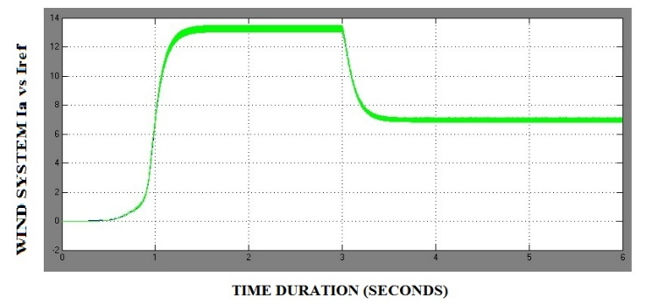

Fig 5.13 The relative variation curve of Actual Current (Ia) and Reference Current (Iref)

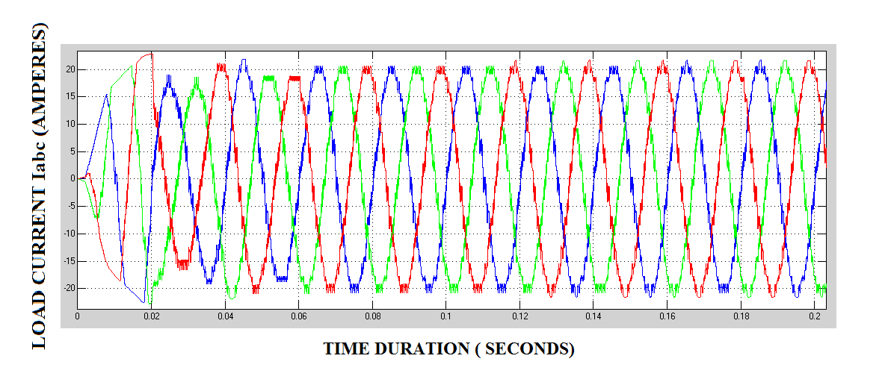

Fig 5.14 The load current supplied to the load is sinusoidal in nature as depicted in the simulation

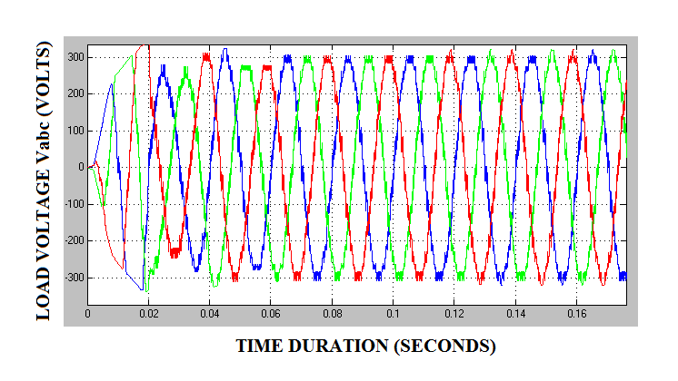

Fig 5.15 Three Phase Voltage Supplied to The Load By The Inverter

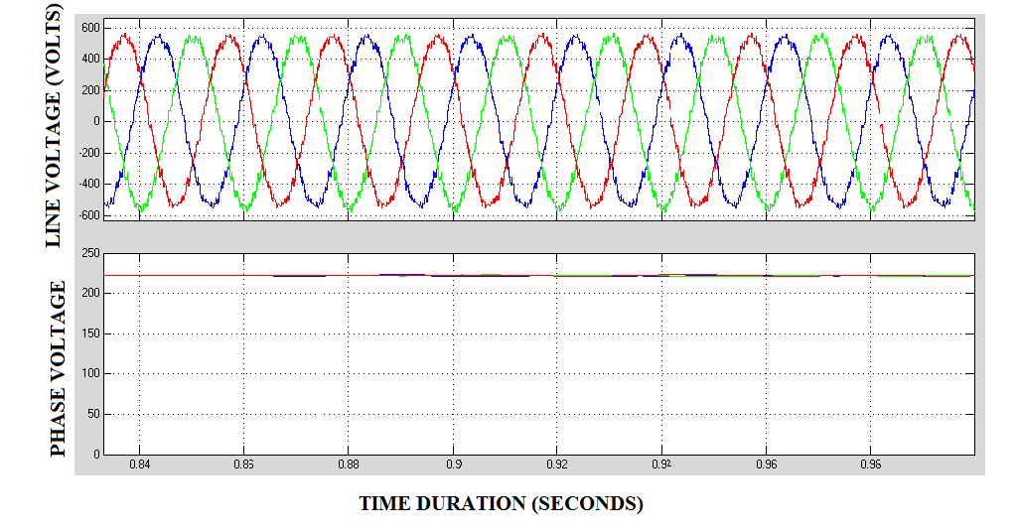

Fig 5.16 AC Line Voltage and Phase Voltage Given by The Inverter

TABLE 5.3 Inverter Output Voltage

|  |  |
| --- | --- |
| TIME | PHASE VOLTAGE |
| 1 s | 230 |
| 2 s | 230 |
| 3 s | 230 |
| 4 s | 230 |
| 5 s | 230 |
| 6 s | 230 |

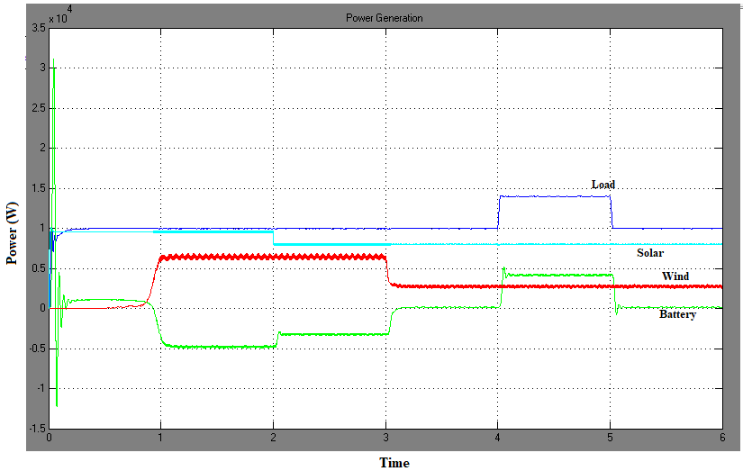

Fig 5.17 Simulation result with PWM (PI) control

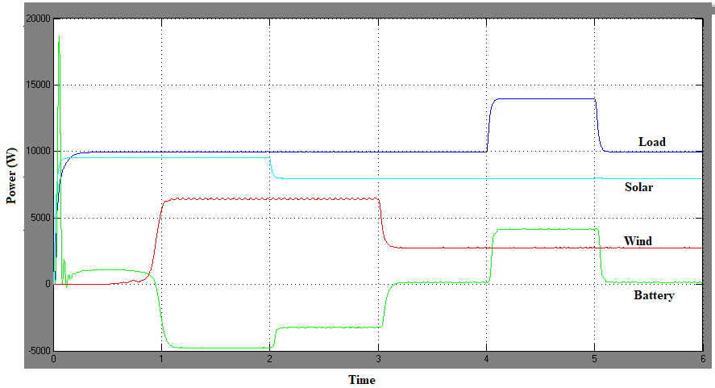

Fig 5.18 Simulation result with ANN controller

# VI. CONCLUSION

In the paper, the wind turbine, PV array and battery work together to meet the load requirement. A solar and wind inverter is used to convert solar and wind energy into AC electricity. It is necessary to utilize a circuit breaker to attach an extra load of 5 KW within the specified time frame. In order to satisfy the demand, this combined system is programmed to provide maximum power output even under operating circumstances to satisfy the load, either a wind or solar system is backed by the battery. Also, batteries for the same load are used to enable the simultaneous operation of wind and solar systems. When compared to a PWM controller, ANN control provides superior inverter system stability. The use of ANN controllers helps decrease the amount of disruption caused by load changes.

# REFERENCES

1. Joanne Hui*, Alireza Bakhshai, and Praveen K. Jain, “A Hybrid Wind-Solar Energy System: A New Rectifier Stage Topology “, in [Applied Power Electronics Conference and Exposition (APEC), 2010 Twenty-Fifth Annual IEEE](http://ieeexplore.ieee.org/xpl/mostRecentIssue.jsp?punumber=5426413), pp 156-161, 21-25 Feb. 2010
2. S.K. Kim, J.H Jeon, C.H. Cho, J.B. Ahn, and S.H. Kwon, “Dynamic Modeling and Control of a Grid-Connected Hybrid Generation System with Versatile Power Transfer,” IEEE Transactions on Industrial Electronics, vol. 55, pp. 1677-1688, April 2008.
3. N. A. Ahmed, M. Miyatake, and A. K. Al-Othman, “Power fluctuations suppression of stand-alone hybrid generation combining solar photovoltaic/wind turbine and fuel cell systems,” in Proc. Of Energy Conversion and Management, Vol. 49, pp. 2711-2719, October 2008.
4. Manoj, V., Manohar, K., & Prasad, B. D. (2012). Reduction of switching losses in VSC using DC link fuzzy logic controller Innovative Systems Design and Engineering ISSN, 2222-1727.
5. V. B. Venkateswaran and V. Manoj, "State estimation of power system containing FACTS Controller and PMU," 2015 IEEE 9th International Conference on Intelligent Systems and Control (ISCO), 2015, pp. 1-6, doi: 10.1109/ISCO.2015.7282281.
6. Y.M. Chen, Y.C. Liu, S.C. Hung, and C.S. Cheng, “Multi-Input Inverter for Grid-Connected Hybrid PV/Wind Power System,” IEEE Transactions on Power Electronics, vol. 22, May 2007.
7. S. Jain, and V. Agarwal, “An Integrated Hybrid Power Supply for Distributed Generation Applications Fed by Nonconventional Energy Sources,” IEEE Transactions on Energy Conversion, vol. 23, June 2008.
8. D. Das, R. Esmaili, L. Xu, D. Nichols, “An Optimal Design of a Grid Connected Hybrid Wind/Photovoltaic/Fuel Cell System for Distributed Energy Production,” in Proc. IEEE Industrial Electronics Conference, pp. 2499-2504, Nov. 2005.
9. dos Reis, F.S., Tan, K. and Islam, S., “Using PFC for harmonic mitigation in wind turbine energy conversion systems” in Proc. of the IECON 2004 Conference, pp. 3100- 3105, Nov. 2004
10. Manohar, K., Durga, B., Manoj, V., & Chaitanya, D. K. (2011). Design Of Fuzzy Logic Controller In DC Link To Reduce Switching Losses In VSC Using MATLAB-SIMULINK. Journal Of Research in Recent Trends.
11. R. W. Erickson, “Some Topologies of High Quality Rectifiers” in the Proc. of the First International Conference on Energy, Power, and Motion Control, May 1997.
12. D. S. L. Simonetti, J. Sebasti´an, and J. Uceda, “The Discontinuous Conduction Mode Sepic and ´ Cuk Power Factor Preregulators: Analysis and Design” IEEE Trans. On Industrial Electronics, vol. 44, no. 5, 1997
13. N. Mohan, T. Undeland, and W Robbins, “Power Electronics: Converters, Applications, and Design,” John Wiley & Sons, Inc., 2003.
14. J. Marques, H. Pinheiro, H. Grundling, J. Pinheiro, and H. Hey, “A Survey on Variable-Speed Wind Turbine System,” Proceedings of Brazilian Conference of Electronics of Power, vol. 1, pp. 732-738, 2003.
15. F. Lassier and T. G. Ang, “Photovoltaic Engineering Handbook” 1990
16. Global Wind Energy Council (GWEC), “Global wind 2008 report,” June 2009.
17. Manoj, V. (2016). Sensorless Control of Induction Motor Based on Model Reference Adaptive System (MRAS). International Journal For Research In Electronics & Electrical Engineering, 2(5), 01-06.