IMPLEMENTATION OF AN EFFICIENT ENERGY GENERATING SYSTEM USING HUMPS WITH AUTOMATIC STREET LIGHT

K.Saraswathi

Assistant Professor, Department of EIE, SCSVMV, India.

Abstract:

Nowadays renewable energy and energy recovery are considered the most efficient strategies to reduce the financial and environmental drawbacks of the excessive utilization of fossil fuel. Nonetheless, most of the investigations have been paying attention on solar energy, wind energy and wave energy.In order to meet the future electricity demand without harming the environment, it is necessary to focus more on renewable energy and unconventional sources for electricity generation. The utilization of waste energy can also be helpful for reducing dependence on conventional sources for electricity generation.

Keywords:

Conversion, Busy Road, Speed Breaker, Energy.

Introduction:

In the present day scenario power has become the major need for human life. The day-to-day increasing population and decreasing conventional sources for power generation, provides a need to think on non- conventional energy resources. Walking is the most common activity in day to day life. When a person walks, he loses energy to the

road surface in the form of impact, vibration, sound etc., due to the transfer of his weight on to the road surface, through foot falls on the ground during every step. This energy can be tapped and converted in the usable form such as in electrical form. In South Africa during the electrical crisis, the foot power was implemented to light up small villages. Power generation using the mechanical energy produced by the pedestrians is used in London.In this paper, the electricity generation by utilizing the kinetic energy of moving vehicles over speed breaker is presented. The proposed system is designed to extract the kinetic energy of moving vehicles which converts into mechanical energy through rack and pinion mechanism

Hardware requirements:

8051 MICROCONTROLLER

6V BATTERY

12V BATTERY MICROCONTROLLER LDR
LCD

STREET LIGHT MECHANISM POWER HUMP

Circuit diagram:

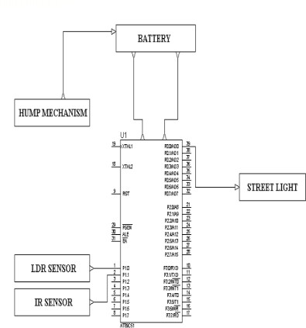

Working :

while moving, the vehicles possess some kinetic energy and it is being wasted. This kinetic energy can be utilized to produce power by using a special arrangement called Power Hump. It is an Electro-Mechanical unit. It utilizes both mechanical technologies and electrical techniques for the power generation and its storage. Power hump is a dome like device likely to be speed breaker. The amount of produced energy is updated Whenever the vehicle is allowed to pass over. The generated energy is stored in a battery and given to the street light

LDR diagram:
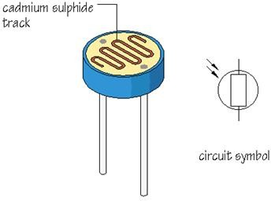

Block diagram:
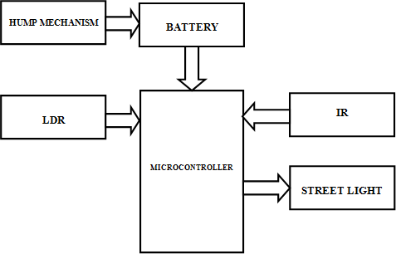

LDR Sensor(Light Dependent Resistor):

LDR an acronym for light dependent resistor is a resistor whose value varies with the amount of light falling on it. It is used as a sensor to detect the light conditions in the surrounding atmosphere. The resistance of the LDR is very high of the order of Mega ohms in absence of light and it drops to a few hundred ohms or even lower in the presence of light.

Working:

Modules description:

4.0V to 5.5V Operating
Range

Fully Static Operation: 0 Hz to 33 MHz
Three-level Program Memory Lock
256 x 8-bit Internal RAM 32 Programmable I/O Lines.

It is used in burglar alarm to give alarming sound when a burglar invades sensitive premises. It is used in street light control to switch on the lights during dusk (evening) and switch off during dawn (morning) automatically. It is used to measure intensity of light. It is used in photo sensitive relay circuit.
A relay is an electrically operated switch. Current flowing through the coil of the relay creates a magnetic field which attracts a lever and changes the switch contacts. The coil current can be on or off so relays have two switch positions and have double throw (changeover) switch

Sr. No | Load (Kg) | Power Generated (Watts)
1 | 10 | 9.81
2 | 20 | 19
3 | 30 | 24
4 | 40 | 28
contacts

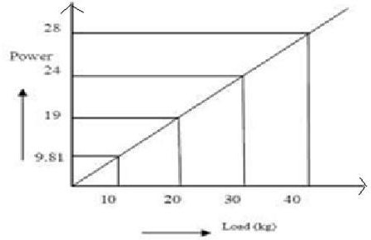

Conclusion:
The Power hump is used in this project can be intended/ upgraded for heavy vehicles Large amount of potential energy generated on the busy road can be converted into electrical energy which can be utilized to light the street lights

This alternative source of energy can be used to provide an aid to the conventional energy sources thus improving the economy of the smart metro cities.

“Energy saved is energy generated”. This project also saves the power by utilizing it optimally during night and only if there is any activity on the road.

Advantage of this system is it has not utilise any external source .Now the time has come to put forward this type of new ideas, and also researches should think to upgrade its proposal.

Future Scope:

The power hump is used in this project can be intended/upgraded for any type of vehicles, thus increasing the input torque and eventually output of generator can also be increased .Output can be further increased by using of multiple transmission system
In further ,if the hump speed control device and voltage protection devices can be added with large generation process, it would be a model all over the world

Output:

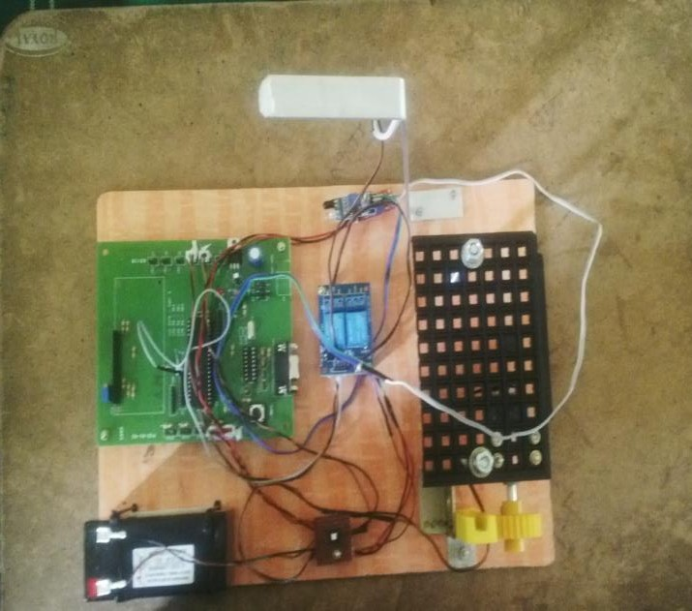

References:
- Ch.Bhanu Prakash1, A.V.Ramana Rao2, P.Srinuva, “Road Power Generation by Speed Breaker”, International Journal of Engineering Trends and Technology (IJETT), and ISSN: 2231-5381, Volume 11 Number 2, pp. 75-78, May 2014.
- Kausal Pratap singh, Priyank Singh,‟Eco-Friendly Electricity Generator From Busy Road‟, International Journal of Emerging Trends in Engineering and Development(IJETED), ISSN 2249-6149, Issue4,Vol.3, pp. 65-73, May 2014.
- Akshay Tank, Prof. Chandni V. Shah, Keyur Shah, “Eco-Friendly Energy Generation through Speed Breaker”, International Journal of Engineering Development and Research (IJERD), ISSN: 2321-9939, Issue 1, Volume 2,, pp. 1232- 1235, 2014.

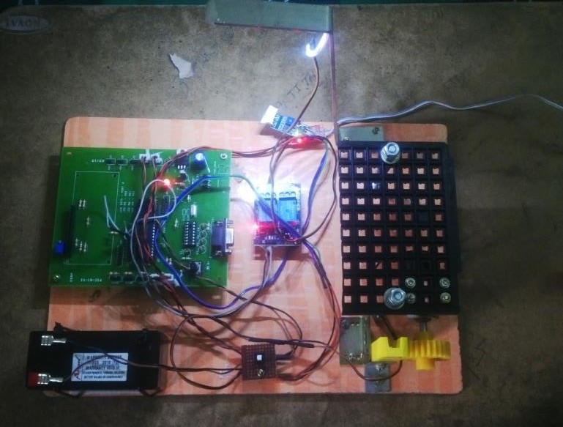
- “The 8051 Microcontroller and Embedded Systems” by Muhammad Ali Mazidi and Janice GillispieMazidi, Pearson Education.
- www.projectsworld .blogspot.com

- “8051 Microcontroller Architecture, programming and application by KENNETH J AYALA.
- ATMEL 89C51 Data sheet.

