INSOLENT HEALTH CARE OBSERVING SYSTEM WITH IOT
Mrs.K.Senthilvadivu Dhanasekar.M, Keerthivasan.N, Bharathkumar.R, Jaganathan.C
Assitant Professor Final Year CSE
Erode Sengunthar Engineering college Erode Sengunthar Engineering college
Perundurai, Erode, Tamilnadu. Perundurai, Erode, Tamilnadu.

ABSTRACT

IoT in healthcare is the key player in providing better medical facilities to the patients and facilitates the doctors and hospitals as well. The proposed system here consists of various medical devices such as sensors and web based or mobile based applications which communicate via network connected devices and helps to monitor and record patient’s health data and medical information. The proposed outcome of the paper is to build a system to provide world-class medical aid to the patients even in the remotest areas with no hospitals in their areas by connecting over the internet and grasping information through about their health status via the wearable devices provided in the kit using a Arduino Uno microprocessor which would be able to record the patient’s heart rate, blood pressure. The system would be smart to intimate the patient’s family members and their doctor about the patient’s current health status and full medical information in case any medical emergency arises. The collected information can be used to analyze and predict chronic disorders or other diseases such as heart attacks in preliminary stage itself using the data mining techniques that will also provide the approach advantageous for decision making.The system will also generate an alert notification which will be sent to doctor. Our system is useful for monitoring health system of every person through easily attaches the device and records it. In which we can analysis patient’s condition through their past data, we will recommend medicines if any emergency occurred through symbolic A.I.
KEY WORDS:bluetooth,mobile app

1. INTRODUCTION
1.1 INTERNET OF THINGS
Internet of Things (IoT) is a new revolution of the Internet. It makes objects themselves recognizable, obtain intelligence, communicate information about themselves and they can access information that has been aggregated by other things. The Internet of Things allows people and things to be connected anytime, anyplace, with anything and anyone.
IoT is an internet of three things such as people to people, people to machine/things, things/machine to thing/machine, interacting through internet.
Internet of Things Vision: IoT is a concept and a paradigm that considers pervasive presence in the environment of a variety of things/object that through wireless and wired connections and unique addressing schemes are able to interact with each other and cooperate with the other things/object to create new application/services and reach common goals.
1.2 IOT ARCHITECTURE
IoT architecture consists of different layers of technologies supporting IoT. It serves to illustrate how various technologies relate to each other and to communicate the scalability, modularity and configuration of IoT deployments in different scenarios.
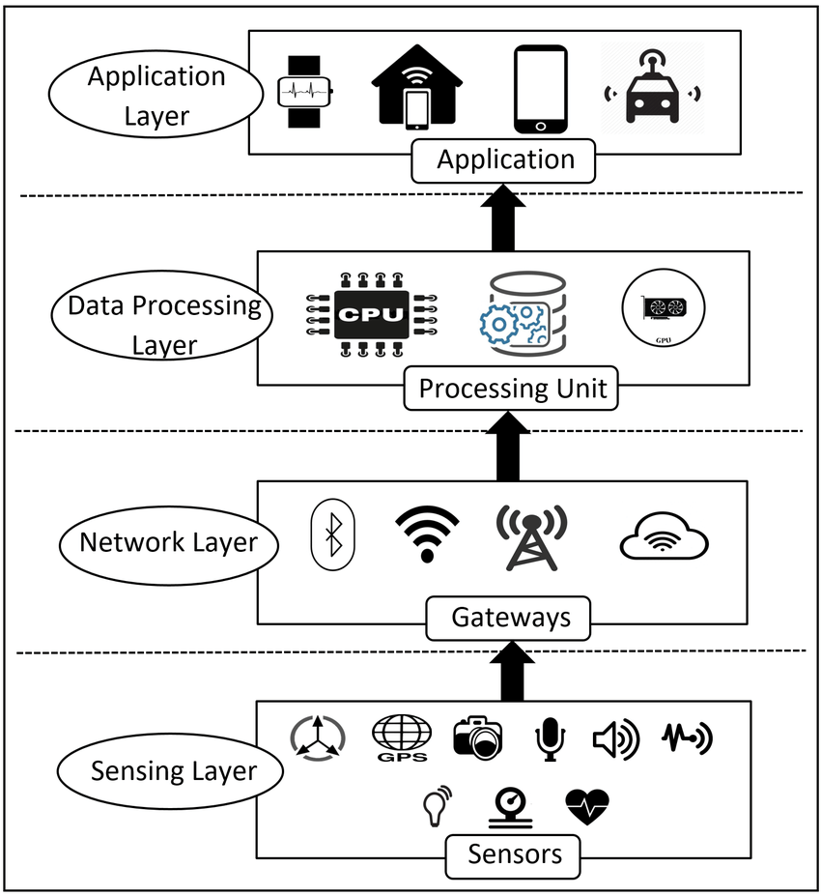
Fig 1.1: IoT Architecture

1.2.1 Smart Device/Sensor Layer
The lowest layer is made up of smart objects integrated with sensors. The sensor enable the interconnection of the physical and digital worlds allowing real – time information to be collected and processed. Sensors are grouped according to their unique purpose such as environmental sensors, body sensor, home appliance sensor and vehicle telematics sensor.

1.2.2 Gateways and Networks
Massive volume of data will be produced by this tiny sensors and this requires a robust and high performance wired or wireless network infrastructure as a transport medium. Current networks, often tied with very different protocols, have been used to support Machine-to-Machine(M2M) networks and their applications. The networks can be in the form of private, public or hybrid models and are build to support the communication requirements for latency, bandwidth or security.
1.2.3 Management Service Layer
The management service renders the processing of information possible through analytics, security controls, process modeling and management of devices. IoT brings connection and interaction of objects and systems together providing information in the form of events or contextual data such as temperature of goods, current location and traffic of data. Some of these events require filtering or routing to post processing system such as capturing of periodic sensory data, while others require response to the immediate situations such as reacting to emergency on patient health condition.
1.2.4 Application Layer
Security of the system prevents system hacking and compromises by unauthorized personnel, thus reducing the possibility of risks. IoT application covers “Smart” environments in domains such as Transportation, Building, City, Lifestyle, Retail, Agriculture, Factories, Supply chain, Emergency, Health care, User interaction, Culture and Tourism, Environment and Energy.
2 PROPOSED SYSTEM:
- Face recognition is a visual pattern recognition problem. Face detection segments the face area from the background.
- Face recognition, as one of the primary biometric technologies, became more and more important owing to rapid advances in technologies such as digital cameras, internet and mobile devices, and increased demands on security.
- Face recognition has several advantages over other biometric technologies: It is natural, nonintrusive, and easy to use.
  - MODULES:
- Patient details gathering module.
- Communication module.
- Verification and maintenance module
2.1.1 Patient details gathering module.
Patient registration forms are used to register patients for procedures offered at medical facilities. Whether you need to register new patients for your hospital, clinic, health center, or private practice, our free Patient Registration Forms will streamline the registration and onboarding process by seamlessly gathering patient information online. Simply customize any of the free templates below to match your medical facility, and you’ll be registering new patients in no time! Patients will be able to provide their personal information, provide emergency contact numbers, write down their medical histories, attach files, and submit payments all at once. Submissions will be stored safely in your secure JotForm account, easy for you and your staff to access from any device.
    - Communication module
The RCC communication module is mainly responsible for data packing/sending and receiving/unpacking processes. Defined classes, including CcommReadThread, CcommWriteThread,CMyComm, and CRCCComm, can accomplish complete functions.CcommReadThread monitors serial ports for the receiving buffer, and reads all the data once the data appear in the buffer.CcommWriteThread monitors serial ports for the sending buffer, and writes data once the buffer is empty. CMyComm inherits a subclassfrom CRCCComm, and it is responsible for packing/sending and receiving/unpacking processes. Member object m_MyAudio conveys speech collecting and playing. m_MyMel and m_MyGsm carries on MELP and LTP encoding/decoding processes respectively.

    - Verification and maintenance module
Planning a maintenance programme is part of a broader effort to establish a comprehensive programme for healthcare technology management (HTM). This planning process includes a review of critical factors. The challenge for planners is to balance these factors to design a maintenance programme that is appropriate and costeffective for their situation.
3. MAINTENANCE:
If there is any risk occurs in the project it is maintained with the help of risk management. The risk management is a process by which risk is planned to increase the probability and impact of positive events, and decrease the probability and impact of events harmful to the project.
All projects follow a similar path:
- Initiation
- Planning
- Execution and control
- Close-out
4.1.1 Initiation:
Initiation defines and authorizes the project. It is made up of two elements, the project charter and the preliminary scope statement. Project charter act as contract between parties and are necessary to document and identify the business needs of the service required to satisfy all parties involved.
The charter authorizes the project and outlines the benefits, as well as provides project justification, lists key constraints such as time, cost, and describes the responsibilities of their involved parties. The preliminary scope statement is a highly defined document that not only lists the project definition, key deliverables, constraints and driving factors, resources, risks and stake holders, but it also defines what is not included in the project. It is important for the project scope to list what is not included in the project.
4.1.2 Planning:
Planning perhaps the most crucial component of project management, but it often mistakenly achieves the status of low importance. Planning encapsulates the project management plan, kick –off, defining planning, developing a project schedule, establishing a budget and setting a project baseline. A critical step in planning is t be aware of the driving factors of the project. These are made up of cost, scope and time, with each of these factors varying in relative priority. The relative sum of these factors will always remain constant. As one these factors increases in value, one or both of the factors will be reduced. The perceived value or priority of one or more of these factors cannot be changed.
4.1.3 Execution and control:
The execution and control phase of a project encompasses kicking off the project, monitoring and control, quality and deliverable acceptance, issues and change management, and finally meetings, reviews and reporting. Although all aspects of the execution and control phase are equally important, the main focus often falls on the deliverables.
Some factors they may be responsible for could include schedule actual, cost actual versus budget constraints, and effort and resources actual. The detail and frequency of monitoring updates should be determined up front with the frequency likely to vary during the project. Depending on the nature of the project manager will be responsible for monitoring and controlling the project. Several tools are available that can help the project manager communicate what is being monitored to the client. Performance curves, Gantt charts and any other visual methods are useful to avoid misinterpretation of the data.
4.1.4 Close-out:
Project close out may seem like a step in the process that happens only when the work is complete. However, it is important to formally terminate all activities of a project or a project phase and hand off the completed product. Products that are not formally closed-out will often suffer from “scope creep.”
5. CONCLUSION:
In this paper, we have presented and proved the prototype for an automatic system that guarantees a constant monitoring of various health parameters and prediction of any kind of disease or disorder that prevents the patient from the pain of paying frequent visits to the hospitals. The proposed system can be set-up in the hospitals and massive amount of data can be obtained and stored in the online database. Even the results can be made to be accessed from mobile through an application.

REFERENCES

[1] B. G. Ahn, Y. H. Noh, and D. U. Jeong. Smart chair based on multi heart rate detection system. In 2015 IEEE SENSORS, pages 1–4, Nov 2015.
[2] S. H. Almotiri, M. A. Khan, and M. A. Alghamdi. Mobile health (m-health) system in the context of iot. In 2016 IEEE 4th International Conference on Future Internet of Things and Cloud Workshops (FiCloudW), pages 39–42, Aug 2016.
[3] T. S. Barger, D. E. Brown, and M. Alwan. Healthstatus monitoring through analysis of behavioral patterns. IEEE Transactions on Systems Man, and Cybernetics - Part A: Systems and Humans, 5(1):22–27, Jan 2005. ISSN 1083-4427.
[4] I. Chiuchisan, H. N. Costin, and O. Geman. Adopting the internet of things technologies in health care systems. In 2014 International Conference and Exposition on Electrical and Power Engineering (EPE), pages 532– 535, Oct 2014.
[5] A. Dwivedi, R. K. Bali, M. A. Belsis, R. N. G. Naguib,P. Every, and N. S. Nassar. Towards a practical healthcare information security model for healthcare institutions. In 4th International IEEE EMBS Special Topic Conference on Information Technology Applications in Biomedicine, 2003., pages 114–117, April 2003

