Real Car Gas Leakage Detector Over IOT
RAGHAVENDRA PATHAK, ANAND YADAV, DEVENDRA KUMAR PANDEY
STUDENT, STUDENT,ASSISTANT PROFESSOR,
BACHELOR OF TECHNOLOGY
DEPARTMENT OF ELECTRICAL AND ELECTRONICS
PRANVEER SINGH INSTITUTE OF TECHNOLOGY, KANPUR, INDIA

Abstract:-
IoT, i.e. Internet of Things, is the currently the most trending field in the Branch of Information Communication Technology. In case of gas leakage in car which is based on LPG and Natural gas, there is requirement of a system that can generate information of the of the car on the basis of the gas getting generated while driving and parked. Gas is generated first and then fire. The objective of this project is to build a gas detection SMS alert system based on IoT technology. A Gas detector is a device which senses the gas and based on the Gas Quantity that is present in the car it will provide alerts to the driver as well as power window system to down the window glass . Nowadays, Gas Detection and SMS alert System has been the basic requirement in various regions as the damage caused by the fire accidents is catastrophic. Also, as now the traffic , walkers are pretty close and congested, fire can spread very quickly. So, if gas detection and SMS alert system is installed while driving and down the window glass for ventilation and driver can stop the before any mishappening or blast. This system also include the detection of C02,CO during the airconditioning . The fire can be suppressed while it is in the small area and further loss of life and property due to fire can be prevented. After studying the literature survey it was planned to overcome the research gaps and the system was tested using the test cases and then the outputs were generated. The output of the gas detectors were been shown according to different test cases and thus the gas detection and

SMS alert system become more responsive then those currently in use.
Keywords:-
Gas sensor, SMS alert system, Arduino Uno, Heat Sensor, Buzzer, Servo Mechanism

- INTRODUCTION

LPG and Natural gas based car ,Nowadays has become more prone to fire because of some or the other issues like short circuit, gas leakages etc. So there is a need of Gas detection and SMS alert system that can help us to overcome the damage to the lives and valuables. It is the fact that Gas is the first to come and then the fire. Hence detecting the fire at the gas level can help avoiding the fire to cause catastrophic destruction. The Gas detection and SMS alert system is a Device that detects relevant amount of gas in the region and based on that it generates the output that there is a fire or not and based on the output of the further actions by fire-fighters and the administrations can be taken.The main driver behind this research relates to real cases which occurred in recent years in Malaysia. The first case was reported in Johor Bahru, Malaysia [1], where a young couple died due to Carbon Monoxide (CO) inhalation. This case occurred after lethal doses of the gas speeded into the car’s inner chamber through its extractor exhaust system, which was found to have been modified. An examination of thebodies showed that there is no sign of trauma.Moreover now a days there has been an increase in this these days, this project also take an initiative to overcome that by discussing about it in the future scope

- PROPOSED SYSTEM

This system is named as real car gas detector over IOT which send the SMS for alert. In this system we are using some highly sensitive sensor for the gas leakage which detects the harmful gases in the car while driving and sleeping for the rest. It alert the driver initially by buzzer and through a pop up message and also it down the window of the car through servo mechanism
And ventilation is started through atmosphere. This very technology helps to prevent lives and fire in the car before any big damage.

- METHODOLOGY

The vehicles gas leakage detector system can be divided into the hardware and software system development. The hardware system development can be divided four parts, which are 1) the gas sensor circuit, 2) microcontroller on-board system, 3) logic detector circuit,
4) alarm system. The sensor circuit is used to detect the gas leakage in the car. Output from the gas sensor circuit will then interrupt the microcontroller to send a signal to logic detector circuit. The logic detector circuit is used to check whether the presence of the gas leakage in the car and lastly send to alarm system.Figure 1 shows the block diagram of vehicle gas leakage detector system. The source sample of CO gas is taken from a motorcycle. CO is a by-product of combustion when fuel is burned. Common home appliances, such gas refrigerators, oil furnaces, orgas/wood burning stoves, etc. produced it. Fumes from automobiles and gas powered lawn movers also contain CO gas and the gas can enter inside a house through walls or doorways if an engine is left running in an attached garage. Therefore, to obtain a sample of CO gas, the exhaust produced by a motorcycle engine was used in this study. The first part of this system is the schematic of the gas sensor circuit (Figure 3). In this system, the NEMOTO semiconductor type of gas sensor NAP-11A is used as the gas sensor in this circuit. This type of sensor (NAP-11A) is able to detect a very low concentration range of CO generated by stoves or other stoking equipment in rooms. NAP-11A is widely used as a detector because of its superb stability against noise gases and ambient temperature and humidity. The other important feature in the choice of the NAP-11A sensor isboard system.
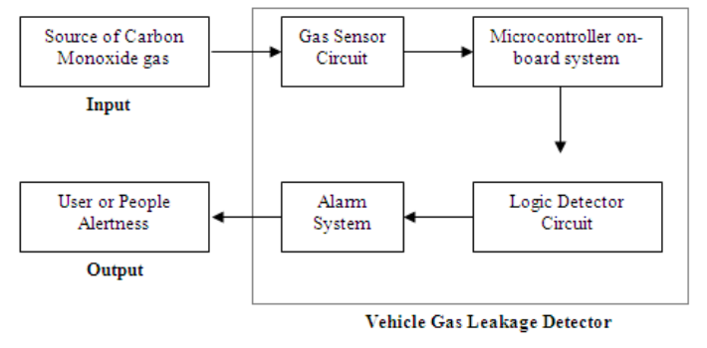
Figure 1: Block diagram of the proposed system

A. Detection unit:
It consists of :

- MQ2 Gas Sensor:
The Grove - Gas Sensor(MQ2) module is useful for gas leakage detection (home and industry). It is suitable for detecting H2, LPG, CH4, CO, Alcohol, Smoke or Propane. Due to its high sensitivity and fast response time, measurement can be taken as soon as possible. The sensitivity of the sensor can be adjusted by potentiometer.
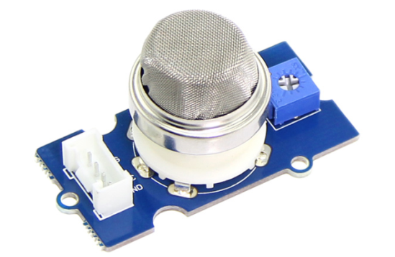
Figure 2 : MQ2 Gas sensor
Using an MQ sensor it detects a gas is very easy. You can either use the digital pin or the analog pin to accomplish this. Simply power the module with 5V and you should notice the power LED on the module to glow and when no gas it detected the output LED will remain turned off meaning the digital output pin will be 0V. Remember that these sensors have to be kept on for pre-heating time (mentioned in features above) before you can actually work with it. Now, introduce the sensor to the gas you want to detect and you should see the output LED to go high along with the digital pin, if not use the potentiometer until the output gets high. Now every time your sensor gets introduced to this gas at this particular concentration the digital pin will go high (5V) else will remain low (0V).You can also use the analog pin to achieve the same thing. Read the analog values (0-5V) using a microcontroller, this value will be directly proportional to the concentration of the gas to which the sensor detects. You can experiment with this values and check how the sensor reacts to different concentration of gas and develop your program accordingly.
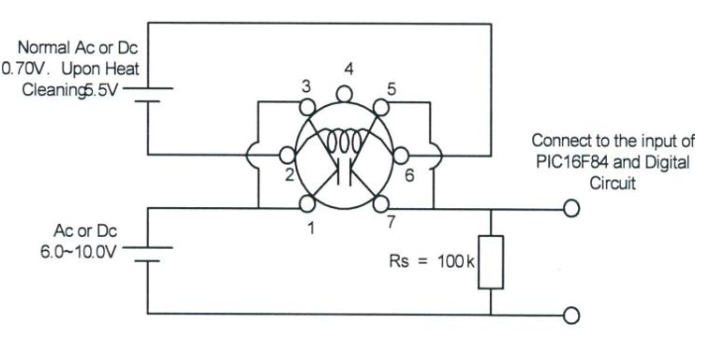
Figure 3: Gas sensor circuit
- Temperature Sensor:
A temperature sensor is an electronic device that measures the temperature of its environment and converts the input data into electronic data to record, monitor, or signal temperature changes. There are many different types of temperature sensors. Some temperature sensors require direct contact with the physical object that is being monitored (contact temperature sensors), while others indirectly measure the temperature of an object (non-contact temperature sensors).
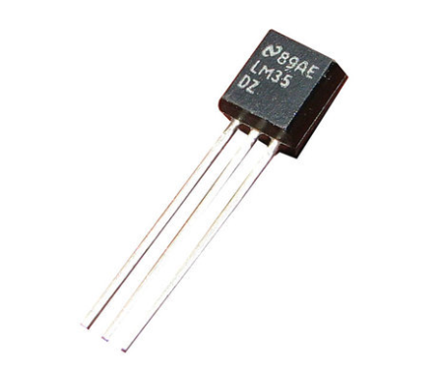
Figure 4 : Temperature Sensor
- Wi-Fi Module:
The ESP8266 WiFi Module is a self contained SOC with integrated TCP/IP protocol stack that can give any microcontroller access to your WiFi network. The ESP8266 is capable of either hosting an application or offloading all Wi-Fi networking functions from another application processor. Each ESP8266 module comes pre-programmed with an AT command set firmware, meaning, you can simply hook this up to your Arduino device and get about as much WiFi-ability as a WiFi Shield offers (and that's just out of the box)! The ESP8266 module is an extremely cost effective board with a huge, and ever growing, community.This module has a powerful enough on-board processing and storage capability that allows it to be integrated with the sensors and other application specific devices through its GPIOs with minimal development up-front and minimal loading during runtime. Its high degree of on-chip integration allows for minimal external circuitry, including the front-end module, is designed to occupy minimal PCB area. The ESP8266 supports APSD for VoIP applications and Bluetooth co-existance interfaces, it contains a self-calibrated RF allowing it to work under all operating conditions, and requires no external RF parts.

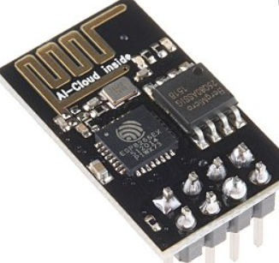

Figure 5: Wi Fi module.

- Heat sensor:
A heat detector is a fire alarm device designed to respond when the convected thermal energy of a fire increases the temperature of a heat sensitive element. The thermal mass and conductivity of the element regulate the rate flow of heat into the element. All heat detectors have this thermal lag.
It is very sensitive to the heat and can detect the heat from far distance. If the sensor detects the heat radiation it will send an electrical signal to the controller and thus audio instruction will be sent to person and also the vibrator and buzzer start alarming.

- LDR sensor:
An LDR is a component that has a (variable) resistance that changes with the light intensity that falls upon it. This allows them to be used in light sensing circuits. A typical LDR. LDR Circuit Symbol.
Light Dependent Resistor, changes its resistances due to change of the light intensity. During night, LDR will have high resistance and no current pass through it but through a LED connected parallel to it which illuminates and acts as a Flashlight, which can be easily noticed by others. It alerts people about the presence of blind person to let him to pass the way.
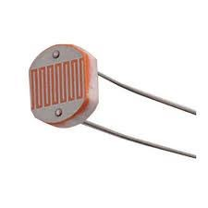
Figure: light dependent resistor

B. Alarm unit
The person was informed through a vibrator and a beep sound of buzzer.
It consists of two parts:

- Buzzer
A transducer (converts electrical energy into mechanical energy) that typically operates A buzzer is in the lower portion of the audible frequency range of 20 Hz to 20 kHz. This is accomplished by converting an electric, oscillating signal in the audible range, into mechanical energy, in the form of audible waves. Buzzer is used in this research to warn the blind person against obstacle by generating sound proportional to distance from obstacle.
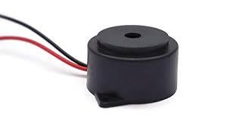
Figure: Buzzer

D. Microcontroller:
A microcontroller is a compact integrated circuit designed to govern a specific operation in an embedded system. A typical microcontroller includes a processor, memory and input/output (I/O) peripherals on a single chip.Sometimes referred to as an embedded controller or microcontroller unit (MCU), microcontrollers are found in vehicles, robots, office machines, medical devices, mobile radio transceivers, vending machines and home appliances, among other devices. They are essentially simple miniature personal computers (PCs) designed to control small features of a larger component, without a complex front-end operating system (OS).
Arduino Uno Microcontroller
Arduino can control the environment by receiving input signals (Digital/Analog) and can effects its surroundings by controlling lights, relays and other devices.
The microcontroller on the board is programmed using Arduino software.

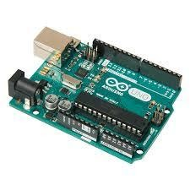
Figure: Arduino uno micro controller

Results:

the DC analysis of the logic detector circuit has been designed . This analysis has been done to indicate that any signal transferred from the gas sensor circuit, will trigger logic detector and hence will turn on the buzzer. The voltage required for logicdetector circuit tooperate at 1.5V. In case of transition from presence of Carbon Monoxide gas to normal operation, the analysis has been done The microcontroller on-board system can be represented by the combinational logic, when the input from the sensor and voltage regulator is high, the red LED and the buzzers will operate. In another case, when the input from sensor and voltage regulator is low, only the green LED will be on. This combinational logic in Figure 8 is made accordingly to the programming in the PIC16F84A.

- CONCLUSION
The implementation of a vehicle gas leakage detector corresponds to increased cases of death caused by gas leakage in cars. These devastating events could be avoided if CO detection systems were installed. Therefore, the main idea of this research is to create a simple and easy system that has high sensitivity and can sense the presence of CO gas in a vehicle‟s cabin. From the experimental results, the system described here is working as expected with simulated and implemented data on record. The system has then been interfaced to the microcontroller on-board system. The microcontroller has been programmed to send a signal to the logic detector circuit then to the alarm system. The development of software was then tested to ensure it worked properly with the hardware. The communication test between hardware and software was successful. The hardware responded correctly to the command sent to it. This result shows that, the system has been implemented and tested successfully. This system has been designed to produce greater flexibility, ease of implementation and lower cost because the system PIC16F84A microcontroller which is a Flash based microcontroller can be programmed and erased several times.

- REFERENCES
1. New Straits Times. 2008. “Couple Died Due to Carbon Monoxide Gas”. 2/1/2000 .Retrieved
August 1, 2008 from http://www.nst.com.my

2.Arkib. 2000 (Sept 10). “Izzayumeninggalselepastigaharitidaksedarkandiri”. Utusan Malaysia (Malay Language). Retrieved August1, 2008
- 2.Arkib. 2000 (Sept 10). “Izzayumeninggalselepas
(Malay Language). Retrieved August1, 2008.

- http://www.utusan.com.my.
3.Sinyang, A. 2007. “Pegawai polis, wanitaditemuimatidalam BMW”. Utusan Malaysia (Malay Language). Retrieved August 1, 2008.

- 3.Sinyang, A. 2007. “Pegawai polis, wanitaditemui
- http://www.utusan.com.my
4.Arkib. 2008 (April 1). “Demi cinta, pasanganmatibersama”. Utusan Malaysia (Malay Language). Retrieved August 1, 2008. http://www.utusan.com.my

5.Arkib. 2007 (Jun 30). “Lelakimatidijumpaidalamkereta”. Utusan Malaysia (Malay Language). Retrieved August 1, 2008. http://www.utusan.com.my

