Smart Home Automation System Implementation and Control via Internet
Deepak Kumar, Aman Maurya , Dhruv Kumar Pandey , Avneesh , Vidhisha Yadav
Department of Computer Science &Engineering
Babu Banarasi Das National Institute of Technology and Management
(BBDNITM, Lucknow-226028)

Abstract: - The world is heading towards automation. Everyone wants their life to be simplified and become efficient which could be done by automating the human’s manual tasks with the help of machines. This paper aim is to develop and design a Home automation using Arduino with Wifi module. Smart Home automation system gives a simple and reliable technology with Android application. Home appliances like fan, Bulb, AC, automatic door lock, security camers, etc. can be controlled by Home automation system using Arduino Uno with Wifi module. The paper mainly focuses on the monitoring and controlling of smart home by Andorid phone and provide a security based smart home when any person isnot present at home. The motive of this paper is controlled home appliances in smart home which is user friendly, designedat low cost & easy to install.

Keyword: - Arduino, Smart Home automation, Wifi, LAN, WAN, Smart phone, Security.

I. Introduction

Mostly everyone uses smart phone and wants to control everything from their phone. Lights, fan , switches , cameras,measuring home temperature and cheking gas leakages for safety purposes, etc. are controlled through Wifi based remote using arduino. The designing of home automation are going to become simpler and more popular because most of people uses smart phone now days. In this device we are using Arduino which is most widely used device for automation purposes. Arduino is a hardware which is used to connect computer and the project model so that we can control it by using Arduino code accordingly. Arduino is a microcontroller just like a human brain. Firstly, it processes information and then it performs some Logical and mathematical operation on that processed information. Arduino receives the information from user through the Wifi module. Arduino is also connected to relay, which receives information from Arduino and perform the operation as switch. Wifi technology is Wireless networking in a long distance providing a necessary technology to create intelligence and controllability. This generates local area network in home environment, where all these appliances can be interconnected and monitored using a microcontroller with Arduino using smart phone. Smart Home automation have a degree of computerized and automatic control to different electrical appliances and electronic systems in the home.

About ESP32 Cam Board :

The ESP32-CAM is a very small camera module with the ESP32-S chip that costs approximately 700 rupees. Besides the OV2640 camera, and several GPIOs to connect peripherals, ESP32-CAM also features a microSD card slot that can be used to store images taken with the camera or to store files to serve the clients.

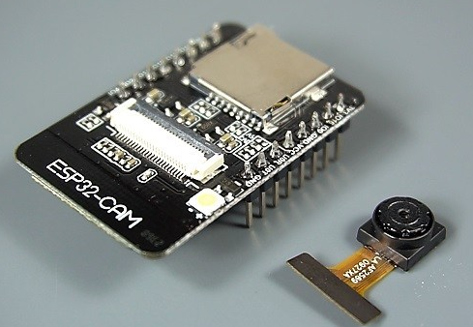
Fig. 1. ESP32-CAM WiFi / Bluetooth Camera

Features:

Some features of ESP32-CAM are:
- The smallest 802.11b/g/n Wi-Fi BT SoC module

- Low power 32-bit CPU,can also serve the application processor

- Up to 160MHz clock speed

- Built-in 520 KB SRAM, external 4MPSRAM

- Support OV2640 and OV7670 cameras, built-in flash lamp

- Support image WiFI upload, TF card and multiple sleep modes.

This Project Includes the following modules:

- Smart Security System using Esp-32 cam
- Automation of Home appliances
- Monitoring of sensors data

Smart Security System :
In this project we have added an ESP-32 cam board which will work according to the code uploaded in it. ESP32 cam board has inbuilt wifi module by which it get connected to the access point.Here we have written some code which will take a picture whenever the PIR motion sensor detects a motion in the house and send that picture to the pointed telegram account or an email or whatsapp or Line account.
Below figure shows the connection of Esp32 cam with the PIR motion sensor and with powering the esp32 cam board. This is how we have connected the pins of camera board and PIR motion sensor.

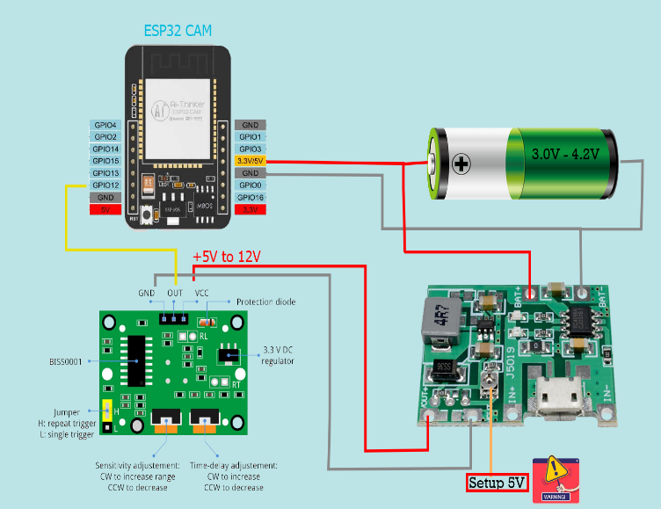
Fig. 2.Pin Connection of Esp32 cam with PIR motion sensor

After doing such connection we uploaded our code to esp32 cam board.As esp32 cam board do not have micro/mini USB port like Arduino uno board and Esp8266 nodemcu board . So we have to program it by using a usb to TTL converter .For which an external board will be required. If you are not able to purchase the TTL programmer then you can also convert your Arduino board in a TTL programmer.

This camera can also do the following things:

- Live video streaming on local network or on a global Network(Internet).

- It can do face detection.

- ESP32 cam board also has SDcard slot ,so it can save the captured pictures to that SDcard.

And many more according to the code uploaded on it.

This module can be placed in front of the door inside the room. By which we can monitor who have opened the door, every time the door opened motion sensor will detect a motion. It will invoke the camera to take a picture and the taken picture will be send to the user/owner of the house.

The security system module works according to the following flow chart:

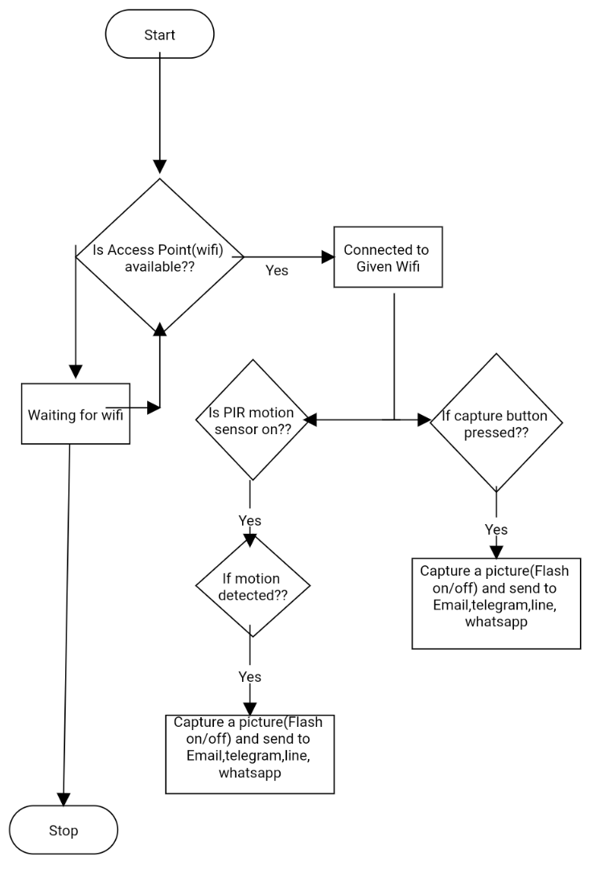
Fig. 3. Flowchart for Security system module

Controlling Camera module via Mobile app:

In order to control the camera we have used a cloud based platform which is popularly known as BLYNK. Via Blynk app we will control inbuilt LED and camera capture and motion sensor.

When ever the button will be pressed in the app, a http request will be sent by blynk servers to our camera module to take a picture and camera module will send that picture to desired destination.

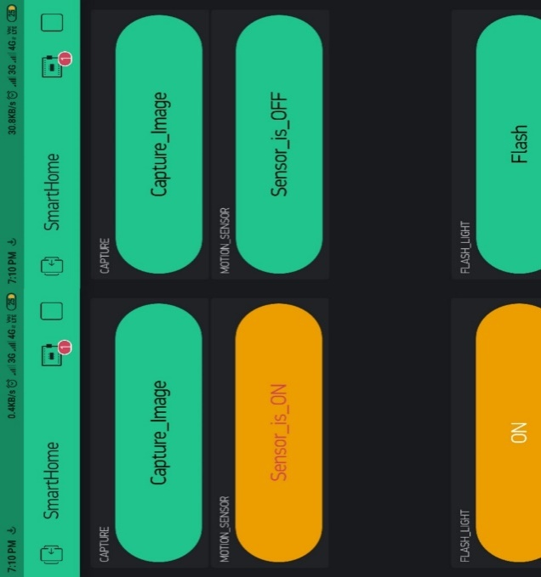
Fig. 4. Controlling camera via Blynk App

Controlling security module by voice command :

We can also give command by our voice in a android mobile phono which have google assistant.

To control the same buttons features which we have added in the blynk app , this all can also be done by the voice command . For this we are using Google Assistant . We have connected IFTTT and Google assistant via webhook.
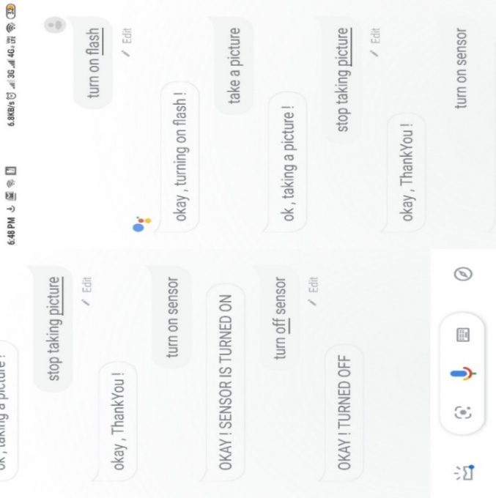
Fig. 5. Controlling ESP32 via Google Assistant

Automation of Home Appliances :

For controlling home appliances we have used a relay module with nodemcu(esp8266) board havinginbuilt wifi module. It gets connected to access point and then we can control these appliances using a cloud based platform such as blynk/ubi dots / cayenne.

Here we are using Cayenne My Devices IoT platform. Cayenne also have the facility of a light weight protocol known as MQTT.

The diagram below shows the connection of the pins of ESP8266 and relay module with the home appliances :

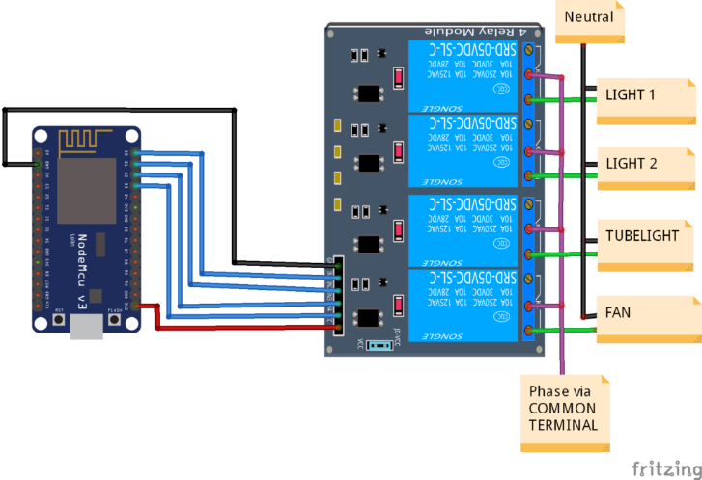
Fig. 6. Connection of pins of NodeMcu & Relay Module with Home Appliances

Google assistant is an AI (Artificial Intelligence) based voice command service. Through voice, we can talk to Google assistant and it can search on the internet, set alarms,schedule events, control home appliances, etc.
This feature is available on smartphones and Google Home devices.We can control smart home devices such as lights, switches, fans and thermostats using our Google Assistant.
Cayenne provide us with an customisale online and mobile dashboard to visualise home appliances.

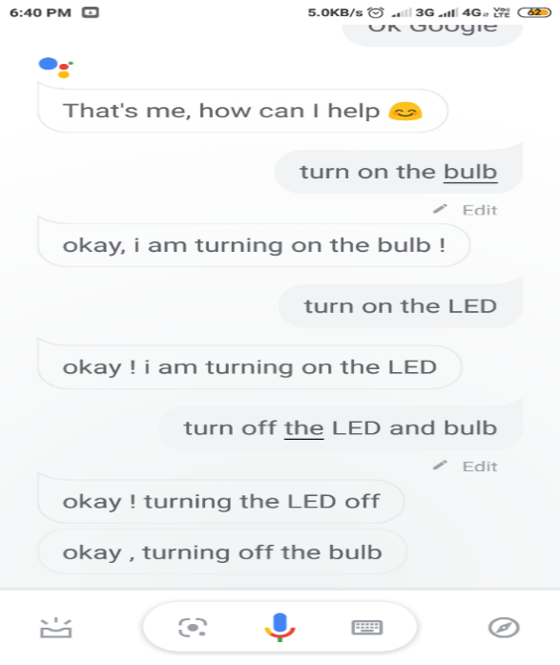
Fig. 7. Home Appliances control via Google Assistant

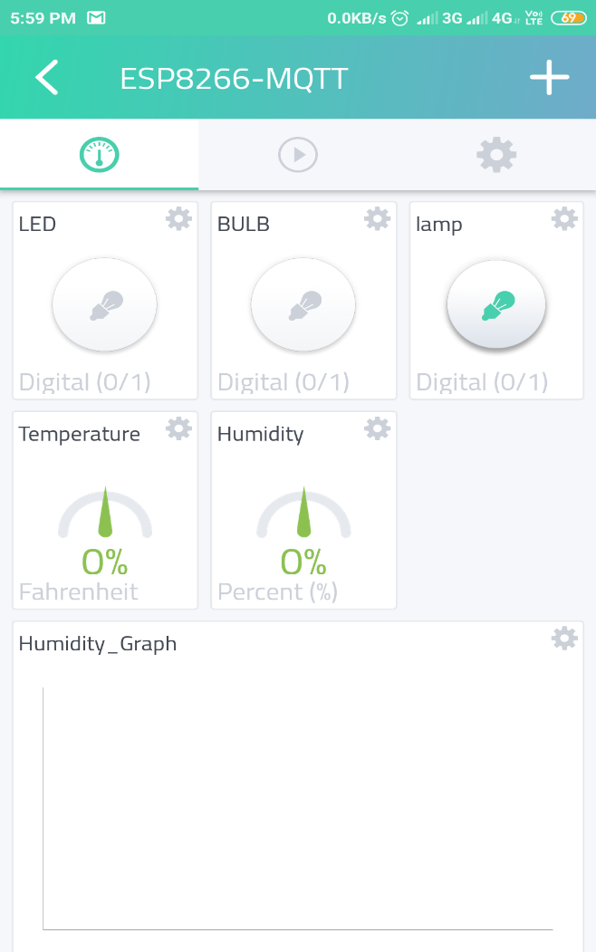
Fig. 8. Appliance control dashboard and monitoring sensors data

Monitoring Sensors Data :

On Cayenne platform we can monitor our sensors data which we have connected in our Nodemcu board.ESP8266 sends sensors reading to the Cayenne cloud which we can monitor using Cayenne dashboard.

Whenever the sensors reading will exceed a particular set limits. This system will send an SMS alert on home owners mobile phone, helping owner to take an appropriate action accordingly.

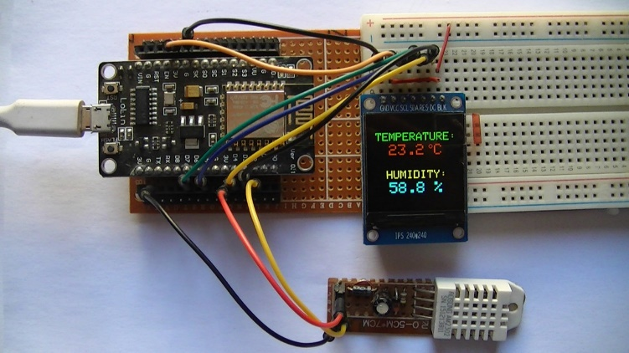
Fig. 9. Temprature and Humidity Sensor

References :

- Zekeriyakeskin, Yunus Emrekocaturk, okan Bingol, Kublai Tasdelen, “Web-based smart home automation: PLC controlled implementation”, vol11, NO 3, 2014.

- Mitali Patil, Ashwini Bedare, Varsha Pacharne "The Design and Implementation of Voice Controlled Wireless Intelligent Home Automation System Based on ZigBee." International Journal of Advanced Research in Computer Science and Software Engineering.

- Mansour H. Assaf, Ronald Mootoo, Sunil R. Das, Emil M. Petriu, Voicu Groza, and Satyendra Biswas “Sensor Based Home Automation and Security System.” 978-14577-1722-7/12/$26.00 ©2012 IEEE.

- N.David, A.Chima, A.Ugochukwu and E.Obinna,”Design of a home automation system using Arduino”, International journal of Scientific & Engineering Research, Vol. 6, pp. 795-801, june-2015.

- Anil Jaiswal, Neeta Gunjal, PoojaLondhe, Shikha Singh, Ramesh Solanki, “Crime Automation & Reporting System” ,International Journal of Science and Modern Engineering (IJISME),Volume-1, Issue-11, October2013.

- Shiju Sathyadevan, Crime analysis and prediction, IEEE, 25Sept2014, 10.1109/ CNSC.20 14.6906719.

- http://topicideas.org/how-to-online-crime-reporting-and-managementsystem-pdf.

- Silviu Folea, Daniela Bordencea, Casiana Hotea, Honoriu Valean “Smart Home Automation System Using Wi-Fi Low Power Devices.

- Prof. M. B. Salunke, Darshan Sonar, Nilesh Dengle , SachinKangude, Dattatraya Gawade, “Home Automation Using Cloud Computing and Mobile Devices”, Vol. 3, Issue 2 (Feb. 2013), ||V2|| PP 35-37.

- A. R. Al-Ali, Member, IEEE, M. AL-Rousan”Java-Based Home AutomationSystem” IEEE Transactions on Consumer Electronics, Vol. 50, No. 2, May 2004.

- Ahmed Elshafee, Karim Alaa Hamed, "Design and Implementation of a Wi-Fi based Home Automation System”, International Journal of Computer, Electrical Automation, Control and Information EngineeringVol: 6, No: 8, 2012, pp 1074 - 1080.

