A STUDY ON OBJECT IDENTIFICATION USING DEEP NEURAL NETWORKS

¹ Ms. RICHA SINGH
Presidency University, Itgalpur, Rajanakunte, Yelahanka, Bengaluru 560064, Karnataka, India
² Ms. SIMRAN JHA
Presidency University, Itgalpur, Rajanakunte, Yelahanka, Bengaluru 560064, Karnataka, India,
³ Mr. A SREEHARSHA
Presidency University, Itgalpur, Rajanakunte, Yelahanka, Bengaluru 560064, Karnataka, India

Abstract-This paper presents the concept of identifying the object using deep neural networks. The blend of convolutional neural networks(CNN) and cognitive supervised learning makes it possible to design different types of neural networks to identify objects in images. Human intelligence after learning, can identify objects cognitively. When it comes to neural networks, series of convolution networks and pooling layers classify the image to a particular class. A decrease in the number of operations and parameters will be shown by combining layers in different patterns with a leaky relu non-linearity and dropout regularization for penalizing the large coefficients. Different combinations of layers show a decrease in the percentage of error.

I. INTRODUCTION

Object identification is a computer technology related to computer vision and image processing. It deals with detecting instances of semantic objects of a certain class in digital images and videos. Main application of object identification includes face detection and pedestrian detection. It is a subset of computer vision, an automated method for locating interesting objects in an image with respect to the background.

Solving the object detection problem means placing a tight bounding box around these objects and associating the correct object category with each bounding box. Similar to other computer vision tasks, deep learning can be used for object detection.

Before identifying the object, for specific features the bounding box should be classified into a certain category. To achieve this classification, human assistance is required, based on the data provided by humans the algorithm will eventually learn to classify the image. This type of learning by the algorithm is called as supervised learning, where the historical inputs and outputs will be provided.

For classifying these images efficiently into output classes, Convolutional Neural Networks like AlexNet, VGG-16, ResNet-50, GoogleNet (with the inception layer) are used widely. For developing the above mentioned CNNs, very deep weight layers are used. These CNNs use a lot of parameters and calculations which in turn makes it necessary for a GPU to be used for computation.

Before cloud computing was introduced, external hardware was necessary to compute deep learning algorithms. In GPUs complex algorithms will be split and fed into several cores. Leading manufacturer of graphics processing unit NVIDIA introduced CUDA in 2006. CUDA helped interfacing of the GPU with the software tool for coding deep learning algorithms.

As neural networks contain millions of neurons, the weight layers with the pooling layers will be more. Therefore, GPUs can help in faster generation of the output when compared to normal CPUs. Google’s TPU was introduced in its cloud platform with similar functioning as JUPYTER NOTEBOOK. The TPU generates the output much faster than most of the GPUs.
To write deep learning codes in TPUs tensor flow has to be used whereas in GPUs PYTORCH with CUDA can be used.

In this paper different types of image classification algorithms will be tested to the limit and further modifications for the algorithm will be suggested.

Keyword: GPU-Graphics Processing unit, TPU-Tensorflow Processing Unit.

II. IMAGE PIXEL PROCESSING

As we all know every coloured image has three layers which are red, green, blue and all the three colour layers combine together to produce colourful and vibrant images. For a convolutional neural network(CNN) the input image size is fixed. To process bigger images bootstrap samples are taken and semantic segmentation is performed on the sample. The sample will be divided into different colour categories based on the pixel values. During segmentation process, the output size reduces. To get back the original size we perform upsampling using SEGNET and all the up sampled outputs will be combined again to regenerate the original image from which the bootstrap sample was taken.

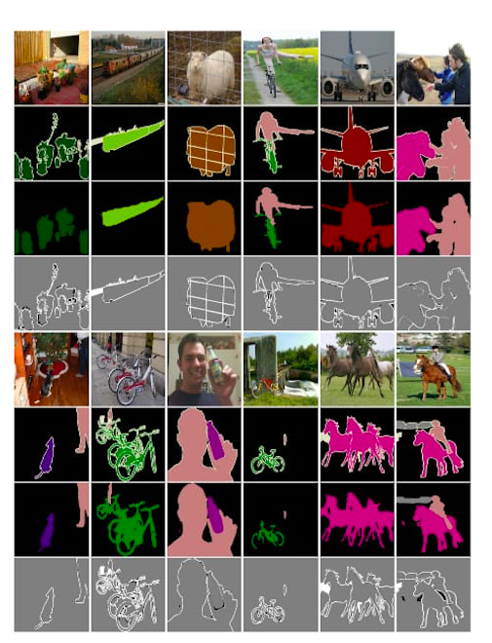
Figure-1
In each example, from top to bottom, there are in turn the original image, the ground-truth, the predicted label, and the difference map between the ground-truth and the predicted label.

The in depth working of the deep neural network is shown in the following steps-

i. Convolution: - This method is performed with kernel. The kernel will be of a smaller size compared to the input image. Consider a (n x n) input matrix and a (m x m) kernel matrix where m<n. when the kernel is mapped with the input matrix, element wise multiplication will be performed and the results will be added. The result will be the first value of the output matrix. Soon after the first output cell is filled, the kernel will shift one cell towards the right and perform the same operation again. The result of the kernel will be stored in the second cell of the output matrix and the process repeats till the kernel reaches the right end of the input image. Then the kernel will come to left of the image and shift one cell down to continue the convolution process, convolution stops when the kernel reaches the right corner of the input image. Generally, in deep neural networks like Alexnet, Resnet, VGG-16 and Lenet, a 3x3 or 5x5 or 7x7 or 11x11 kernels are used. To retain the input image size zero padding process is used.

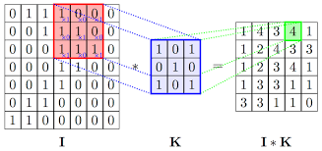

Figure-2
The process of convolution is picturised in the above figure.

ii. Pooling: - Pooling focuses on salient aspects of each feature map instead of focussing on each and every detail. This is very similar to how humans recognise and interpret images. The general function of a pooling layer is to extract the important features from the input image fed to the pooling layer. Matrix from the convolutional layer is very big in size when it reaches to pooling layer and here the necessary features are pulled out which in turn compresses the size of the matrix.

For example, the input to a 2 x 2 pooling layer is 24 x 24 , then after pooling size of the matrix will be reduced to 12 x 12.Advantage of pooling layer is that it summarises the information from 5760 neurons in the convolutional layer to 1440, which is four times less.

There are three major types of pooling techniques performed, which are:
- Max Pooling: - To perform this function, filter kernel of different sizes are used. When the max pooling kernel is mapped against the input matrix, the cell having the maximum scalar value will be chosen as the first cell value of the output matrix.

- Average Pooling: - When the filter kernel is mapped with the input matrix, mean of the mapped values will be taken as the first cell value of the output matrix.

- Unpooling: - It is used to regenerate the size of input matrix and reconstruct the input received, into the space of the input matrix.

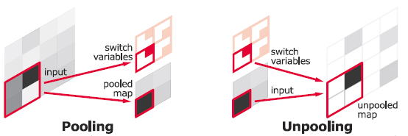

Figure-3

iii. Fully Connected Hidden Layer: - All the neurons in the input layer are connected to all the neurons in the first hidden layer which are further connected to the next hidden layer. Finally, all neurons in the last hidden layer are connected to the output neurons which in turn is connected to a softmax non-linearity.

iv. Regularization Parameter: - Regularization techniques are used to ensure that networks generalize the results when faced with unseen data.one if the regularization techniques is to add the additional constraint of minimizing the weights, apart from minimizing the cost. Regularization parameter controls the level of influence of regularization on the training algorithm. In the further sections dropout regularization will be used.

III. NEURAL NETWORK FOR IMAGE CLASSIFICATION

There are different algorithms used for classification. The first convolutional neural network to take part amongst all of them in the image net challenge was AlexNet, which had an error rate of 15.3%. Over the next few years’ different algorithms have taken part in the image net challenge and have presented less error rates compared to their other counter parts.
Few popular image classification algorithms with their error rates have been mentioned in the below table.

Algorithms | Percentage of error
VGG Net | 7.3%
Google net (with bottle neck layers) | 6.7%
Res Net | 3.57%
Dense Net | 4.51%

All these algorithms in the table-1 were trained using stochastic gradient descent to achieve the exact classification. The algorithms had to classify over a million images into 1000 output classes.

As the dataset used for several applications of object identification is very huge. Most of the unnecessary data is also present. To reduce the dimensionality of the data and to remove the unwanted data, principle component analysis (PCA) is widely used. When the dimensionality is more, the features given out will be more and as a result more training examples has to be given. Due to this the algorithm could lead to the worst performance.

PCA follows the below steps to reduce the dimensionality
- Reduce dimensionality be selecting subsets (feature elimination).
- Combines with linear and non-linear transformation.
- Creates different single features from multiple features.

i. Single value decomposition: - This is a matrix factorisation method used for PCA. The advantage of this decomposition is that it does not require a square data set. Generally used by Scikit-learn for PCA.

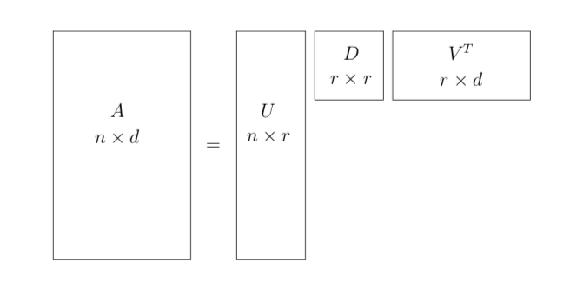
Figure-4
The singular value decomposition of an n x d matrix

Therefore, PCA is used to reduce the dimensionality of the dataset and increase the performance of the algorithm.

IV. APPLICATIONS

i. Predicting cardiovascular risk factors from retinal fundus photographs

Most of the people having cardiovascular problems, die when they are asleep and none of the relatives could identify it. To overcome this issue, we would like to predict the cardiovascular risk beforehand by taking images of retinal fundus. To train the deep learning algorithm, we collect different categories of retinal fundus image dataset of people. The dataset will be categorised into various groups containing different age groups, retina colour and record of people having heart attack. All these retinal colours will be classified into different categories. Based on the dataset the algorithm will be trained and the output classes will be ready to be applied.

When a new sample is taken, the colour of the sample will be compared with the available dataset and will be classified into a category. If the category shows that the risk factors are more the subject will be informed and thus preventive measures are taken.

ii. Gene Editing

Deoxyribo Nucleic Acid(DNA) is the hereditary material in humans. DNA is the building block of the body, that adds up to make you-you. Any malfunction in the DNA might lead to fatal health issues, affecting millions of people. Here gene editing comes into picture, where scientists can identify faulty gene and replace it with a healthy gene. However, one of the biggest hurdles of gene editing is to precisely cut the faulty gene out of the DNA sequence without harming the other genes. To achieve this renowned scientist from all over the world would have to try out every possible cut for a particular gene to be taken out. This process requires a lot of time, effort and money. Here machine learning can be used. Using a computational model, it can accelerate the process, an efficient algorithm can be run on these genes by analysing the patterns and irregularities in the DNA sequence. This would reduce the chances of side effects drastically. Performing these types of computation over a normal computer will take more than 200 years, but in cloud machines it will take weeks, hence reducing time and cost.

iii. Brain controlled wheel chair

For physically handicapped people, controlling the wheel chair is very difficult.
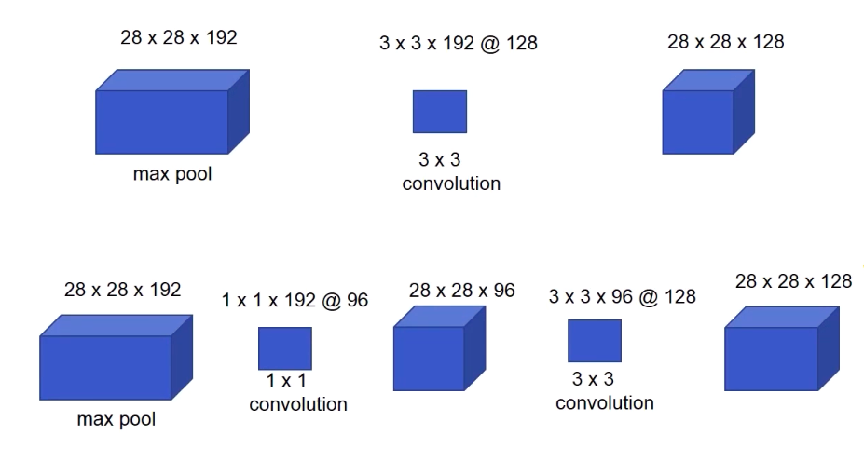
Using their direct brain waves and deep learning algorithms, patients can easily control the wheel chair. Electroencephalography(EEG) electrodes will be mounted on a devise which will be used by the patient. Whenever the brain waves are generated, the electrodes will transfer the signals to the machine learning algorithm. The signal will the be compared with the ground truth. If the incoming signal is matched with the ground truth, the intended instruction will be carried out. A camera and a proximity sensor will be mounted at the front of the foot rest. The two devices combined together transfer continuous data to the deep learning algorithm. If an obstacle comes in front of the wheel chair, the algorithm will initiate a stop signal. In this way a combination of deep learning and brain computer interfacing systems can be very helpful for physically challenged people.

iv. Simulations in the large hadron collider

Atoms are the building blocks of all the mater in our universe. To understand the universe or ourselves better, we have to know the internal structure of the atom itself. Over the past few decades, scientists like bhor, Rutherford and etc. discovered that the atom consists of electrons and nucleus. They also discovered that the nucleus itself can be broken down into small particles call protons and neutrons. To get to know what is inside the neutrons and protons, two atoms had to be bombarded with each other. Two atoms had to be accelerated close to the speed of light (~2.8 x 10^8) in the opposite direction for the atoms to break into even smaller particles. To do this process, the large hadron collider comes into picture. It consists of a 27km radius tube in which the experiments are carried out. To accelerate the particle, electric field is used and to deflect it into a circular orbit, very powerful magnetic field is used. When two atoms are accelerated in different smaller tubes at close to the speed of light, a gateway is opened, due to this opening the fast moving protons will collide. When the collision happens, the proton breakdown into the subatomic particles which cannot be divided further.

There are three categories of subatomic particles which are, leptons, quarks, and bosons. Under these three categories there are totally 27 subatomic particles (including the higgsboson). when the protons collide these subatomic particles will be spewed in all the direction. All the subatomic particles will be tracked and their spins will be calculated to analyse the process a replica of the real collision has to be simulated in the supercomputer.
To further study the process in detail a heuristic dataset has to be given to the computer. After every new observation in real LHC, a very fresh dataset has to be fed to the computer for new simulation. Using deep neural network, when a new data is fed to the algorithm, it will learn and predict the post outcome. Which makes it very helpful in the simulation process. The algorithm can predict the future outcomes, any costly modification can be simulated and checked whether it is feasible to be implemented in the real equipment.
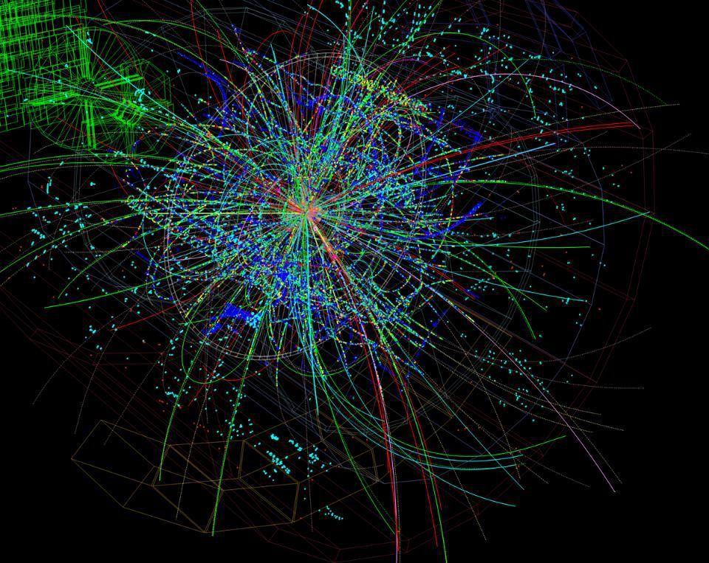
Figure-5
Simulation of particles in supercomputer after collision.

v. Self - Driving cars

As human negligence is increasing day by day, the number of accidents are also increasing. Over the past few years scientists have developed technologies to warn the drivers. Due to the lack of attention given by the drivers to these technologies, now the scientists have come up with the idea of self-driving cars. For the cars to drive by themselves, computer chips need to be installed inside the car. Along with the chips, different types of sensors and cameras should be mounted around the car. Based on the signals received by the sensors several protocols will be initiated. The cameras mounted will send real time information to the computer installed inside the car. The continuous video will be analysed by the deep learning algorithm in the computer for detecting objects around the car. The moment the passenger enters the car and chooses the destination, the car is expected to take over by itself from that moment. As soon as the destination is set the car will check for all the safety measures which has to be taken and thus the car will start to move forward. When the car is in motion, it will use sensors such as ultraviolet, infrared, sonar, proximity and etc. if an object is detected using the above mentioned sensors the algorithm will use sematic segmentation to divide the raw image data into different colours. As the object approaches close to the car, it will notify the passenger using the head sub display. If the object comes too close to the car, the car stops and lets the object to go past it and it starts over again and heads to the destination following the same process. If a pedestrian comes close to the car, then the car stops and a holographic zebra crossing will be projected. When it reaches the destination, the algorithm will stop. Hence, deep neural network algorithms can very helpful in autonomous drive technology.

V. RESULTS

To obtain the above results, we have trained google nets inception layer with 1x1 convolution layers(also called as the bottle neck layers) which will take less number of operations and parameters.
After the modified inception layer, the algorithm performed better.
In the first case we had observed 173M operations and in the second case with the bottle neck layer we had observed 101M operations, which reduces the number of operations by a large scale.

VI. CONCLUSION

Deep convolutional networks have brought major breakthroughs in the area of object identification and image processing. It has allowed computational models to represent data with multiple level of abstraction. Convolutional neural networks have been established as a powerful class of models for image recognition problems.
In this paper, we have talked about how the input image goes through several layers of an object identification algorithm and gives us the desired output. We also highlighted its importance in the coming future, and how it can be used in several domains of the real word like – health care, physics and automation. The computational models will not only accelerate the applications, they will also help us in cost reduction and provide us with an efficient output, saving a lot of time. These algorithms will be written in tensor flow using google cloud platform.

VI. REFERENCES

[1] Y. Le Cun, B. Boser, J.S. Denker, D. Henderson, R.E. Howard, W. Hubbard, L.D. Jackel, et al. Hand- written digit recognition with a back-propagation network. In Advances in neural information processing
systems, 1990.

[2] A. Krizhevsky and G. Hinton. Learning multiple layers of
features from tiny images. Tech Report, 2009.

[3] B.C. Russell, A. Torralba, K.P. Murphy, and W.T. Freeman. Labelme: a database and web-based tool for
image annotation. International journal of computer vision, 77(1):157–173, 2008.

[4]
P.Y. Simard, D. Steinkraus, and J.C. Platt. Best practices for convolutional neural networks applied to
visual document analysis. In Proceedings of the Seventh International Conference on Document Analysis
and Recognition, volume 2, pages 958–962, 2003.

[5] J. T. Springenberg, A. Dosovitskiy, T. Brox, and M. Ried- miller. Striving for simplicity: The all convolutional net. arXiv preprint arXiv:1412.6806, 2014.
[6] G.E. Hinton, N. Srivastava, A. Krizhevsky, I. Sutskever, and R.R. Salakhutdinov. Improving neural net works by preventing co-adaptation of feature detectors. arXiv preprint arXiv:1207.0580, 2012.
[7] Makeig, S.; Kothe, C.; Mullen, T.; Shamlo, N. B.; Zhang, Z. & Kreutz-Delgado, K. (2012), 'Evolving Signal Processing for Brain-Computer Interfaces.', Proceedings of the IEEE 100 (Centennial-Issue) , 1567- 1584 .
[8] Ajit Kumar; Kavathekar; B.B.P Gupta; Biology Textbook for XIIth standard.
[9] A Sreeharsha; controlling electronics using brain wave detection. National Conference on Electronics & Communication Engg., NCEC-2019, 9 – 11 May 2019, DSCE, Bangalore, Karnataka
10] T. Mensink, J. Verbeek, F. Perronnin, and G. Csurka. Metric Learning for Large Scale Image Classifi-
cation: Generalizing to New Classes at Near-Zero Cost. In ECCV - European Conference on Computer
Vision, Florence, Italy, October 2012.
[11] V. Nair and G. E. Hinton. Rectified linear units improve restricted boltzmann machines. In Proc. 27th
International Conference on Machine Learning, 2010.
[12]
N. Pinto, D.D. Cox, and J.J. DiCarlo. Why is real-world visual object recognition hard? PLoS computational biology, 4(1):e27, 2008.

