A STUDY ON “THE EFFECTIVENESS OF PERFORMANCE APPRAISAL AT HCL TECHNOLOGIES BPO

By-

Name of Student- Sanskriti Parashar

Roll No- 22GSOB2010212
Batch 2022-2024

Submitted To:
Dr. Rani Jaiswal

Galgotias university , Greater Noida – 201310 (UP)

CHAPTER -1
INTRODUCTION

I.1 Performance Appraisal

Formal appraisal of an individual’s performance began in Wei dynasty (AD 221-265) in China, where an imperial appraised the performance of the member of official family. During the First World War, at the instance of Walter Dil Scott, the U.S army adopted “man-to-man” rating system for evaluating military personnel.

The objective of the system is primarily for development and to some extent for remedial; it is not simply to control. The data generated through system could be put to several uses, such as, either to the identification of potentials, as to form the basis of rewards to high performance and remedial actions for low performance. The success of such a system assumes openness within the organization, trust between supervisors and subordinates and above all a certain degree of self-detachment and objectivity at all levels in the evaluation of performance and potentialities.

I.1.2 DEFINITION

According to Heyel, “Performance appraisal is the process of evaluating the performance and qualifications of employees in terms of the requirements of the job for which he is employed, for the purpose of administration including placements, selection for promotions, providing financial rewards and other actions which require different treatment among the members of the group as, distinguished from actions affecting members equally.”

Performance appraisal is systematic evaluation of personnel by supervisors and others familiar with their performance because employers are interested in knowing about employee performance. Appraisal is essential for, making any administrative decisions such as selection, training, promotion, transfer, etc. Performance appraisal thus is a systematic, orderly, and objective method of evaluating the present and potential usefulness of the employees to the employees to the organization. In the words of

Dale Yoder:

Performance appraisal refers to all formal procedure used in working organization to evaluate personalities and contribution and potential of group members.

I.1.3FUNCTIONS:

- It seeks to provide an adequate feedback to each individual for his or her performance.

- It purports to serve as a basis for improving or changing behavior toward some more effective working habits.

- It aims at providing data to managers with which they may judge future job assignments and compensation.

I.1.4 Performance Appraisal

The history of performance appraisal is quite brief. Its roots in the early 20th century can be traced to Taylor's pioneering Time and Motion studies. But this is not very helpful, for the same may be said about almost everything in the field of modern human resources management.

As a distinct and formal management procedure used in the evaluation of work performance, appraisal really dates from the time of the Second World War - not more than 60 years ago.

Yet in a broader sense, the practice of appraisal is a very ancient art. In the scale of things historical, it might well lay claim to being the world's second oldest profession!

There is, says Dulewicz (1989), "... a basic human tendency to make judgements about those one is working with, as well as about oneself." Appraisal, it seems, is both inevitable and universal. In the absence of a carefully structured system of appraisal, people will tend to judge the work performance of others, including subordinates, naturally, informally and arbitrarily.

The human inclination to judge can create serious motivational, ethical and legal problems in the workplace. Without a structured appraisal system, there is little chance of ensuring that the judgements made will be lawful, fair, defensible and accurate.
Performance appraisal systems began as simple methods of income justification. That is, appraisal was used to decide whether or not the salary or wage of an individual employee was justified.

The process was firmly linked to material outcomes. If an employee's performance was found to be less than ideal, a cut in pay would follow. On the other hand, if their performance was better than the supervisor expected, a pay rise was in order.

Little consideration, if any, was given to the developmental possibilities of appraisal. If was felt that a cut in pay, or a rise, should provide the only required impetus for an employee to either improve or continue to perform well.

Sometimes this basic system succeeded in getting the results that were intended; but more often than not, it failed.

For example, early motivational researchers were aware that different people with roughly equal work abilities could be paid the same amount of money and yet have quite different levels of motivation and performance.

These observations were confirmed in empirical studies. Pay rates were important, yes; but they were not the only element that had an impact on employee performance.

It was found that other issues, such as morale and self-esteem, could also have a major influence.

As a result, the traditional emphasis on reward outcomes was progressively rejected. In the 1950s in the United States, the potential usefulness of appraisal as tool for motivation and development was gradually recognized. The general model of performance appraisal, as it is known today, began from that time.

I.1.5 Modern Appraisal

Performance appraisal may be defined as a structured formal interaction between a subordinate and supervisor, that usually takes the form of a periodic interview (annual or semi-annual), in which the work performance of the subordinate is examined and discussed, with a view to identifying weaknesses and strengths as well as opportunities for improvement and skills development.

In many organizations - but not all - appraisal results are used, either directly or indirectly, to help determine reward outcomes. That is, the appraisal results are used to identify the better performing employees who should get the majority of available merit pay increases, bonuses, and promotions.

By the same token, appraisal results are used to identify the poorer performers who may require some form of counseling, or in extreme cases, demotion, dismissal or decreases in pay. (Organizations need to be aware of laws in their country that might restrict their capacity to dismiss employees or decrease pay.)

Whether this is an appropriate use of performance appraisal - the assignment and justification of rewards and penalties - is a very uncertain and contentious matter.

I.1.6 Controversy, Controversy

Few issues in management stir up more controversy than performance appraisal.

There are many reputable sources - researchers, management commentators, psychometricians - who have expressed doubts about the validity and reliability of the performance appraisal process. Some have even suggested that the process is so inherently flawed that it may be impossible to perfect it (see Derven, 1990, for example).

At the other extreme, there are many strong advocates of performance appraisal. Some view it a potentially "... the most crucial aspect of organizational life" (Lawrie, 1990).

Between these two extremes lie various schools of belief. While all endorse the use of performance appraisal, there are many different opinions on how and when to apply it. There are those, for instance, who believe that performance appraisal has many important employee development uses, but scorn any attempt to link the process to reward outcomes - such as pay rises and promotions.

This group believes that the linkage to reward outcomes reduces or eliminates the developmental value of appraisals. Rather than an opportunity for constructive review and encouragement, the reward-linked process is perceived as judgmental, punitive and harrowing.

For example, how many people would gladly admit their work problems if, at the same time, they knew that their next pay rise or a much-wanted promotion was riding on an appraisal result? Very likely, in that situation, many people would deny or downplay their weaknesses.

Nor is the desire to distort or deny the truth confined to the person being appraised. Many appraisers feel uncomfortable with the combined role of judge and executioner.

Such reluctance is not difficult to understand. Appraisers often know their appraisees well, and are typically in a direct subordinate-supervisor relationship. They work together on a daily basis and may, at times, mix socially. Suggesting that a subordinate needs to brush up on certain work skills is one thing; giving an appraisal result that has the direct effect of negating a promotion is another.

The result can be resentment and serious morale damage, leading to workplace disruption, soured relationships and productivity declines.

On the other hand, there is a strong rival argument which claims that performance appraisal must unequivocally be linked to reward outcomes. he advocates of this approach say that organizations must have a process by which rewards - which are not an unlimited resource - may be openly and fairly distributed to those most deserving on the basis of merit, effort and results.

There is a critical need for remunerative justice in organizations. Performance appraisal - whatever its practical flaws - is the only process available to help achieve fair, decent and consistent reward outcomes.

It has also been claimed that appraisees themselves are inclined to believe that appraisal results should be linked directly to reward outcomes - and are suspicious and disappointed when told this is not the case. Rather than feeling relieved, appraisees may suspect that they are not being told the whole truth, or that the appraisal process is a sham and waste of time.

I.1.7 The Link to Rewards

Recent research (Bannister & Balkin, 1990) has reported that appraisees seem to have greater acceptance of the appraisal process, and feel more satisfied with it,
when the process is directly linked to rewards. Such findings are a serious challenge to those who feel that appraisal results and reward outcomes must be strictly isolated from each other.

There is also a group who argues that the evaluation of employees for reward purposes, and frank communication with them about their performance, are part of the basic responsibilities of management. The practice of not discussing reward issues while appraising performance is, say critics, based on inconsistent and muddled ideas of motivation.

I.2 STATEMENT OF PROBLEM

HCL BPO is a leading third party BPO and is ranked third in India . Performance Appraisal is an index of productivity. Performance appraisal facilitates to motivate employees, learning of skills, employee contribution to the overall effectiveness of the organization, continuous development of the employee, prepares employees to anticipate problems and help in planning strategies, facilitates constructive suggestions, facilitates information gathering and enhances the relationship with superiors

This study was needed to know the performance and perception of the employees. It helps to identity the needs of the employees and it also assists in taking corrective action when necessary and in setting future goals. This study also lays emphasis in providing ideas, in order to improve the quality of the system.

I.3 OBJECTIVES OF THE STUDY

- A study on present effectiveness of Performance appraisal system

- Identify any strengths and weaknesses in the existing appraisal process,.

- Explore employee perceptions and experiences with the appraisal system to gauge its fairness, transparency, and usefulness in providing constructive feedback for performance improvement.

- Assessing the impact of the current appraisal system on employee productivity, job satisfaction, and organizational performance.

CHAPTER 2
COMPANY PROFILE

In 1976, a group of eight engineers, all former employees of Delhi Cloth & General Mills, led by Shiv Nadar, started a company that would make personal computers. Initially floated as Microcomp Limited, Nadar and his team (which also included Arjun Malhotra, Ajai Chowdhry, D.S. Puri, Yogesh Vaidya and Subhash Arora) started selling teledigital calculators to gather capital for their main product. On 11 August 1976, the company was renamed Hindustan Computers Limited (HCL). The company originally was focused on hardware but, via HCL Technologies, software and services became a main focus.

HCL Technologies began as the R&D Division of HCL Enterprise, a company which was a contributor to the development and growth of the IT and computer industry in India. HCL Enterprise developed an indigenous microcomputer in 1978, and a networking OS and client-server architecture in 1983. On 12 November 1991, HCL Technologies was spun off as a separate unit to provide software services. Later subsidiaries included HCL Infosystems and HCL Healthcare.

On 12 November 1991, a company called HCL Overseas Limited was incorporated as a provider of technology development services. It received the certificate of commencement of business on 10 February 1992 after which it began its operations. Two years later, in July 1994, the company name was changed to HCL Consulting Limited. On 6 October 1999, the company was renamed 'HCL Technologies Limited' for "a better reflection of its activities."
Between 1991 and 1999, the company expanded its software development capacities to US, European and APAC markets.

HCLTech operates in 52 countries,^{[47]} including its headquarters in Noida, India. It has establishments in Australia, China, Hong Kong, India, Indonesia, Israel, Japan, Malaysia, New Zealand, Saudi Arabia, Singapore, South Africa, the United Arab Emirates, Qatar and Morocco. In Europe it covers Belgium, Bulgaria, Czech Republic, Denmark, Estonia and Romania^{[48]} Finland, France, Germany, Italy, Lithuania, Netherlands, Norway, Poland, Sweden, Switzerland, Portugal, and United Kingdom. In the Americas, the company has offices in Brazil, Canada, Mexico, Puerto Rico, Guatemala, and United States.
Cary, North Carolina is the base for the American operation and as the Cary Global Delivery Center.^{[49]}
Old logo of the company which was used until 2022

Infrastructure Services Division
A subsidiary of HCLTech, HCL Infrastructure Services Division (ISD) is an IT services company. Headquartered in Delhi, NCR, India, HCL ISD was instituted in 1993 with the objective to address the demand for cost-effective management of technology infrastructure across geographically dispersed locations. HCL ISD, also known as HCL Comnet Systems and Services Ltd. in India, diversified ito provide enterprise IT infrastructure globally in 1993 winning the first order to establish India's first floorless stock exchange

Whom to Target from HCL Technologies BPO Services Ltd Emails and Contacts?

Entering the right inbox of HCL Technologies BPO Services Ltd executives like the HR Head Email, Management, CEO, O Level, Marketing Head, Founder, Sales Head, Admin, CFO Contact, CXO, Managing Director Email and other Key Executives' Email can help you create your brand visibility. With a revenue of 5001 & Above and an Employee Range of 5000 & Above you can target HCL Technologies BPO Services Ltd top decision makers, top management, and get the appropriate email format and crack exciting deals for your business.

HCL Technologies BPO Services Ltd

Here you can view the details of the competitors of HCL Technologies BPO Services Ltd that sells the same product. Check the competitors and get the email addresses and contact details of their executives as well. You can also check the competitor's revenue, employee range, and official website, and have an overview of HCL Technologies BPO Services Ltd competitors.
The headquarters of HCL Technologies BPO Services Ltd is in Delhi, India
.

Name | Industry | Headquarters | No. of Employees
Caretel Infotech Ltd | Outsourcing/Offshoring | Delhi,India | 5001 & Above
Teleperformance India Pvt Ltd | Outsourcing/Offshoring | Haryana,India | 5001 & Above
Quatrro Global Services Pvt Ltd | Outsourcing/Offshoring | Haryana,India | 1001 - 2500
Shriram Value Services Pvt Ltd - SVS | Outsourcing/Offshoring | Tamil Nadu,India | 5001 & Above
Sutherland Global Services India Pvt Ltd | Outsourcing/Offshoring | Tamil Nadu,India | 5001 & Above
Companies Similar to
HCL Technologies BPO Services Ltd

As India's original IT "garage start-up", HCL has been hardwired into India's digital multiplier right from the start. Starting with calculating machines, HCL moved onto computers and now spans the entire infotech and digital spectrum. It created saveral path breaking technology at the same time as US Global corporations. It was HCL that spawned the concept of computer literacy and education way back in 1981, identifying a yawning gap between the growth in technology and education at the user level.

HCL has always had the uncanny ability to read ahead, of any market inflexion point and adapt itself to derive maximum advantage. In all such transitions (or 'genesis points') in the company's 30-year-history, it has repeatedly leveraged its fundamental strengths in imagining a future, taking calculated risks to make the future a reality and being at the leading edge of technology, on its own or jointly with customer/partners.

HCL had its 'first' genesis with grassroot development of complete systems in the mid 70s, an era of proprietary systems and vertically integrated industry. Subsequently, it saw a great opportunity in combining Unix with 32 bit processors to offer 'open systems' that would be more powerful and cost effective compared to proprietary ones. HCL had its 'second genesis' by anticipating this inflexion and moving rapidly to adopt this technology abandoning its proprietary approach. In its 'third genesis' in the 90s, it rode the wave of engineering innovation by shifting focus from Unix servers to networking hardware and software, positioning itself as an R&D services provider to other OEMs and database companies. By the time it experienced its 'fourth genesis', HCL stood at the threshold of a great new opportunity of being a Design House for the world, and setting the stage for technology outsourcing. It was ready for the new world of desktop and server centric computing, and a multi tier, distributed processing paradigm for the web.

Among the first to understand the benefits of partnerships and employee involvement, HCL created a culture of entrepreneurship within the company. A large part of its predominant position in services came from a very creative carve-out strategy which involved building financial services competencies with numerous JVs and a host a similar acquisitions which transformed HCL from a pure-play Tech/ R&D/Product Engineering player into a very well rounded IT services player. This impact is quite a dramatic strategic turnaround where many have fallen by the wayside

It is HCL that pioneered the sub-Rs 10,000 PC and has taken connectivity to the remotest parts of India by setting up the country’s largest V-Sat network. It is the only Indian IT company to have as large a domestic presence as its international presence. India’s banking network has virtually been set up by HCL. HCL has built networks for over 40,000 bank branches and 6,000 ATMs across the country. The financial markets, too, are powered by HCL’s IT infrastructure. Traders in any part of the country enjoy real time connectivity to the country’s leading stock exchange. HCL is also developing a comprehensive solution to help the market regulator monitor the market.

Indian corporations are bridging the digital divide internationally too. HCL is engaged in mission-critical work on next generation aircraft, implantable pain relieving medical devices and remote monitoring of complex IT infrastructure. Such high-end work is being carried out of design and development centers based in India.

Supersonic planes, cutting edge medical devices, or a routine share transaction, HCL influences every aspect of technology be it in corporations, governments, schools, hospitals or your home. With its focus on "collaborative outsourcing" and exponential growth, HCL is ready for the future.

HCL BPO currently consists of two operational entities under a single management - HCL Technologies BPO Services, India and Northern Ireland. Whilst the India operation is a wholly owned subsidiary of HCL Technologies Ltd., the operation in Northern Ireland is a joint venture with British Telecom (BT). HCL BPO represents HCL Technologies’ most significant strategic business extension and investment to date. The focus on and commitment to BPO is based on the following assets and attributes of the parent organization, HCL Technologies:
- Global Client Base & Relationships

- Global Presence & Reach

- Related Technology Domain Expertise

- Relevant Industry Practices

- Funding & Scalability

III .4 PROCESS PROFILE

The Phoenix process is a customer support service and is one of the leading DSL provider and one of the top five ISP’s in the United States. They do have a global network that operates in 25 states and 22 countries outside the United States.

At HCL BPO, Project Phoenix is a 1000 seat technical call center providing technical support to its clients. Presently, it is 678 strong. It is an international inbound technical call center. The CSR’s in inbound call centers will always respond to the clients, customers or prospects in a timely, polite and professional manner.

III.5 Top Ten Client Profiles of HCL

- Global Telecom Major – U.K

- Fortune 500 Retail Conglomerate – U.S.A

- Fortune 500 Retail Chain – U.S.A

- Property Services & Insurance Major – U.K

- Global E-integration Solution Provider – U.S.A

- Global Retail/ Financial Automation Systems – U.S.A

- Global Telecom Major – U.S.A

- Global Network Security Solution Provider – U.S.A

- Global Insurance Major – U.K

10. Global Media & education Company – U.S.A

Literature Review

The primary reason to use this full circle of confidential reviews is to supply the worker with information about his/her performance from multiple perspectives.

From this feedback, the worker is able to set goals for self-development which will advance their career and benefit the organization. Under ideal circumstances, 360-degree feedback is used as an assessment for personal development rather than evaluation (Tarnow, W., 1998). Criticisms are seen as opportunities for improvement (Randel, A., 2004).

Feedback tool includes area for comments (Hoffmanner, A., 2004). This method possesses high employee involvement and also has the strongest impact on behavior and performance. II. BALANCED SCORE CARD Balanced Score Card may be a strategic planning and management system that's used extensively in business and industry, government, and nonprofit organizations worldwide to align business activities to the vision and strategy of the organization, improve internal and external communications, and monitor organization performance against strategic goals. It was originated by Drs. Robert Kaplan (Harvard Business School) and David Norton as a performance measurement framework that added strategic non-financial performance measures to traditional financial metrics to give managers and executives a more 'balanced'

view of organizational performance. The balanced scorecard has evolved from its

early use as an easy performance measurement framework to a full strategic

planning management system. Balanced scorecard method addresses four business perspectives, which are as follows: • Financial Perspective • Customer Perspective • Learning and Growth Perspective • Business Process. There are four processes
during which balanced score card relies on. They are translating the vision,

communicating and linking, business planning and feedback and learning. The first new process: translating the vision—helps managers build a consensus round the organization’s vision and strategy. Despite the simplest intentions of these at the highest, lofty statements about becoming “best in school,” “the favorite supplier,” or an “empowered organization” don’t translate easily into operational terms that provide useful guides to action at the local level.

view of organizational performance. The balanced scorecard has evolved from its early use as an easy performance measurement framework to a full strategic planning management system. Balanced scorecard method addresses four business perspectives, which are as follows:
• Financial Perspective
• Customer Perspective
• Learning and Growth Perspective
• Business Process.

There are four processes during which balanced score card relies on. They are translating the vision, communicating and linking, business planning and feedback and learning. The first new process: translating the vision—helps managers build a consensus round the organization’s vision and strategy. Despite the simplest intentions of these at the highest, lofty statements about becoming “best in school,” “the favorite supplier,” or an “empowered organization” don’t translate easily into operational terms that provide useful guides to action at the local level. For people to act on the words in vision and strategy statements, those statements must be expressed as an integrated set of objectives and measures, agreed upon by all senior executives, that describe the long-term drivers of success.

The second process: communicating and linking—lets managers communicate their strategy up and down the organization and link it to departmental and individual objectives. Traditionally, departments are evaluated by their financial performance, and individual incentives are tied to short-term financial goals. The scorecard gives managers how of ensuring that each one levels of the organization understand the long-term strategy which both departmental and individual objectives are aligned with it. The third process: business planning—enables companies to integrate their business and financial plans. Almost all organizations today are implementing a variety of change programs, each with its own champions, gurus, and consultants, and each competing for senior executives’ time, energy, and resources. Managers find it difficult to integrate those diverse initiatives to achieve their strategic goals—a situation that leads to frequent disappointments with the programs’ results.

The fourth process: feedback and learning—gives companies the capacity for what we call strategic learning. Existing feedback and review processes specialise in whether the corporate, its departments, or its individual employees have met their budgeted financial goals. With the balanced scorecard at the center of its management systems, a company can monitor short-term results from the three additional perspectives—customers, internal business processes, and learning and growth—and evaluate strategy in the light of recent performance. The scorecard thus enables companies to switch strategies to reflect real-time learning.

.

ADVANTAGES OF BALANCED SCORE CARD

The balanced scorecard transforms an organization’s strategic plan from an attractive but passive document into the "marching orders" for the organization on a daily basis. It provides a framework that not only provides performance

measurements, but helps planners identify what should be done and measured. It enables executives to truly execute their strategies. Without a balanced scorecard, most organizations are unable to realize an identical consistency of vision and action as they plan to change direction and introduce new strategies and processes. The balanced scorecard provides a framework for managing the implementation of strategy while also allowing the strategy itself to evolve in response to changes in the company’s competitive. Managers using the balanced scorecard don't need to believe short-term financial measures because the sole indicators of the company’s performance. The scorecard lets them introduce four new management processes that, separately and together, contribute to linking long-term strategic objectives with short-term actions. Companies are using the scorecard to • Clarify and update strategy; • Communicate strategy throughout the company; • Align unit and individual goals with the strategy; • Link strategic objectives to long-term targets and annual budgets;

DISADVANTAGES OF BALANCED SCORE CARD

It takes time to adapt to balanced scorecard strategic system. So, this will require a lot of motivation from the management to be able to successfully complete the process. Balanced scorecard gives you an in-depth overview of the corporate. It will give you facts about your company's execution and performance. But it'll not offer you recommendations on the way to amend strategies and policies to beat discrepancies.

Therefore, for attainment of an entire analysis of a company's performance, a more magnanimous strategy are going to be required. While the balanced scorecard gives you an overall view of the four areas for concern in business growth and development, these four areas don't paint the entire picture. The financial information included on the scorecard is restricted. Instead, to be successfully implemented, the balanced scorecard must be a part of a much bigger strategy for company growth that has meticulous accounting methods. Many companies use metrics that aren't applicable to their own situation. It is vitally important when using balanced scorecards to form the knowledge being tracked applicable to their needs. Otherwise, the metrics will be meaningless. Balanced Score Card system would require a high initial cost and time spent. This will make the balance sheet depict that the company is not making profit and that implementing the balanced scorecard system is a waste of money. IV.

Research Objective

- It helps to understand how the appraisal system works.

- It gives valuable suggestions to improve the appraisal system.

- It helps to find the need for change in appraisal system.

- It helps to find the awareness of the existing performance appraisal system by the employees.

Scope of the study

- The study will focus specifically on performance appraisal practices within HCL Technologies BPO. This includes understanding the structure, culture, and goals of the organization as they relate to performance management.

- The study may involve employees at various levels within the organization, including frontline staff, supervisors, managers, and HR personnel involved in the performance appraisal process.

- The study may specify the timeframe during which performance appraisal data will be collected and analyzed. This could include recent performance cycles or a historical review of past practices.

- The scope will define the performance appraisal methods and processes that are under scrutiny. This might include traditional methods such as annual reviews, as well as any newer approaches or tools being utilized by HCL Technologies BPO.

CHAPTER-3

RESEARCH METHODOLOGY

Research Design:

The research design is the blue print for fulfilling objectives and answering questions of specific research problem. A research design is purely and simply the framework a plan for a study that guides the collection and analysis of the data.

The research designs used in this project are :

- Descriptive Research

To describe the characteristics of certain groups e.g. users of a product with different age, sex etc., to determine whether certain variables are associated e.g., age and usage of a product.

Data Collection Method:

The main sources through which data is collected are

- Primary data

- Secondary data

The data collected for this research is through primary data collection method.

The instrument used for collecting primary data is pretested questionnaire.

Primary Data

Primary data was collected using questionnaire as the second phase of the study. A questionnaire is a preformulated written set of questions to which the respondents record their answers, usually within rather closely defined alternatives. In this study, a questionnaire has been prepared with a view to capture the present working conditions and the possible effectiveness of Current Appraisal System .

Secondary Data:

Secondary data marks the beginning of the research process. Information gathered from both internal and external sources. Secondary data is required to analyses the primary data. Secondary data gathered through journals, broachers, websites and questionnaire.

SAMPLING METHODOLOGY

Type of Sampling

Disproportionate stratified sampling is used in this project. Convenience sampling technique is, those, which do not provide every item in the universe with a known chance of being included in the sample.

Sampling Area:

Sampling area includes Processing Department, Administration and Human Resources.

Pilot Study:

Pilot study was conducted to find out the feasibility of the questionnaire. Based on the necessity of information the questionnaire was prepared and questionnaire was given to the set of cadres. Based on the response the questionnaire was modified and finalized for the survey

The survey was conducted from January – March. The data obtained from these areas state the employee’s perception on performance appraisal during the study period. The study may vary from time to time.

Chapter 4:
Data analysis and interpretation

1.Classification On The Basis Of Age

S.NO. | PARTICULARS | NO. OF | % OF
 |  | RESPONDENTS | RESPONDENTS
1 | < 25 | 18 | 18
2 | 26-35 | 43 | 43
3 | 36-45 | 20 | 20
4 | 46-50 | 8 | 8
5 | > 51 | 11 | 11
 | TOTAL | 100 | 100

Inference :

From the above table it is clear that 18% of the respondents are below 25 years of age and 43% of respondents are between 27 –35 years of age and 20% of respondents are between 36 to 45 years of age and 8% of respondents are between 46 to – 50 years of age and 11% of respondents are more than 51 years and above.

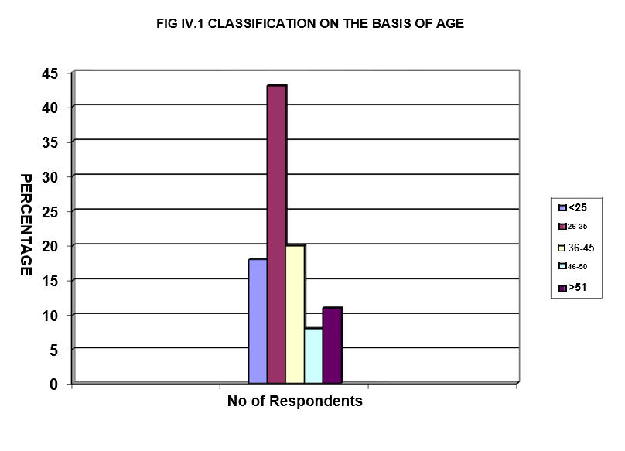

PERCENTAGE

45

40

35

30

25

20

15

10

5

0

FIG IV.1 CLASSIFICATION ON THE BASIS OF AGE

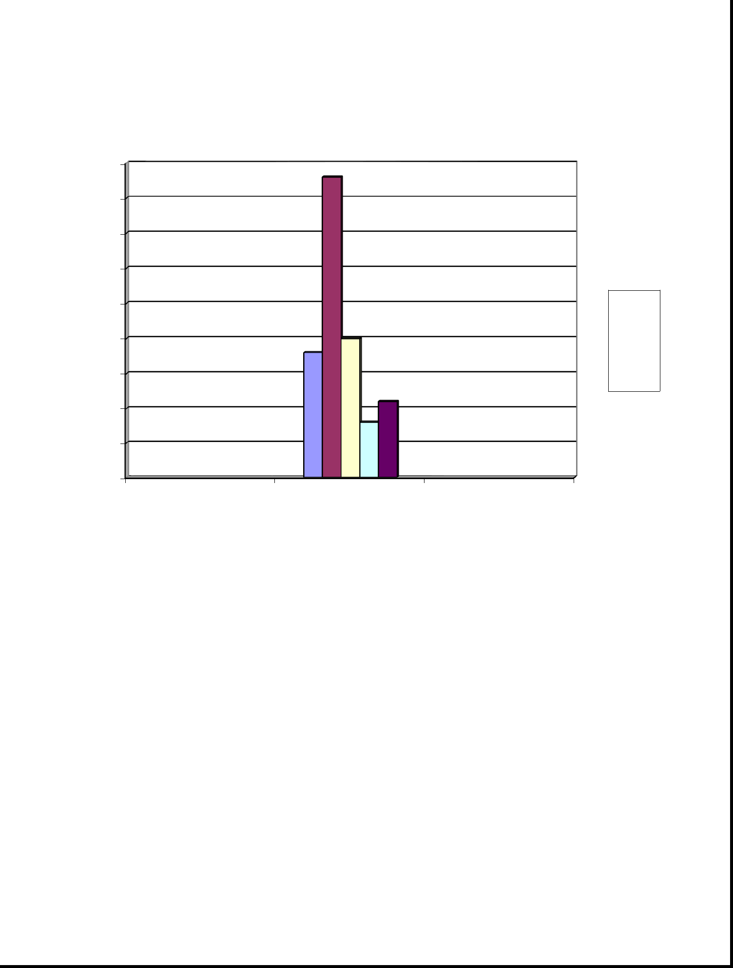

<25

26-35

36-45

46-50

>51

No of Respondents

2.Classification Of Educational Qualification

S.NO. | PARTICULARS | NO. OF | % OF
 |  | RESPONDENTS | RESPONDENTS
1 | Graduate | 50 | 50
2 | Post Graduate | 29 | 29
3 | Diploma | 20 | 20
4 | Others | 1 | 1
 | TOTAL | 100 | 100

Inference:

From the above table it is clear that most of the respondents are Graduate and where as some of them are post graduates and few of them are Diploma holder.

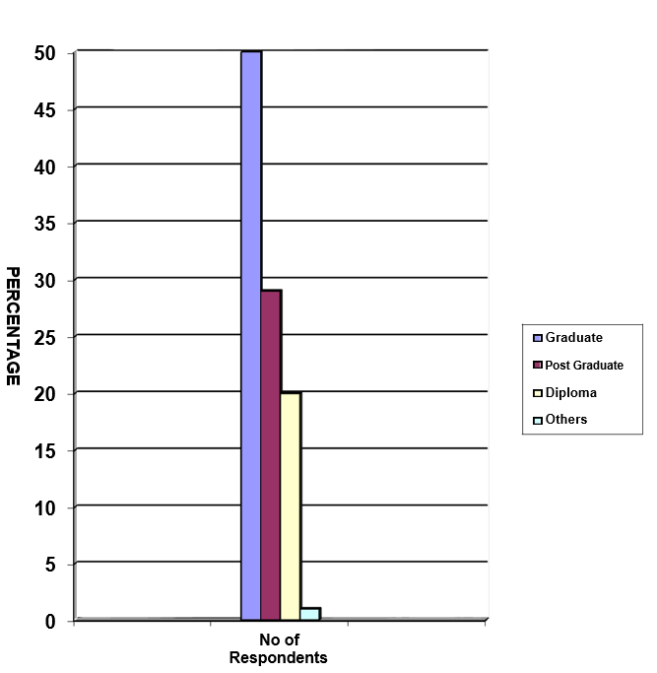

50

45

40

35

30

25

20

15

10



Graduate

Post Graduate

Diploma

Others

Rating Of The Performance Appraisal System

S.NO. | PARTICULARS | NO. OF | % OF
 |  | RESPONDENTS | RESPONDENTS
1 | Good | 23 | 23
2 | Satisfactory | 58 | 58
3 | Poor | 13 | 13
4 | No Idea | 6 | 6
 | TOTAL | 100 | 100

Inference:

From the above table it is clear that 58% of the respondents rating on the Performance Appraisal System is satisfactory and where as 23% of the respondents rate them as good and 6% of them have no idea.

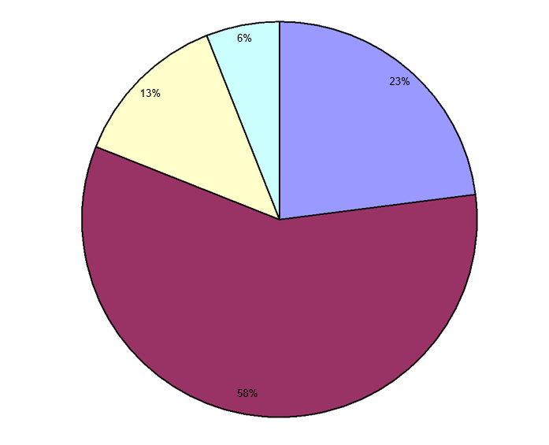



Understanding Between The Superior And Subordinate To Perform Better

S.NO. | PARTICULARS | NO. OF | % OF
 |  | RESPONDENTS | RESPONDENTS
1 | Strongly Agree | 30 | 30
2 | Agree | 58 | 58
3 | Neutral | 10 | 10
4 | Disagree | 2 | 2
5 | Strongly | 0 | 0
 | Disagree
 | TOTAL | 100 | 100

Inference:

From the above table it is clear that 58% of the respondents agree that Performance Appraisal System helps to develop a better understanding between the superior and subordinate to perform better and whereas 30% of them strongly agree.

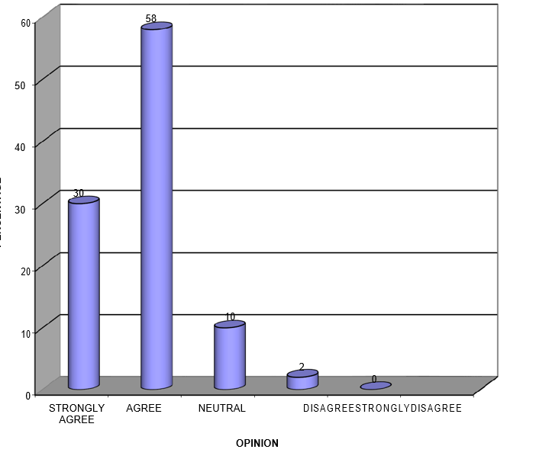

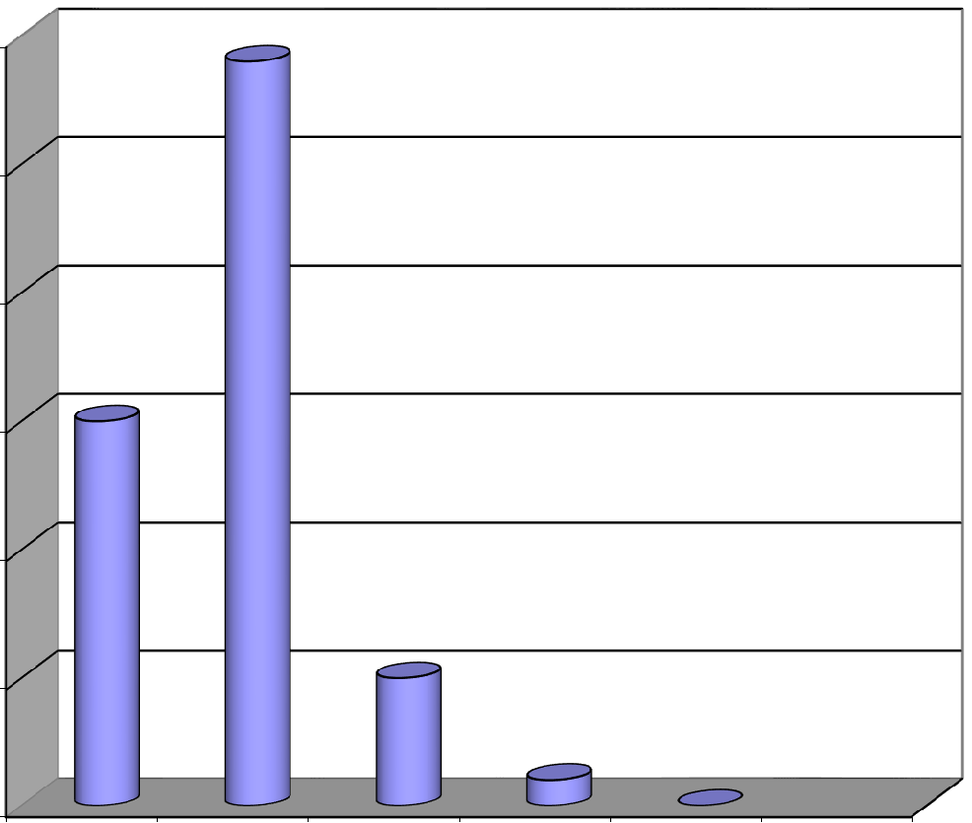

PERCENTAGE

60 | 58

50

40

30

30

20
10

Participation In Performance Appraisal Meeting

S.NO. | PARTICULARS | NO. OF | % OF
 |  | RESPONDENTS | RESPONDENTS
1 | YES | 40 | 40
2 | NO | 60 | 60
 | TOTAL | 100 | 100

Inference:

From the above table it is clear that 60% of the respondents do not participate in the Performance Appraisal Meeting and 40% participate in the Performance Appraisal Meeting.

FIG.IV. 6 PARTICIPATION IN PERFORMANCE APPRAISALS MEETING



60% 40%


YES NO

Respondent And Reporting Authority Agree With The Targets Fixed

S.NO. | PARTICULARS | NO. OF | % OF
 |  | RESPONDENTS | RESPONDENTS
1 | Yes | 90 | 90
2 | No | 10 | 10
 | TOTAL | 100 | 100

Inference :

From the above table it is clear that 90% of the respondents agree with the targets fixed and few of them do not.




NO 10

OPINION

YES |  | 90

0 10 20 30 40 50 60 70 80 90 100

PERCENTAGE

EFFECTS OF THE TARGETS GIVEN

S.NO. | PARTICULARS | NO. OF | % OF
 |  | RESPONDENTS | RESPONDENTS
1 | Attainable | 38 | 38
2 | Challenging | 50 | 50
3 | Not Realistic | 12 | 12
4 | Others | 0 | 0
 | TOTAL | 100 | 100

Inference :

From the above table it is clear that 50% of the respondents feel that the targets given are challenging and whereas 38% feel the target are attainable and 12% feels the target are not realistic.

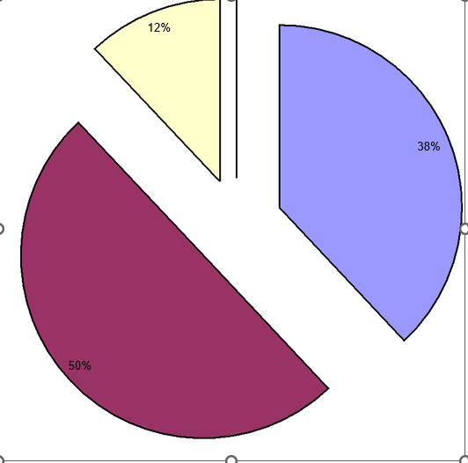

38%

ATTAINABLE CHALLENGING NOT REALISTIC OTHERS

Guidance Provided By The Superior

S.NO. | AWARENESS | NO. OF | PERCENTAGE
 |  | RESPONDENTS | %
1 | Highly Satisfied | 10 | 10
2 | Satisfied | 73 | 73
3 | Neutral | 15 | 15
4 | Dissatisfied | 2 | 2
5 | Highly | 0 | 0
 | Dissatisfied
 | TOTAL | 100 | 100

Inference :

From the above table it is clear that 73% of the respondents are satisfied with the guidance provided by the superior and whereas 15% feel it to be neutral

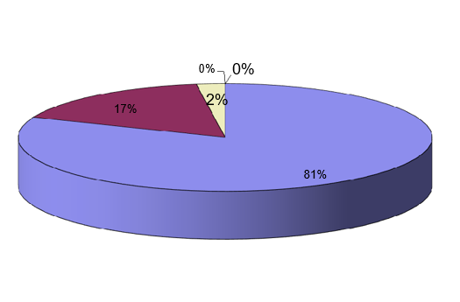

_{0%}

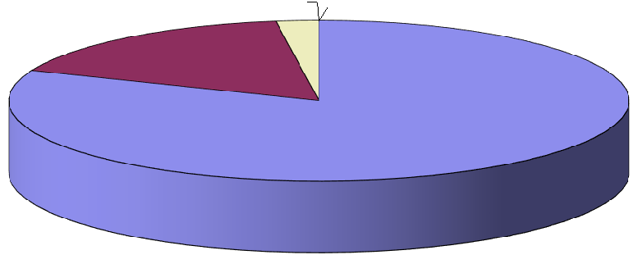

^{2%}

SATISFIED NEUTRAL DISSATISFIED HIGHLY DISSATISFIED

Respondent And The Reporting Authority Agree With The Major Improvement And Achievement

S.NO. | PARTICULARS | NO. OF | % OF
 |  | RESPONDENTS | RESPONDENTS
1 | To A Great Extent | 50 | 50
2 | Completely | 15 | 15
2 | To A Limited Extent | 35 | 35
3 | Not At All | 0 | 0
 | TOTAL | 100 | 100

Inference :

From the above table it is clear that 50% of the respondents agree to a great extent with the major improvements and achievements and whereas 35% of them agree to a limited extent.


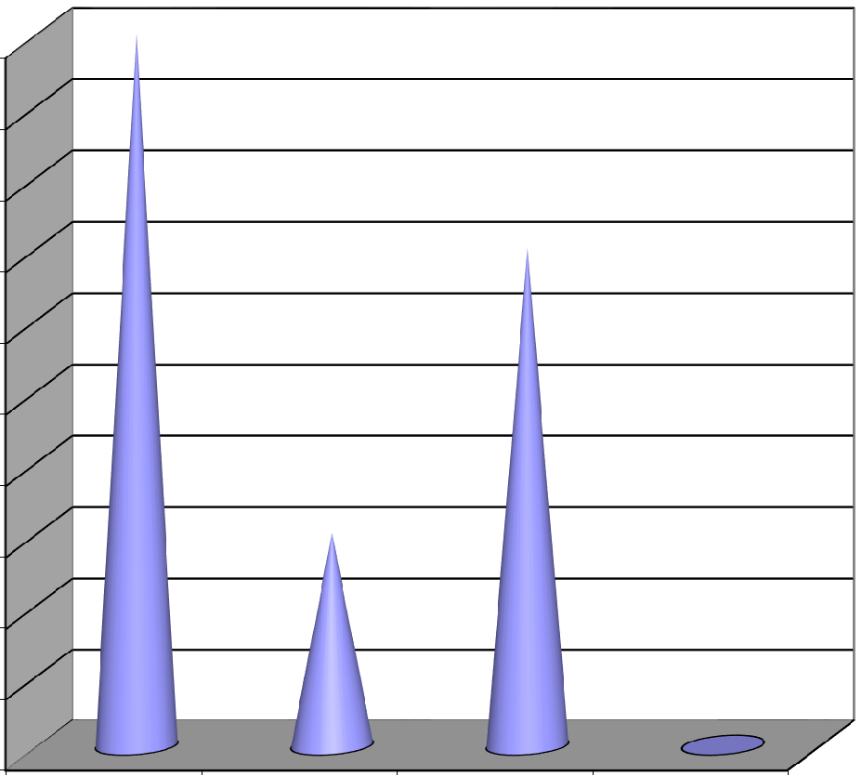

PERCENTAGE

50

50
45
40
 |  | 35
35
30
25
20
 | 15
15
10
5
 |  |  | 0
0
TO A GREAT | COMPLETELY | TO A LIMITED | NOT AT ALL
EXTENT |  | EXTENT

OPINION

Suggestion

S.NO. | PARTICULARS | NO. OF | % OF
 |  | RESPONDENTS | RESPONDENTS
1 | Considered | 98 | 98
2 | Ignored | 2 | 2
 | TOTAL | 100 | 100

Inference :

From the above table it is clear that 98% of the respondents suggestion are

Considered

2%


98%

CONSIDERED IGNORED

Barriers In Performance Appraisals

S.NO. | PARTICULARS | NO. OF | % OF
 |  | RESPONDENTS | RESPONDENTS
1 | Inattentive Appraisers | 24 | 24
2 | Insufficient Time | 43 | 43
3 | Improper Data Base | 33 | 33
 | TOTAL | 100 | 100

Inference :

From the above table it is clear that 43% of the respondents feel that the barriers experienced while undergoing Performance Appraisal is due to insufficient time and whereas 33% feel due to improper database and 24% feel due to inattentive appraisers.

FIG.IV. 12 BARRIERS IN PERFORMANCE APPRAISALS

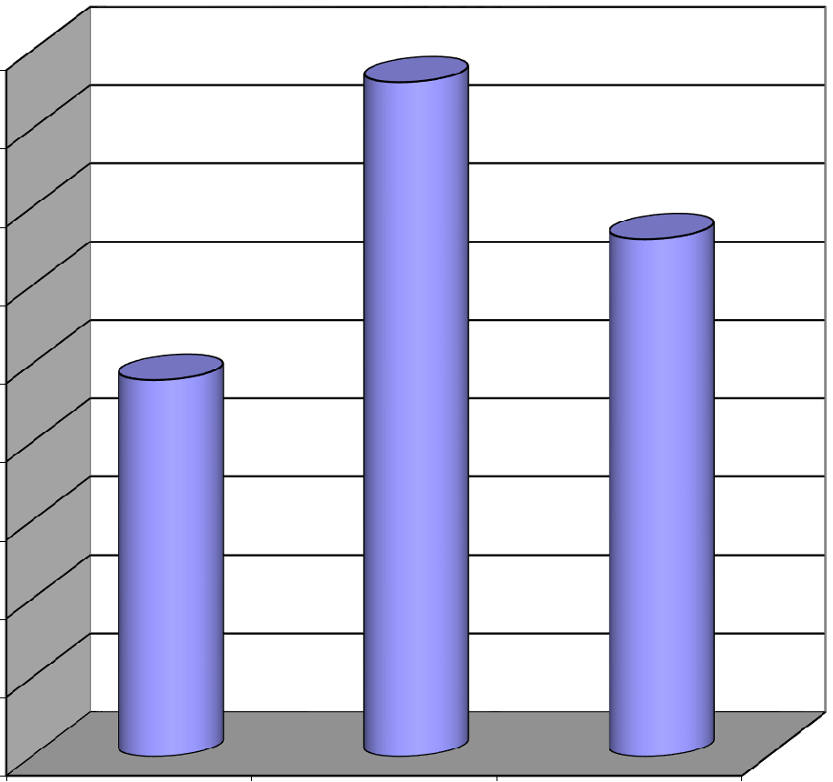

PERCENTAGE

45 | 43
40
35 | 33

30

24

25

20

15

10

5

0
INATTENTIVE INSUFFICIENT TIME IMPROPER DATA BASE
APPRAISERS

BARRIERS

BENEFITS OF PERFORMANCE APPRAISAL

S.NO. | PARTICULARS | NO. OF | % OF
 |  | RESPONDENTS | RESPONDENTS
1 | Career Development | 35 | 35
2 | Fixing Of Targets | 2 | 2
3 | Pay Revision | 10 | 10
4 | All The Above | 53 | 53
 | TOTAL | 100 | 100

Inference :

From the above table it is clear that 53% of the respondents opinion in using Performance Appraisal is all the above and whereas 35% of the respondents opinion is career development.

FIG IV.13 BENEFITS OF PERFORMANCE APPRAISAL

PERCENTAGE

60
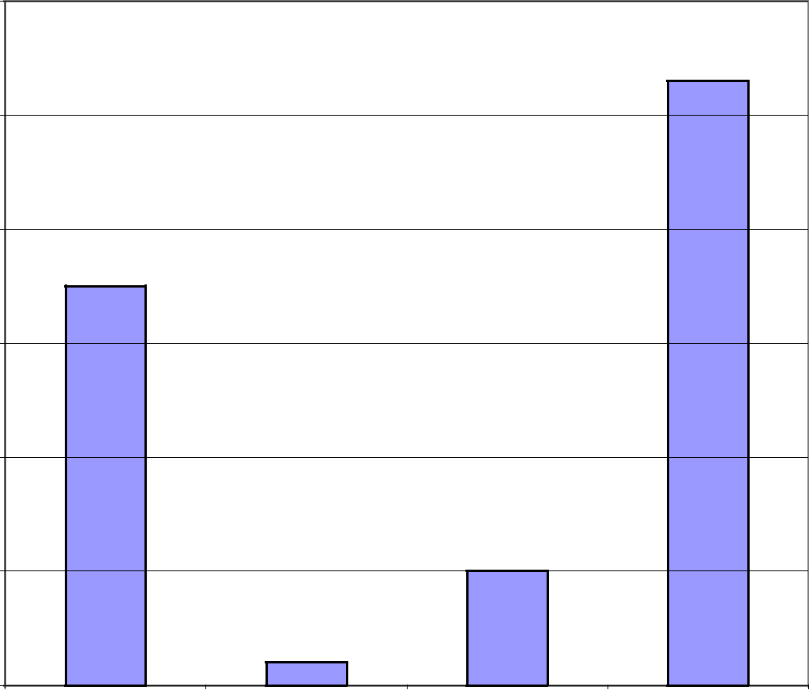

53

50

40

35

30

20

10
10

2

0

CAREER DEVELOPMENT FIXING OF TARGETS PAY REVISION ALL THE ABOVE

BENEFITS

Feeling Of The Respondent At The End Of The Appraisal

S.NO. | PARTICULARS | NO. OF | % OF
 |  | RESPONDENTS | RESPONDENTS
1 | Delighted | 13 | 13
2 | Encouraged To A | 73 | 73
 | Certain Extent
3 | Discouraged | 1 | 1
3 | Don’t Know | 13 | 13
 | TOTAL | 100 | 100

INFERENCE :

From the above table it is clear that 73% of the respondents feels that they are encouraged to a certain extent.

FIG IV. 14 FEELINGS OF THE RESPONDENT AT THE END OF THE APPRAISAL

PERCENTAGE

80
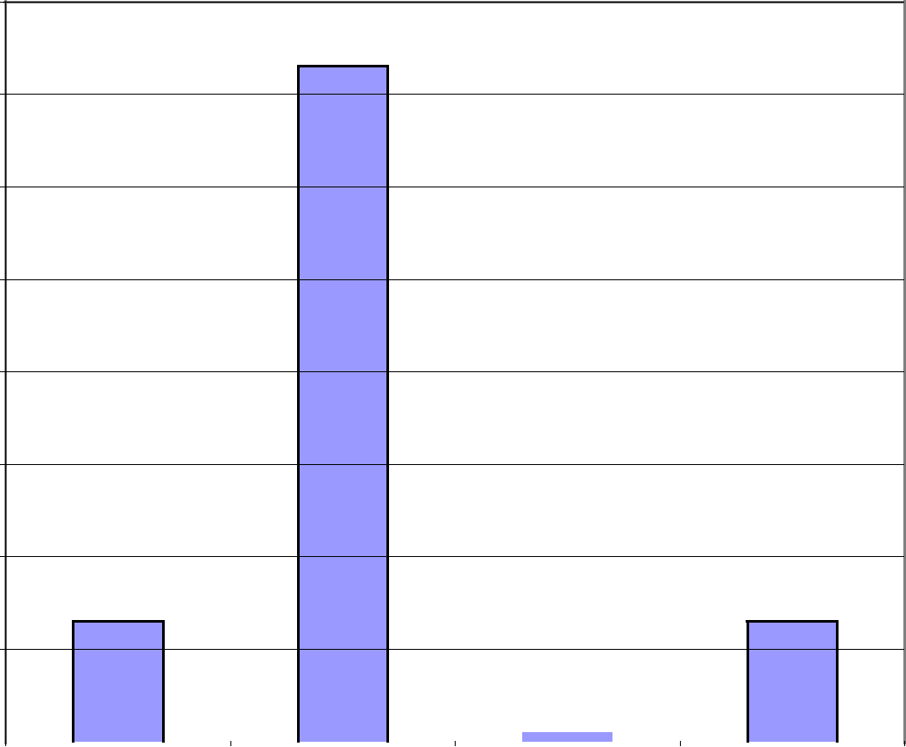

73

70

60

50

40

30

20

13 | 13

10

 |  |  |  |  |  |  |  | 1
0
0 |  | DELIGHTED |  |  | ENCOURAGED TO A |  |  | DISCOURAGED |  |  |  |  | DON’T KNOW
 |  |  |  |  | CERTAIN EXTENT

OPTIONS

MODIFICATION IN THE PERFORMANCE APPRAISAL

S.NO. | PARTICULARS | NO. OF | % OF
 |  | RESPONDENTS | RESPONDENTS
1 | Yes | 55 | 55
2 | No | 45 | 45
 | TOTAL | 100 | 100

Inference :

From the above table it is clear that 55% of the respondents feels that the modification is necessary for the method performance appraisal conducted in the company and whereas 45% of them that the modification is not necessary.



45% 55%

YES NO

CHAPTER – 5
Limitations

- The effectiveness of performance appraisal may be influenced by subjective perceptions and biases. Self-reported data from employees or managers may be subject to social desirability bias, where respondents provide answers they think are socially acceptable rather than reflecting their true opinions or experiences

- There may be factors within the organization that could affect the results but are not accounted for in the study. For instance, changes in leadership, organizational culture, or external market conditions could impact the effectiveness of performance appraisal but are not controlled for in the research design.

- The findings of the study may not be generalizable to other organizations or industries beyond HCL Technologies BPO. Factors specific to the company's culture, structure, or industry may limit the applicability of the research findings to different contexts.

CHAPTER – 6

FINDINGS, SUGGESTIONS AND

CONCLUSION

- Most of the employees in the organization are between the age group of 25 - 35.

- It has been found that most of the employees in the company have at least five years of experience.

- It is inferred that most of the employees are satisfied with their job

- It is seen that most of the respondents are Graduates and Post graduates

- Most of them in the company are aware of the existing performance appraisal system to limited extent.

- It is inferred that most of the employee’s agree that performance appraisal system helps in better understanding between superior and subordinate to

perform better.

- It is seen that most of the respondents don’t know to express their feeling at the end of the appraisal.

It is inferred that most of the employees feel that modification is necessary for the method of performance appraisal system conducted in the company. HR Challenges faced by DSOs along with recommended strategies Based on the data analysis, various HR challenges of DSOs have emerged which have been described in seven categories as mentioned below. Along with the challenges related to each category, researcher has also recommended some strategies which would help DSOs to cope up with these challenges.

- Challenges related to attracting and acquiring talent such as Difficulty to find talent, Identifying the right candidate, Lack of Career Prospects, Inadequacy of education inputs, Challenges in Urban areas, Challenges in Rural and Tribal areas, Gender aspects. Recommended strategies are Proactive Human Resource.

- Challenges related to Training & Employee Performance such as Need for training, Lack of resources for training, Evaluating Employee Performance. Recommended strategies are Developing competencies among senior members, Developing skills of employees, Developing effective Performance management system.

- Challenges related to employee motivation and retention such as Inability to provide competitive Remuneration & Benefits, The nature of field work, High attrition, Government and policy climate. Recommended Strategies Are Transcending employees through motivational levels, providing non-monetary benefits, Providing Flexibility Challenges related to Work culture such as Decision making process, Diversification v/s Consolidation. Recommended strategies are Inclusive decision making, Providing pleasant work environment. 269

- Challenges related to Organizational growth such as Managing Expansion, Managing change in organization structure, Handling HR as per size of the organization Recommended strategies are Evolving HR in various stages of Organizational growth, Developing Policies and procedures

- Challenges related to Funding and support system such as Funding pattern, Effect of CSR, Effect of Support system, Sector specific challenges Recommended strategies are Exploring alternative forms of organization, seeking active involvement of donors, Building Institutional Capacity Lateral strategies These strategies are broad in nature. They would be helpful in dealing with many of the above mentioned HR challenges and also in strengthening HR function. It includes: • Assessment of HR function • Outsourcing HR • Use of latest Technology

6.Challenges related to Leadership such as Lack of continuity, Hiring an ‘outsider’ at top, Lack of vertical growth Recommended strategies are Succession planning, Maintaining field presence

Recommendation
Team leaders may understand the employees competencies, and the tasks can be assigned accordingly and then assess their performance periodically.

The existing performance appraisal system may have more provisions to have exposure in such a way that all the employees participate in the performance appraisal review meetings.

The superiors may emphasis on guiding their team members in order to accomplish the improvement in their performance, subsequently achieving the original goal.

The performance appraisal system may be used effectively to motivate the employees to attain the departmental and organization targets to the employees.

The sufficient time may be given to the employees to fulfill the procedures of performance appraisal to make the system more productive and effective. The Parameters followed for appraising performance of the employees were contained only to the output of the employees. They may also emphasis on other equally conflict resolution and dedication etc.,



BIBLIOGRAPHY

HUMAN RESOURCES MANAGEMENT

- (ICFAI PUBLICATION)

PERFORMANCE MANAGEMENT AND APPRAISAL SYSTEMS

- HR TOOLS FOR GLOBAL COMPETITIVENESS,

- T.V. RAO. NEW DELHI ,

- FROM VEDAM EBOOKS (P) LTD

RESEARCH METHODOLOGY

- RESEARCH METHODS & TECHNIQUES

- KOTHARI, NEW DELHI

ORGANISATIONAL BEHAVIOUR

- L.M. PRASAD

REFERENCES

- Aguinis.H and Printice Hall, “Performance management”, 2007.

- Ashwathappa.K, “Human Resource and personnel management”, 1997.

- Boswell W. R. and Boudreau J. W.,“Employee satisfaction with performance

appraisals and appraisers: The role of perceived appraisal use. Human Resource Development”, vol. 11, 2000.

- Boswell W. R. and Boudreau J.W., “Separating the developmental and evaluative performance appraisal uses. Journal of Business & Psychology”, Vol.
16, 2002.

5. Cokins, G, John Wiley and Sons,“Performance management: Finding the missing pieces and closing the intelligence gap”, 2004.

6. Decenzo, D. A, Robbins and Stephen P, “Human resource management”7th edition, 2002.

7. Fletcher.C, “Appraisal and Feedback: Making Performance Review Work”, CIPD, 2004.

- Greer,R. Strategic Human Resource Management: A general managerial approach, 2001. 9. Weihrich, H. Essentials of Management: An International Perspective, 2005

WEBSITES

http://www.performance-appraisal.com/home.htm

www.bpoindia.org/

http://hclbpo.com/

http://www.hcl.in/history.asp

https://www.upgrad.com/blog/mba-hr-project-ideas-topics-for-beginners/

https://www.scribd.com/document/426820358/Recritment-and-Selection

https://www.google.com/search?q=signature+and+stamp+of+hcl+technologies&rl

z=1C1CHBF_enIN940IN941&sxsrf=AOaemvLl-

Dck_QDxTvuQQiRhYSPotsa0AA:1638625322034&source=lnms&tbm=isch&sa=

X&ved=2ahUKEwjY9PSBo8r0AhXvUGwGHe4vASUQ_AUoAXoECAEQAw&

biw=1280&bih=577&dpr=1.5#imgrc=xUaWTdhIKuygrM

Questionnaire

“The Effectiveness of Performance Appraisal at HCL TECHNOLOGIES BPO”

Dear Respondent

This questionnaire is part of an academic study being carried out in partial fulfillment of the MBA degree. Please take few minutes to complete this survey. Please do not leave any question unanswered. Your views, in combination with those of others, are extremely important. Your survey responses will be strictly confidential and data from the survey will be reported only in the aggregate.
1. Gender ٱ Male ٱ Female

- Department …………………………………………………

2b. | Designation / Grade ………………………………………..
3. | Age <26 yrs | ٱ
 | 27-35 yrs | ٱ
 | 36-45 yrs | ٱ
 | 46-50 yrs | ٱ
 | > 51 yrs | ٱ

- Educational Qualification
  - Graduate

  - Post Graduate

  - Diploma

  - Other (specify)

- No. of years served at HCL BPO ---------------------- Yrs

6. Total work experience ------------------ Yrs.

- How aware are you of the performance appraisal system followed by

HCL BPO.

  - To a great extent

  - To a limited extent

  - Not at all

- How would you rate the present performance appraisal system

    - Good

    - Satisfactory

    - Poor

    - No idea

- Performance Appraisal system helps to develop a better understanding between the superior and subordinate to perform better.

    - Strongly Agree

    - Agree

    - Neutral

    - Disagree

    - Strongly Disagree

- Do you fully participate in performance appraisal meeting ?

  - Yes

  - No

- Do you & your reporting authority agree with targets fixed ?

  - Yes

  - No

- Are the targets given ?

  - Attainable

  - Challenging

  - Not realistic

  - Others Please specify) ………………

- Are you satisfied with the guidance provided by your superior ?

  - Highly satisfied

  - Satisfied

  - Neutral

  - Dissatisfied

  - Highly Dissatisfied

- How far you and your reporting authority agree with the major improvements & achievements made by you ?

  - Completely

  - to a great extent

  - to a limited extent

  - Not at all

14a Are your suggestions Generally

  - Considered

  - Ignored

- Which of the following barriers have you experienced while undergoing performance Appraisals ?

  - Inattentive Appraisers

  - Insufficient time

  - Improper Database

  - Others (Please specify) ………..

- What is your opinion about using performance Appraisal?

  - Career Development

  - Fixing of targets

  - Pay revision

  - All the above

- At the end of the appraisal do you feel?

  - Delighted

  - Encouraged to a certain extent

  - Discouraged

  - Don’t know

- Do you think modification is necessary for the method of performance appraisal conducted in your company?

  - Yes

  - No

- If yes, Your Suggestion_________________________________________

