“HUMAN RESOURCE MANAGEMENT” at AMDOCS Pvt. Ltd.

SUBMITTED TO : SUBMITTED BY :

PRATIBHA VERMA NIKHIL GUPTA
(Assistant professor) 19021010673

BBA 6th Sem

Bachelor of Business Administration
Sector – 17A, Greater Noida, Uttar Pradesh – 203201
Session: 2019-2022

CHAPTER NO. 1

INTRODUCTION

INTRODUCTION OF THE TOPIC

HUMAN RESOURCE MANAGEMENT

Behind the production of every product or service there is a human mind, effort and man hours (working hours). No product or service can be produced without help of human being. Human being is the fundamental resource for making or constructing anything.
Today many experts claim that machines and technology are replacing human resource and minimizing their role or effort. However, indeed, machines and technology are built by the humans; they need to be operated or at least monitored by humans. Maybe because of this reason, companies have continuously been searching for talented, skilled and qualified professionals to further develop latest machines and technology, which again have to be controlled or Monitored by humans to bring out products.

"The automation of factories has already decimated jobs in traditional manufacturing, and the rise of artificial intelligence is likely to extend this job destruction deep into the middle classes, with only the most caring, creative or supervisory roles remaining" - British theoretical physicist Stephen Hawking

MEANING:-

Human resource management (HRM or simply HR) is
the management of humanresources. It is designed to maximize employee performance in service of an employer's strategic objectives. HR is primarily concerned with the management of people within organizations, focusing on policies and on systems. HR departments are responsible for overseeing employee benefits design,
employee recruitment, training and development, performance appraisal, and rewarding (e.g., managing pay and benefit systems). HR also concerns itself with organizational change and industrial relations, that is, the balancing of organizational practices with requirements arising from collective bargaining and from governmental laws.

Human Resources is a business field focused on maximizing employee productivity. Human Resources professionals manage the human capital of an organization and focus onImplementing policies and processes. They can be specialists focusing in on recruiting, training, employee relations or benefits. Recruiting specialists are in charge of finding and hiring top talent. Training and development professionals ensure that employees are trained and have continuous development. This is done through training programs, performance evaluations and reward programs. Employee relations deals with concerns of employees when policies are broken, such as harassment or discrimination. Someone in benefits develops compensation structures, family leave programs, discounts and other benefits that employees can get. On the other side of the field are Human Resources Generalists or Business Partners. These human resources professionals could work in all areas or be labor relations representatives working with unionized employees.
Human Resource Management is the process of recruitment and selecting employee, providing orientation and induction, training and development assessment of employee (performance of appraisal), providing compensation and benefits, motivating, maintaining proper relations with employees and with trade unions, maintaining employee’s safety, welfare and healthy measures in compliance with laborlaws of the land.

Why name 'Human Resource Management'?

Human: refers to the skilled workforce in the organization. Resource: refers to limited availability or scarceness.
Management: refers how to optimize and make best use of such limited and a scarce resource so as to meet the ordination goals and objectives.

Definitions:
Many great scholars had defined human resource management in different ways and with different words, but the core meaning of the human resource management deals with how to manage people oremployees in the organization.

BY Edwin Flippo - HRM as “planning, organizing, directing, controlling of procurement, development, compensation, integration, maintenance and separation of human resources to the end that individual, organizational and social objectives are achieved.”

Decenzo and Robbins, “HRM is concerned with the people dimension” in management. Since every organization is made up of people, acquiring their services, developing their skills, motivating them to higher levels of performance and ensuring that they continue to maintain their commitment to the organization is essential to achieve organsational objectives. This is true, regardless of the type of organization – government, business, education, health or social action”.

TRAINING AND DEVOLPMENT

DISTINCTION BETWEEN TRAINING AND DEVELOPMENT

TRAINING | DEVELOPMENT
1. Training means learning skills and | 1. Development means growth of an employees in
knowledge for doing a specific job. | all respects.
2. It is concerned with maintaining and | 2. It seeks to develop competence and skills for
improving current job performance. Thus, it | future performance. Thus, it has a long-term
has short-term perspective. | perspective.
4

3. It is job-centered in nature. | 3. It is career-centered in nature.
4. Role of trainer is very important. | 4. The executives has to be motivated internally for self-development.

TRAINING AND DEVELOPMENT

MEANING OF TRAINING AND DEVELOPMENT:-

In simple terms, training and development refer to imparting specific skills,abilities and knowledge to an employee.
A formal definition of training and development is: “It is any attempt to improve current or future employee performance
by increasing an employee’s ability to perform through learning, usually

by changing the employee’s attitude or increasing his skills and Knowledge.” The need of training and development is determined by employee’s performance deficiency, compute as follows:-

Training and development need = Standard performance – Actual performance.

Training is an organised activity for increasing the knowledge and skills of people for a definite purpose. It involves systematic procedure for transferring technical know-how to employees so as to increase their knowledge and skills for doing specific jobs with proficiency.
According to Edwin B. Flippo, “Training is the act of increasing the knowledge And skills of an employee for doing a particular job.”
Training involves the development of skills that are usually necessary to perform a specific job. Its purpose is to achieve a change in the behavior of those trained and to enable them to do their jobs better. It makes newly appointed workers fully productive in the minimum of time. It is equally important for the old employees due to frequent changes in technology.
PROCESS OF TRAINING AND DEVELOPMENT

Process of training and development is a well planned process. The following graph represents this in a graphical manner:-

TRAINING AND DEVELOPMENT PROCESS
ORGANISATIONAL
OBJECTIVES AND STRATEGIES
ASSESSMENT OF TRAINING
NEEDS

ESTABLISHMENT OF TRAINING AND DEVELOPMENT GOALS

DEVISING TRAINING AND DEVELOPMENT PROGRAMME

IMPLEMENTATION OF TRAINING AND DEVELOPMENT PROGRAMME

EVALUATION OF RESULTS

NEED OF TRAINING AND DEVELOPMENT

Training is important not only from the point of view of organization; but also for the employees. Training is valuable to the employees because it will give them greater job security and opportunity for advancement.
The need of training arises in an enterprise due to following reasons:-

CHANGINGTECHNOLOGY:-Technology is changing at a fast pace. The workers must learn new techniques to make use of advanced technology. Thus, training should be treated as a continuous process to update the employees in new methods and procedures.

QUALITY CONSCIOUS CUSTOMERS:-Customers have become quality conscious and their requirements keep on changing. To satisfy the customers, quality of products must be continuously improved through training of workers.

GREATER PRODUCTIVITY:-It is essential to increase productivity and Reduce cost of production for meeting competition in the market. Effective training can help increase productivity of workers.

STABLE WORKPLACE:-Training createsa feeling of confidence in the minds of the workers. It gives them a security at the work-place.As a result, labor turnover and absenteeism rates are reduced.

TRAINING AND DEVELOPMENT OBJECTIVES

Training objectives are formed keeping in view company’s goals and objectives.

- To prepare the employee [both new and old] to meet the present as well as changing requirements of job and organization.
- To impart to the new entrants the basic knowledge and skill needed for the performance of a definite job.
- To assist employees to function more effectively in their present positions by exposing them to latest concepts, information and techniques and developing the skill sets that may need further.
- To develop the potentialities of people for the next level of job.

- To ensure smooth and efficient working of department.

- To bridge the gap between “existing performance ability” and “deMamed performance”.
- To improve organizational climate since an endless chain of positive reactions can result from a well-planned training programme.

IMPORTANCE OF TRAINING AND DEVELOPMENT

Training plays an important role in human resource department. It is necessary, useful and productive for all categories of workers and supervisory staff. The importance of training and development in an enterprise are:-
OPTIMUM UTILIZATION OF RESOURCES:-Training and development helps in optimizing the utilization of human resources that further helps the employees to achieve the organizational as well as their individual goals.

DEVELOPMENT OF SKILLS OF EMPLOYEES:- Training and development helps in increasing the job knowledge and skills of employees at each level.
It helps to expand the horizons of human intellect and an overall personality of the employees.

PRODUCTIVITY:-Training and development helps in increasing productivity of the employees that helps organization to achieve its long-term goals.

TEAM SPIRIT:-Training and development helps in inculcating the sense of team-work, team spirit, and inter-team collaborations.

QUALITY:-Training and development helps in improving upon quality of work and work-life.

TYPES OF TRAINING

On the basis of purpose, several types of training programes are offered to employees. The important types of training programmes are as follows:
INDUCTION TRAINING:-Induction is concerned with introducing a new employee to the organization and its procedures, rules and regulations. When a new employee reports for work, he must be helped to get acquainted with the work environment and fellow employees.It is better to give him a friendly welcome when he joins the organization, get him introduced to the organization and help him to get a general idea about rules and regulations, working conditions, etc of the organization.

JOB TRAINING:-Job training relates to specific job which workers has to handle. It gives information about machines, process of production, instructions to be followed, methods to be used and so on. It develops skills and confidence among the workers and enables them to perform the job efficiently. It is the most common of formal in-plant training programmes.It helps in creating interest of the employees in their jobs.

APPRENTICESHIP TRAINING:-Apprenticeship training programmes tend more towards education than merely on vocational training. Under this, both skills and knowledge in doing a job or a series of related jobs are involved. The government of various countries have passed laws which make it obligatory on certain classes of employers to provide apprenticeship training to young people. The usual apprenticeship programmes combine on the job training and experience with class room instructions in particular subjects. This training is deMamable in industries which requires a constant flow of new employees expected to become all round craftsmen. It is very much prevalent in printing trades, building and construction and crafts like mechanics, electricians, welders, etc.

INTERNSHIP TRAINING:- Under this method, the educational and vocational institute enters into arrangement with an industrial enterprise for providing practical knowledge to its students. This training is usually meant for such vocations where advanced theoretical knowledge is to be backed up by practical experience on the job. For instance, engineering students are sent to big industrial enterprises for gaining practical work experience and medical students are sent to hospitals to get practical knowledge. The period of such training varies from six months to two years.

REFRESHER TRAINING:-As the name implies, the refresher training is meant for the old employees of the enterprise. The basic purpose of this training is to acquaint the existing work-force with the latest methods of performing their jobs and improve their efficiency further. In the words of Dale Yoder, “Retraining programmes are designed to avoid personnel obsolescence.” The skills with the existing employees become obsolete because of technological changes and of the human tendency to forget.

TRAINING FOR PROMOTION:-The talented employees may be given adequate training to make them eligible for promotion to higher jobs in the organization.
Promotion means a significant change in the Responsibilities and duties. Therefore, it is essential that employees are provided sufficient training to learn new skills to perform their jobs more efficiently. The purpose of training for promotion is to develop the existing employees to make them fit for undertaking higher job responsibilities. This serves as a motivating force to the employees

METHODS OF TRAINING

The success of any training program depends upon operational commitments, policies and directives from higher authorities. The following factors are considered while selecting a suitable method.
- Skill required.

- Qualification of candidates.

- Cost of training.

- Period of time available.

- Depth of knowledge required.

- Purpose of training.

- Back ground of training.

- Nature and size of the group to be trained.

- Nature of the job.

- Type of employee

The various methods of training may be classified into the following categories: On-the-job training
Vestibule training Off-the-job training

ON-THE-JOB TRAINING:-On-the-job training is considered to be the most effective method of training the operative personnel.Under this method, the worker is given training at the work place by his immediate supervisor. In other words, the worker learns in the actual work environment. It is based on the principle of “learning by doing”

MERITS OF THE ON THE JOB TRAINING.

- This method is economical.

- The trainee applies rules, regulations and procedure while doing work.

- Short period is enough for learning.

- It can be used for unskilled and semi-skilled jobs.

- This is the most widely used method for teaching knowledge. and skills

which can be acquired through personal observation.

- The trainee learns on the actual machine and in the real work environment.

DEMERITS

- The employee is trained at the work place. He is not able to concentrate and learn due to noises and interruptions.
- It is an unorganised and haphazard method.

- There is a chance of making damage to the valuable machines and equipments.

Four methods of on-the-job training described below:-

COACHING:-Under this method, the supervisor imparts job knowledge and skills to his subordinate.The emphasis in coaching the subordinate is on learning by doing.This method is very effective if the superior has sufficient time to provide coaching to his subordinates.
UNDERSTUDY:-The superior gives training to a subordinate as his assistant. The subordinate learns through experience and observation. Itprepares the subordinate to assume the responsibilities of the superior’s job in case the superior leaves the organization. The purpose of understudy is to prepare someone to fill the vacancy caused by death, retirement, transfer, or promotion of the superior.
POSITION ROTATION: The purpose of position rotation is to broaden the background of the trainee in various positions. The trainee is periodically rotated from job to job instead of sticking to one job so that he acquires a general background of different jobs.
However, rotation of an employee from one job to another should not be done frequently. He should be allowed to stay on a job for sufficient period so that he may acquire the full knowledge of the job.

JOB ROTATION:-Job rotation is used by many firms to develop all-round workers. The employees learn new skills and gain experience in handling different kinds of jobs. They also come to know interrelationship between different jobs. It is also used to place workers on the right jobs and prepare them to handle other jobs in case of need.
OFF-THE-JOB TRAINING:-It requires the workers to undergo training for a specific period away from the work place. Off-the-job methods are concerned with both knowledge and skills in doing certain jobs. The workers are free of tension of work when they are learning.

There are several off-the-job methods of training as described below:-

SPECIAL LECTURE CUM DISCUSSION:-Training through special lectures is also known as “class-room training”. It is more associated with imparting knowledge than skills. The special lectures may be delivered by some executives of the organization or specialists from vocational and professional institutes. Many firms also follow the practice of inviting experts for special lectures for the staff on matters like health, safety, productivity, quality, etc.
CONFERENCE TRAINING:-A conference is a group meeting conducted According to an organised plan in which the members seek to develop Knowledge and understanding by oral participation. It is an effective training device for persons in the positions of both conference member and conference leader. As a member, a person can learn from others by comparing his opinions with those of others. He learns to respect the viewpoints of others and also realizes that there is more than one workable approach to any problem.
CASE STUDY:-The case method is a means of stimulating experience in the classroom. Under this method, the trainee are given a problem or case which is more or less related to the concepts and principles already taught. They analyze the problem and suggest solutions which are discussed in the class. The instructor helps them reach a common solution to the problem. This method gives the trainee an opportunity to apply his knowledge to the solution of realistic problems.

CHAPTER NO. 2 REVIEW OF LITERATURE

COMPANY PROFILE

AMDOCS LTD

• | Type | Public
• | Traded as | NASDAQ: DOX
• | Founded | Aurec Information & Directory Systems (today known as
 |  | Amdocs), Israel (1982)
• | Founder | Morris Kahn, Boaz Dotan
• | Headquarters | Chesterfield, Missouri, United States (corporate)Saint Peter
 |  | Port, Guernsey(registered office)
• | Key people | Eli Gelman (President & CEO)Tamar Rapaport-Dagim (Sr.
 |  | Vice President & CFO)
• | Revenue | US$3.7 billion (FY 2016)
• | Net income | US$409 million (FY 2016)
• | Number of | 26,000 +
 |  | 16

employees

- Website • amdocs.com

Amdocs is a leading software & services provider to the world’s most successful communications and media companies. As our customers reinvent themselves, we enable their digital and network transformation through innovative solutions, delivery expertise and intelligent operations.
Amdocs and its 26,000 employees serve customers in over 85 countries. Listed on the NASDAQ Global Select Market, Amdocs had revenue of $3.7 billion in fiscal 2016.

AMDOCS PROVIDES SERVICES TO THIS FOLLOWING COMPANIES

3rd Generation Partnership Project
3GPP is an ITU initiative based at ETSI headquarters. It fosters collaboration between telecommunications standards bodies, including ARIB, CWTS, ETSI, T1, TTA, and TTC. The scope of 3GPP is to produce globally applicable technical specifications for a third generation mobile system based on evolved GSM core networks, GPRS and EDGE and the radio access technologies that they support.

Cable Television Laboratories, Inc.
Cable Television Laboratories, Inc. (CableLabs®) is a non -profit research and development consortium, founded by cable operating companies, that is dedicated to pursuing new cable telecommunications technologies and to helping its cable
17

operator members integrate those technical advancements into their business objectives. Amdocs is an NDA vendor of (and contributor to) several Cablelabs projects and initiatives including: DOCSIS, OpenCable, Go2Broadband, PacketCable, and Advanced Advertising.

Customer Experience Professionals Association (CXPA)
The Customer Experience Professionals Association (CXPA) is a global, non - profit organization dedicated to the advancement of customer experience management best practices. The CXPA’s members include individuals who develop, manage, optimize, and envision how organizations interact with their customers. This community includes cross -industry customer experience practitioners at companies and vendors who support customer experie nce efforts, as well as other stakeholders in the industry.

European Association of Directory and Database Publishers
Founded in 1966, the European Association of Directory Publishers (EADP) owes its existence to the aspirations of European publishers who anticipated the importance of intra-European contact and co-operation. Meanwhile, it has become the nerve centre for year-round contact and the key representative for the industry. It is the only international association in Europe to speak for the sec tor as a whole.

Today, the EADP has some 180 members in 36 countries world -wide, including member companies based in the 25 EU member states but also in the candidate countries : publishers, suppliers of products and services for the publishing industry and 6 national associations representing 340 directory publishers.

Local Search Association
Formerly the Yellow Pages Association, the Local Search Association (www.localsearchassociation.org) is the largest trade organization of print, digital, mobile and social media that help local businesses get found and selected by ready-to-buy consumers. Association members include U.S. and international Yellow Pages companies, search engines, online listings and review sites, digital advertising agencies and mobile search providers. The Association has members in 29 countries.

Neg Norton is President of the Association. Joe Walsh, CEO of Yellowbook, is the chairman of the board of directors. YPA board member companies include Super Media, Local Insight Media, DexOne, DAC Group, AT&T Advertising Solutions, Wahlstrom, Telmetrics, Inc, Nationwide Media, Yellow Pages Group and Marquette Group.

Chapter no. 3 OBJECTIVES OF THE STUDY

OBJECTIVES OF THE STUDY

The project is entitled as, “Study of Training and Development of employees in Amdocs LTD.”So, the basic objectives of the project is as follows:-

- To study how Training and Development programmes are undertaken in the organization.
- To study the induction programme at Amdocs LTD

- To study the effectiveness of Training and development in the organization.

- To measure the satisfaction level of employees regarding training and development.

.TRAINING AND DEVELOPMENT AT Amdocs LTD(India) LTD

TRAINING AND DEVELOPMENT AT INDORAMA SYNETHETIC (India) LTD.

The vision is to, “THINK GLOBAL GROW GLOBAL”

Training is the process of increasing the knowledge and skills for doing a particular job. It is organized procedure by which people learn knowledge and skill for a definite purpose. The purpose of training is basically to bridge the gap between jobs basically to bridge the gap between job requirement and present competence of an employee.
Training is closely related with the education and development. Employee Training is distinct from management development. Training is the short term process utilizing a systematic & organized procedure by which non –managerial personnel learn technical and mechanical operations of machines. It for short duration and for specific job related purpose.

Development is the long term process utilizing a systematic and organized procedure by which managerial personnel learn conceptual and theoretical knowledge for general purpose. It involves philosophical and theoretical educational concept and it is designed for manager.

The AMDOCS provides the training session to the every level of employee in the organization. It begins from manager level to the worker level.

Even the new fresher including Management trainee (MT’s) and General engineering trainee (GET’s) gets the training.

TRAINING PROGRAME

The training program is given at AMDOCS at every month according to the training calendar is being schedule. The induction program at AMDOCS is normally of 6month. It is designed as per the departmental requirements.

In the beginning of this program, the employee is required to fill a particular form. This form contains his basic information. The induction program for the employee is designed after studying this form, taking into consideration his background, areas of interests, weaknesses, strengths etc.

Normally, Pune is the only centre for induction at AMDOCS. Employees from different place are trained at Pune plant. To begin with the induction the very first thing is to develop amongst these employees, a feeling of togetherness. For this, these employees are given classroom training for about a month. Various departments come to the class room to deliver lecture. During these classrooms training the employees get familiar &

friendly with each other. To strengthen the feeling of togetherness &develop a sense of belonging groups are formed in the classroom. These groups are given various tasks and intergroup competitions are conducted. Thus they are kept busy all the time.

In the evening these employees are taken for plant visits. Outing is also planned to frame people in the area. During this one month training examinations business games, presentations are taken after this 1 month.
Here the GET’s and MT’s are taken to different units. In this training they learn the setup of the company. Until this rotational training the placements of the candidates are not disclosed. Placements are decided on completion of the rotational training. At placement branch again the candidate is sent to different department. This may take 2-4 months.
Then they are back to their respective departments. No leaves are allowed during the 6 months of induction period. After the completion of induction period a week’s leave is permitted before joining.
The difference between the induction of GET’s and MT’s is that the MT’s have to go deeper into the management part than the technical part.

At the end of the induction a report and feedback s has to be submitted by the employee.

Induction of the GM and above level includes only the visit to different department people. Induction program for workers is restricted to his department & place at work.

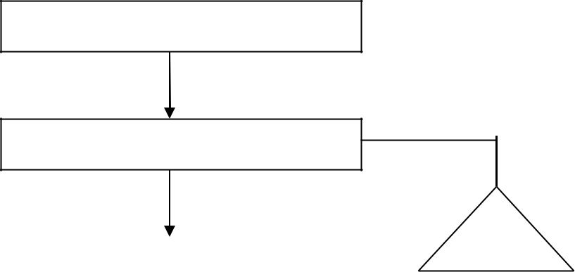

FLOW CHART OF TRAINING PROCEDURE

Identify training needs

Training needs assessment forms

File
Employ-ee tanning record
Identify employees for training Program

Design training program

Program schedule

Prepare training calendar

A

Send nomination

Nomination letter

Organize training program

Collect feedback assess competency
File

Prog. Feedback from below training Mgt.

s File

Prog. Feedback from worker

File

Follow up action on feedback

Prog. Feedback from Mgt. and above

File

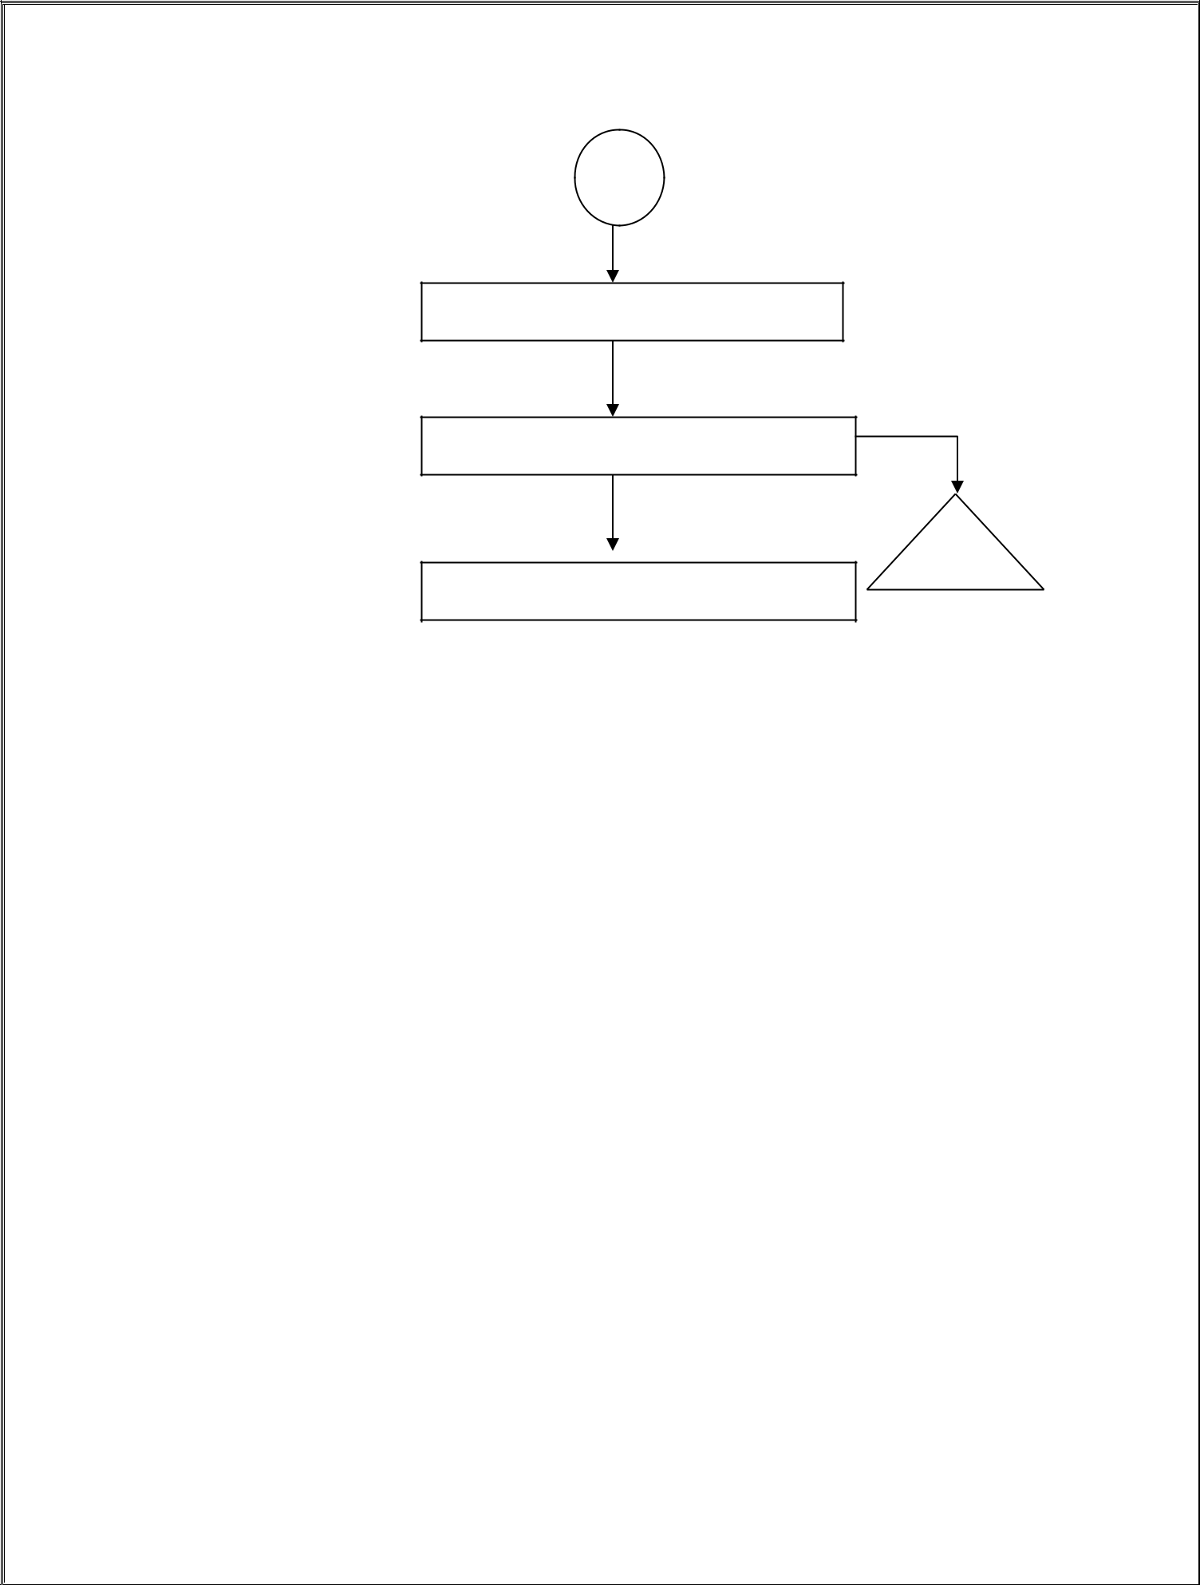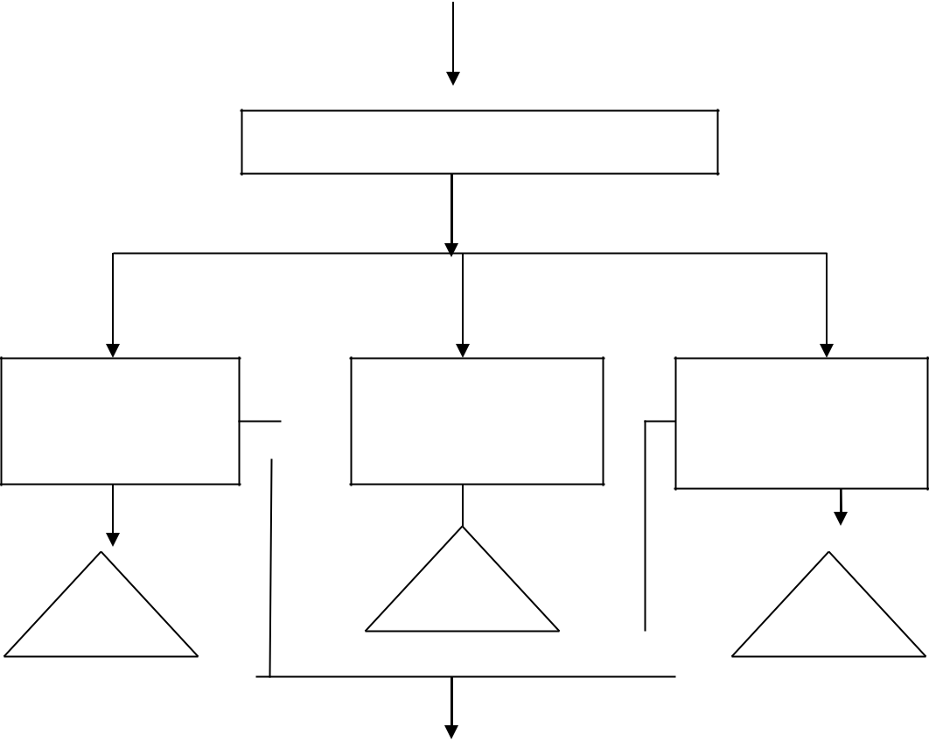

B
25

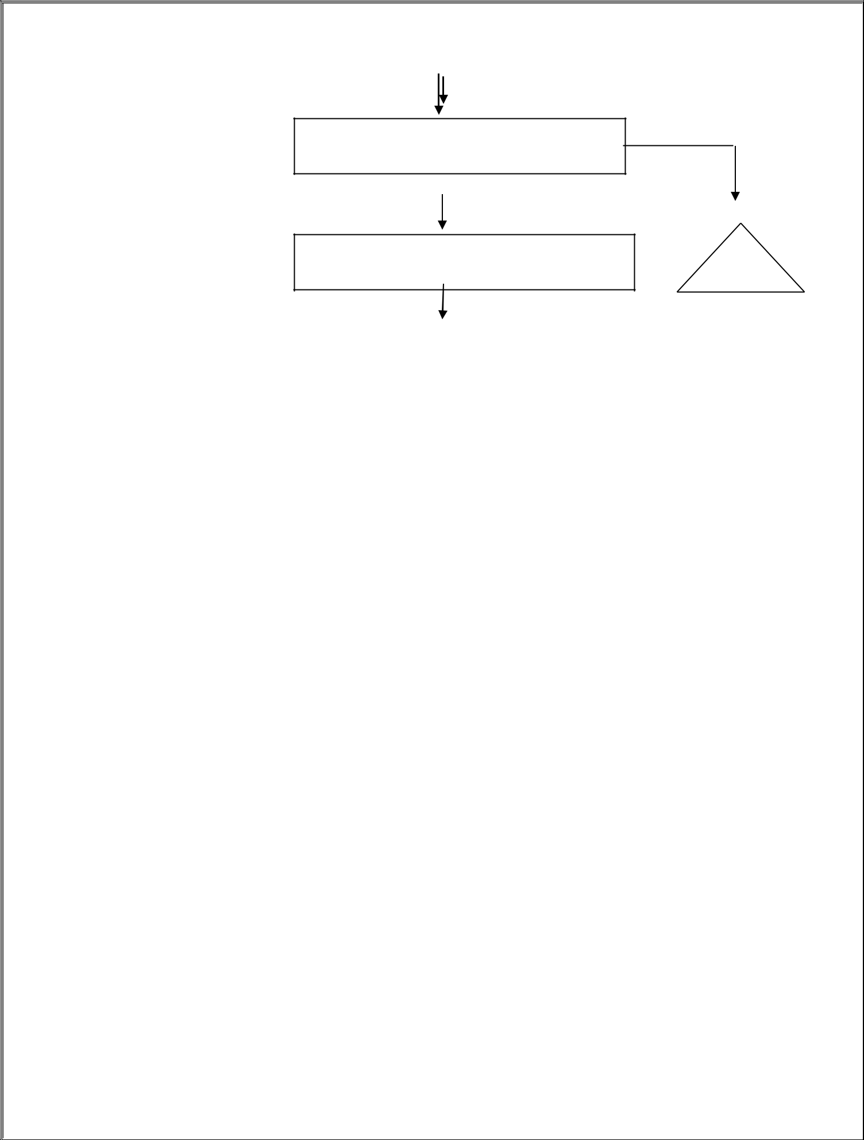

Follow up action

Update employee training record
File

Employee training record

File

26

CHAPTER NO. 4 RESEARCH METHODOLOGY

RESEARCH METHODOLOGY

Research in common parlance refers to the search for knowledge. It can be also defined as a scientific and systematic search for pertinent information on specific topic. Infact, search is an art of scientific investigation. In simple terms, research means, ‘ a careful investigation or enquiry especially through search for new facts in any branch of knowledge.’

LOGICAL FLOW OF RESEARCH IS AS FOLLOWS

Identification of problem Research objective Sources of data
Data collection Sample Sample Size
Data interpretation Data analysis
Finding and observation Conclusion Recommendation

RESEARCH DESIGN

Research design can be thought of as the structure of research. It is the glue that holds all the elements in a research project together. Research design is a vital part of the research study. It is the logical and systematic planning and directing of piece of research. It is the master plan and blue print of the entire study.

SOURCES OF DATA

The sources of the data are as follows:-

PRIMARY DATA:-

- Internal data about working of HR department gathered from organization.

- Interview.

- Observation.

- Sufficient data collected through feedback forms by the employees. [ Questionnaires ].

SECONDRAY DATA:-

- Magazines, journals, brochures , etc.
- Website of the company. [www.AMDOCS.com ].

- Books.

- Earlier researches on similar topic.

SAMPLES

We always have to work with a sample of subjects rather than the full population. But people are interested in the population, not the sample. To generalize from the sample to the population, the sample has to be representative of the population. The safest way to ensure that it is the representative is to use a Random selection procedure.

METHOD OF SAMPLING USED: “ RANDOM SAMPLING METHOD”

In the random sampling method, all items have some chance of selection that can be calculated. Random sampling technique ensures that bias is not introduced regarding who is included in the survey.

SAMPLE SIZE

The sample size taken is 20 employees from the Human Resource Department of Amdocs ltd. Pune

DATA COLLECTION

Survey-questionnaire:- Behaviors, beliefs and observations of specific groups are identified, reported and interpreted.

CHAPTER NO.5 SCOPE OF THE STUDY

Scope Of The Study:

The development of any organization depends on the employees. For organizational productivity training and development assumes great significances

- The study is conducted to know the level of knowledge and skills given to employees in the organization.

- This will help the management to know the satisfaction levels of employees and they can take measures to increase productivity.

- This study may help the management students to prepare their own reports.

CHAPTER NO. 6

DATA ANALYSIS / INTERPRETATION

DATA ANALYSIS AND DATA INTERPRETATION
Q 1. Your organization considers training as a part of organizational strategy. Do you agree with this statement?

No of | Strongly agree | Agree | Disagree | Somewhat
employees |  |  |  | agree
20 | 08 | 10 | 01 | 01

Chart Title
Strongly agree Agree Disagree Somewhat agree
5%
5%
40%
50%

According to the above data, it is clear that out of 100% employees of Amdocs LTD : 50% of employees consider training as a part of firm’s strategy.
40% of employees strongly agree with the statement. 5% of employees disagree with the statement.

  - To whom training is given more in your organization?

No.of | New staff | Junior staff | Senior staff | Based on
employees |  |  |  | requirement
20 | 8 | 2 | 8 | 2

Chart Title
New staff Junior staff Senior staff Based on requirement
10%
40%
40%
10%

According to the above data, out of 100% employees in Amdocs LTD: 40% of new staff are given training.
10% of junior staff are given training. 40% of senior staff are given training.
10% of employees are given training based on requirements.

  - What are the barriers to training and development in your firm?

No of | Time | Lack of interest | Money | Non availability
employees |  |  |  | of skilled trainer
35

20 | 07 | 08 | 03 | 02

Chart Title

Time Lack of interest Money Non availability of skilled trainer

15%
10%

35%

40%

According to above data, out of 100% employees fo Amdocs: 35% of employees consider time as a barrier in their training. 40% of employees consider lack of interest as a barrier.
15% of employees consider money as a barrier.

10% of employees consider non availability of skilled trainer as a barrier.

  - What mode of training method is used in your firm?

No of | Job relation | Conference/Discussion | External | Programmed
employees |  |  | training | instruction
20 | 06 | 08 | 03 | 03

36

Chart Title

Job relation
External training
Conference/Discussion
Programmed instruction

15%

15%

30%

40%

According to the above data, out of 100% employees in Amdocs 30% of employees said job relation is used as a mode of training.
40% of employees said conference/discussion is used as mode of training. 15% of employees said external training is done.
15% of employees said programmed instruction is used as a mode of training.

  - “ Training and development sessions conducted in your firm are useful.” Do you agree with this statement?
No of | Strongly agree | Agree | Disagree | Somewhat
employees |  |  |  | agree
20 | 05 | 13 | 01 | 01

37

Chart Title

Strongly agree Agree Disagree Somewhat agree

5%
5%

25%

65%

According to above data, out of 100% employees in Amdocs 25% of employees strongly agree with the statement.
65% of employees agree with the statement. 5% of employees disagree with the statement.
5% of employees somewhat agree with the statement.

  - How long does it take to implement the trained process?

No of | Less than one | 1-2 months | 2-4 months | More than 4
employees | month |  |  | months.
20 | 05 | 12 | 03 | 00

38

Chart Title

Less than one month 1-2 months 2-4 months More than 4 months.

0%

15%
25%

60%

According to above data, out of 100% employees in Amdocs 25% of employees said it took less than one month.
60% of employees said it took 1-2 months. 15% of employees said it took 2-4 months.

  - How well the workplace of the training is physically organised?

No of | Excellent | Good | Bad | Average
employees
20 | 13 | O5 | 01 | 01

39

Chart Title

Excellent Good Bad Average

5%
5%

25%

65%

According to the above data, out of 100% employees in Amdocs

65% employees said that workplace of training is organised excellently. 25% employees said workplace is good organised.
5% employees said workplace is badly organised.

  - What are the conditions that have to be improved during training sessions?

No of | Re-design the | Remove | Re organise the | Up grade the
emlpoyees | workplace | interference | work place | information
20 | 11 | 03 | 02 | 04

40

Chart Title

Re-design the workplace Re organise the work place
Remove interference
Up grade the information

20%

10%

15%

55%

According to the above data, out of 100% employees in Amdocs 55% employees needs re-design of job.
15% of employees needs removal of interferences during training. 10% of employees needs re-organisation of the work place.
20% of employees needs up graded information during training sessions

  - What are the general complaints about training sessions?

No of | Time Wastage | Gaps between | Training | Sessions are
employees |  | the sessions | sessions are | boring.
 |  |  | unplanned
20 | 14 | 04 | 01 | 01

41

Chart Title

Time Wastage Gaps between the sessions Training sessions are unplanned Sessions are boring.
5% 5%

20%

70%

According to the above data, out of 100% employees in Amdocs 70% of employees have a complaint of time wastage during training.
20% of employees have a complaint of too many gaps between the sessions.

10% of employees said training sessions are unplanned and are boring.

42

CHAPTER NO. 7

FINDINGS

FINDINGS

The collected data analyzed and general observations has proven that AMDOCS INDIA PVT LTD has done remarkable job in its Human Resource Department.

The main findings are as follows:

- In Amdocs India Pvt. Ltd. Employees feel that HR department is good.

- The training and development process is decentralized (Gurugram, Pune)

- About 90% of the employees are satisfied with the training and development process.

- Most of the managers prefers personal interviews.

- Mostaly external sources training are considered.

- About 70% of the employees feel and complain that the training which they are getting is the wastage of time in which 20% of the students feel and complain that the training that they are getting has a lot of gapes and breaks and they complain about that and the rest 10% of the employees feel and complain that the training they are getting is unplanned and bore as there are no fun activities held in training sessions. The company has the policy to submit one original documents and can can not leave the company before 1 year, if done so that they have to pay 10,000 to the company to get the certificate back, which some of the employees find unnecessary and also risky.

CHAPTER NO. 8
LIMITATIONS OF STUDY

LIMITATIONS :

The present study is limited to many aspects providing information about training and development is the outcome of various variables . It is not possible to take in to consideration each and every criteria in this study .

  - Some of the information given by respondents may be bias.
  - Could not able to collect the information from all the employees of organization because of busy schedule of employees.
  - The Questionnaire that are asked being personal, some of them hesitated to answer it.
  - Analysis is done on the assumption that respondents have given correct information through the Questionnaires.
  - Due to the limitation of the time the research could not be made more detailed.

CHAPTER NO.9 CONCLUSION AND RECOMMENDATIONS

CONCLUSIONS

On the basis of the analysis made, the following conclusions are drawn:

  - Maximum number of the employees finds healthy environment at the work place.
  - Lack of interest in employees act as a barrier in training programmes.

  - Maximum employees said that they get help whenever they require.

  - Employees are satisfied with the training and development programmes given to them.
  - The training programmes has helped in developing skills of the employees.

  - After attending the training programme most of the workers find their attitude better towards the job.
  - Most of the employees wants to the workplace to be redesigned where the training sessions are been conducted.
  - Employees felt the time wastage during training session. But trainees were satisfied with activities conducted during training program because it was related to their job .

RECOMMENDATION

RECOMMENDATIONS AND SUGGESTIONS

  - Some advanced training is required in technology department.

  - The company should adopt some other ways for nominating the trainees like training need identification survey, self nomination, personal analysis, organisational analysis, etc.
  - Training should be a continuous process i.e., it should be imparted at regular intervals.
  - The duration of training program should be less and details should be precise and accurate.
  - HR department should conduct seminars on some vital topics so that employees are always motivated and encouraged to work.

CHAPTER NO.10

BIBLIOGRAPHY

BIBLIOGRAPHY

BOOKS REFERRED:

❖
Personnel and Human Resource Management by P. Subba Rao.
- Personnel Management by C. B. Mamoria.
- Human Resource and Personnel Management by K. Aswathappa.
- Human Resource Management by Anjali Ghanekar.
- Human Resource Management by T. N. Chhabra.

WEBSITES:
www.wikipedia.org
www.amdocs.com

QUESTIONNAIRE:

Training and development process of personnel in Amdocs India Pvt. Ltd. Gurugram.

This questionnaire survey is purely for academic purpose. Any information collected through this survey is confidential and would not be shared with anyone other than people involved in this.

Name: ………………………………………………………….

Designation: ……………………… Age: …………………….

Department: …………………… Qualification: ………………

Answer the following questions: (Kindly give your unbiased response)

Q 1. Your organization considers training as a part of organizatinal strategy. Do you agree with this statement?

- Strongly agree
- Agree
- Disagree
- Somewhat agree
- Overall

  - To whom training is given more in your organization?

    - Strongly agree
    - Agree
    - Disagree
    - Somewhat agree
    - Overall

  - What are the barriers to training and development in your firm?

    - Strongly agree
    - Agree
    - Disagree
    - Somewhat agree
    - Overall

  - What mode of training method is used in your firm?

    - Internal training
    - External training
    - Conference
    - Job relation

  - “ Training and development sessions conducted in your firm are useful.

    - Strongly agree
    - Agree
    - Disagree
    - Somewhat agree
    - Overall

  - How long does it take to implement the trained process?

    - Less than one month
    - 1-2 months
    - 2-4 months
    - More than 4 months

  - How well the workplace of the training is physically organised?

    - Excellent
    - Good
    - Bad
    - Average

  - What are the conditions that have to be improved during training sessions?

    - Re-organise the job
    - Remove the interference
    - Re-organise the work place
    - Upgrade the information of material given during training

  - What are the general complaints about training sessions?

    - Less supportive
    - Not in favour with employee
    - Less importance towards trainee
    - Hard training method

  - Which form of training and development is used in Amdocs Pvt. Ltd. ?
    - Centralised
    - Decentralised

  - How do you rate HR practises of the company ?
    - Exellent
    - Good
    - Average
    - Bad

