Manuscript IJSREM template, Bold, Times New Roman ,Size 16, 1.5 Line Spacing
First Author¹, Second Author², Third Author³ Font Size 12
¹First Author Department & College
²Second Author Department & College
³Third Author Department & College

---------------------------------------------------------------------***---------------------------------------------------------------------
Abstract - This document shows the required format and appearance of a manuscript prepared for IJSREM e-journals. The abstract should consist of a single paragraph containing no more than 200 words. It should be a summary of the paper and not an introduction. Because the abstract may be used in abstracting and indexing databases, it should be self-contained (i.e., no numerical references) and substantive in nature, presenting concisely the objectives, methodology used, results obtained, and their significance. A list of up to six keywords should immediately follow, with the keywords separated by commas and ending with a period.

Key Words: optics, photonics, light, lasers, templates, journals

1.INTRODUCTION ( Size 11, Times New roman)

This document shows the suggested format and appearance of a manuscript prepared for IJSREM journals. Accepted papers will be professionally typeset. This template is intended to be a tool to improve manuscript clarity for the reviewers. The final layout of the typeset paper will not match this template layout.

2. Body of Paper
The body of the paper consists of numbered sections that present the main findings. These sections should be organized to best present the material.
It is often important to refer back (or forward) to specific sections. Such references are made by indicating the section number, for example, “In Sec. 2 we showed…” or “Section 2.1 contained a description….” If the word Section, Reference, Equation, or Figure starts a sentence, it is spelled out. When occurring in the middle of a sentence, these words are abbreviated Sec., Ref., Eq., and Fig.
At the first occurrence of an acronym, spell it out followed by the acronym in parentheses, e.g., charge-coupled diode (CCD).

Table -1: Sample Table format

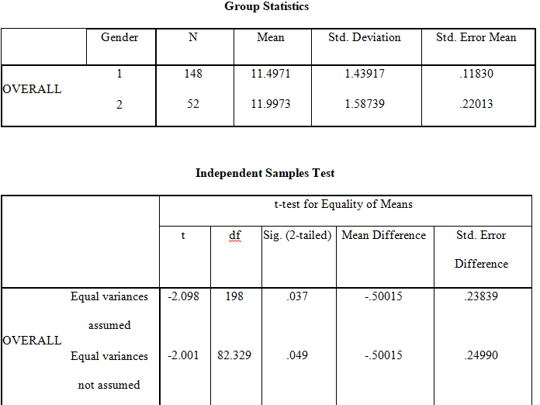

IJSREM sample template format ,Define abbreviations and acronyms the first time they are used in the text, even after they have been defined in the abstract. Abbreviations such as IEEE, SI, MKS, CGS, sc, dc, and rms do not have to be defined. Do not use abbreviations in the title or heads unless they are unavoidable.


Fig -1: Figure

Charts
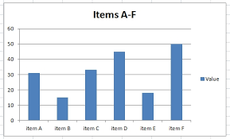
3. CONCLUSIONS

The online version of the volume will be available in LNCS Online. Members of institutes subscribing to the Lecture Notes in Computer Science series have access to all the pdfs of all the online publications. Non-subscribers can only read as far as the abstracts. If they try to go beyond this point, they are automatically asked, whether they would like to order the pdf, and are given instructions as to how to do so.

ACKNOWLEDGEMENT

The heading should be treated as a 3rd level heading and should not be assigned a number.

REFERENCES

1. Baldonado, M., Chang, C.-C.K., Gravano, L., Paepcke, A.: The Stanford Digital Library Metadata Architecture. Int. J. Digit. Libr. 1 (1997) 108–121
2. Bruce, K.B., Cardelli, L., Pierce, B.C.: Comparing Object Encodings. In: Abadi, M., Ito, T. (eds.): Theoretical Aspects of Computer Software. Lecture Notes in Computer Science, Vol. 1281. Springer-Verlag, Berlin Heidelberg New York (1997) 415–438
3. van Leeuwen, J. (ed.): Computer Science Today. Recent Trends and Developments. Lecture Notes in Computer Science, Vol. 1000. Springer-Verlag, Berlin Heidelberg New York (1995)
4. Michalewicz, Z.: Genetic Algorithms + Data Structures = Evolution Programs. 3rd edn. Springer-Verlag, Berlin Heidelberg New York (1996)

BIOGRAPHIES (Optional not mandatory )
1’st Author  Photo | Description about the author1  (in 5-6 lines)

