Social Entrepreneurship: A new platform

Dr. S.K. Thakur
Asst. Prof. University Deptt. of Commerce and Business Administration.
L.N.Mithila University, Darbhanga

ABSTRACT

Social Entrepreneurship plays catalyst role in the process of Social transformation. It combines business and Social issues in such manner that uplift the lives of people. The management of Social Entrepreneurship is no doubt, a challenging task, which is found more complicated in the Indian Society since the mass lack awareness. In the age of info-superhighway the Social Entrepreneurship need an overriding priority to attract attention of boardroom or the policy maker. Most of the Social Entrepreneurs are so weak that they are found struggling to project their own existence then what to talk of their positive contribution to the process of Social Entrepreneurship.
Key Words: Awareness, Business entrepreneurship, profit, Socio- economic context Social Entrepreneurship.

Introduction:
Broadly speaking a new term Social Entrepreneurship referring to a new breed and brand of entrepreneurs in economic literature and has gained widespread attention in the Socio- economic context till today. It plays role of catalyst for Social transformation. In nutshell it is resultant of Social entrepreneur, who have been pioneer of innovations that benefit social engineering at large. It generates innovative solutions to current social problems and also mobilises ideas, resources, and social orders and arrangements needed for social transformation. It may be referred as all trustic entrepreneurship, doing business for social cause. It combines business and social issues in such a manner that uplifts the lives of people connected to the cause.

AMBIT OF SOCIAL ENTREPRENEURSHIP:
Truly speaking the concept of Social Entrepreneurship is gaining increasing popularity, its meaning is so far blurring. It means different things to different people. Few associate Social Entrepreneurship exclusively with no-profit making organization starting for profit, some use it to state anyone who starts a no-profit organization. There are yet others who use it to refer those business owners who integrate and discharge Social responsibility in their business. Hence there is a need for marking the ambit of Social Entrepreneurship to understand it more accurately.
Social Service provision and social activities are two socially valuable cousins of Social entrepreneurship. These need to be distinguished and excluded from Social entrepreneurship. As, regards social service provision, a committed individual identifies an unfortunate stable equilibrium, initiates some initiatives to address it, but fails to establish a new long lasting equilibrium. Various organizations abound around us with good in their intension and exemplary in execution, since they remain confined and constrained to limited frame. They should not be mingled and confused with social entrepreneurship. Therefore Social entrepreneurship is different from social service provisions not in initiation but in the out comes. The other type of socially valuable activity is social activist. Unlike Social entrepreneur the social activities does not take direct action but takes indirect action through others like NGO,s, governments, workers etc. In sum and substance, Social entrepreneurship takes direct action and generates new superior equilibrium, the social service providers takes direct action to improve the outcomes of the current equilibrium and the social activist influences others to generate a new and sustained equilibrium.
Difference between Business Entrepreneurships & Social Entrepreneurship:

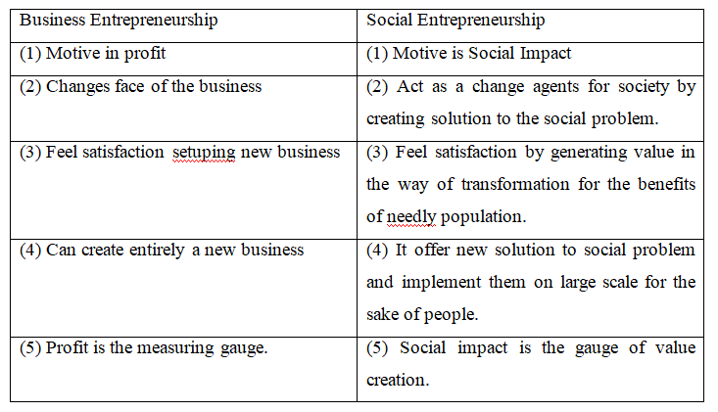
Top Ten Indian Heroes of Social Entrepreneurship:
Unlike western countries like the U.K.Isaly, Korea and others, where the agenda is being driven by state and big private houses. India's Journey into the world of Social entrepreneurship has been led by the vision and energy of outstanding individuals, who have shaped the India's tryst with Social entrepreneurship. The are-
1. Mahatma Gandhi- Father of the Nation Solved old problems with new ways.
(Introduction of Khadhi, salt March)
2. Vinoba Bhave - Land gift movement
3. Dr. Virghese karien- Milk revolution.
4. Anil Kumar Gupta- Founder of Honeybee Network
5. Harish Hande - Co-founder selco solar.
6. Dr. G. Venkataswamy - Founder Aravind Eye Hospital
7. Satyan Mishra - CEO, Drishtee
8. Banker Roy- Creator of Barefoot College
9. Vineet Roe - Founder of Aavishkaar.
10. Sam Pictroda- Chairman -National Innovation council.

Road Ahead:
Social entrepreneurship is the use of techniques by startup companies and other entrepreneurs to develop, fund and implement solution to social culture and environmental issues. This concepts may be applied to a variety of organizations with different sizes, aims and beliefs, There are
1. To become pragmatic visionary for achieving large scale, systematic and sustainable Social change through new invention.
2. To focus on Social and ecological value creation and try to optimise financial value creation.
3. To innovate by finding new product, new service or new approach to a social problem.
4. To refine approach in response to feed back.
5. To combine the characteristics represented by Mahatma Gandhi and Mother Teresa.

Conclusion:
Social entrepreneurship is approach that sets the Social entrepreneurship apart from the rest of the crowed of well- meaning people and organizations, who dedicate their lives to Social improvement.
It is a term that captures a unique approach to economic and Social problems, an approach that cuts across sectors and disciplines grounded in certain values and processes that are common to Social entrepreneur, independent of whether his/ her area of focus has been education, health, welfare reforms, human rights, workings rights, environment, economics development, agriculture etc or whether the organizations they set up are non-profit or profit insities.
It provides unparalleled platforms at the social, national and global level to highlight the advance leading models of sustainable social innovation.
Reference:
1. Cantillon, Richard, (1971): In Peter Kilby. (Ed.): Entrepreneurship and Economic Development, The Free Press, New York.
2. Emerson, Jed and Fay Twerksy (Eds.) (1996): New Social Entrepreneurs. The Success, challenge and lessons of Non-profit Enterprises Creation, The Roberts Foundation, Homeless Economic Development Fund, San Francisco.
3. Jha, S.M. (2007) : Service Marketing, Himalaya publishing House, Mumbai.
4. Martin, Roger, L., and Sally Osberg (2007): Social Entrepreneurship: The Cae for Definition, Stanford Social Innovation Review, Spring.
5. Rose, Kalima (1992): Where Women are Leaders: The SEWA Movement in India, Zed Books, London.
6. Schumpeter, Joseph A. (1939): Business Cycles, Mc Graw- Hill Book Co., New York.
7. Shreenivasan, Jyotsna (2000): Ela Bhatt: Uniting Women in India, Feminist Press of the City, University of New York, New York.
8. Yunus, Muhammad (1995): Banker to the Poor: Micro Lending and the Battle against World Poverty, Public Affairs, New York.

