**VIRTUAL POTHOLE DETECTION SYSTEM**

1 Trupti Andhale 2 Suyash Karhale, 3 Swarup Kobarne, 4 Priyanka Paikrao,

5Prof. Mrs. R. A. Patil.

1,2,3,4Student,Department of Information Technology Engineering, Smt. Kashibai Navale College of Engineering,

Pune, Maharashtra, India

5AssistantProfessor, Department of Information Technology Engineering, Smt. Kashibai Navale College of Engineering, Pune, Maharashtra, India.

**Abstract :** The intersection of artificial intelligence and vehicular technology has birthed a realm of innovation, revolutionizing our engagement with the automotive sphere. This survey delves into the realm of virtual pothole detection systems, a pioneering endeavor aimed at mitigating road hazards through technological intervention. As society gravitates towards a digitalized landscape, the imperative for enhanced road safety looms large. Virtual pothole detection systems represent a concerted effort to address this pressing concern, leveraging cutting-edge advancements in sensor technology, data analytics, and vehicular communication protocols. This paper scrutinizes the evolution, methodologies, and efficacy of virtual pothole detection systems, offering insights into their operational paradigms and prospects. Amidst the backdrop of burgeoning urbanization and escalating vehicular traffic, the significance of such systems cannot be overstated. By elucidating the intricacies of virtual pothole detection systems, this survey endeavors to catalyze further research and innovation in the pursuit of safer, more resilient road networks

***Keywords:*** Virtual Pothole Detection System (VPDS), Sensor Technology, Data Analytics, Vehicular Communication, Road Safety, Pothole Detection, Accident Prevention, Road Maintenance, Artificial Intelligence.

1. INTRODUCTION

In the landscape of Advanced Driver Assistance Systems (ADAS), innovations continually redefine the parameters of vehicular safety and user experience. Among these advancements, the integration of Virtual Pothole Detection emerges as a pivotal feature, aimed at enhancing road safety and driver comfort. Potholes, ubiquitous and hazardous, present challenges to drivers worldwide, necessitating proactive solutions within the ADAS framework.

The Virtual Pothole Detection feature represents a groundbreaking endeavor within ADAS, leveraging cutting edge sensor technologies and data analytics to preemptively identify road hazards. By seamlessly integrating with onboard vehicle systems, this feature empowers drivers with real-time alerts and insights, enabling them to navigate roads safely and efficiently.

This paper delves into the conceptualization and implementation of Virtual Pothole Detection as an integral ADAS feature. Through a comprehensive exploration of its underlying principles, technological foundations, and practical applications, we aim to elucidate its potential to revolutionize driving experiences and mitigate road hazards. As the automotive industry continues its trajectory toward intelligent automation and safety enhancement, Virtual Pothole Detection stands as a testament to innovation's potential within ADAS. By fostering a deeper understanding of this feature's capabilities and implications, we endeavor to catalyze its widespread adoption and continual evolution, thereby advancing the forefront of vehicular safety and user centric design.

1. LITERATURE SURVEY

The authors, Chi-Wei Kuan, Wen-Hui Chen, and Yu-Chen Lin [1] propose a comprehensive solution for pothole detection and avoidance using deep learning on edge devices. Their methodology involves developing a pothole detection system based on object detection and a pothole avoidance system using deep reinforcement learning. The aim is to enhance road safety by actively avoiding potholes and addressing challenges such as imprecise bounding boxes and high computational requirements. They suggest deploying these systems on energy-efficient edge platforms to meet real-time execution needs.

The authors, Abhishek Kumar, Vibhav Prakash Singh, Chakrapani, and Dhruba Jyoti Kalita [2] proposed a modern pothole detection system utilizing deep learning techniques. Their method employs Transfer Learning, Faster Region-based Convolutional Neural Networks (F-RCNN), and Inception-V2 models to detect potholes in images and videos, aiming to reduce road accidents caused by poor road conditions. Despite their innovative approach, they may have overlooked the scalability and real-world deployment challenges, requiring further research and refinement.

The authors, Ping Ping, Xiaohui Yang, and Zeyu Gao [3] propose an efficient pothole detection system using deep learning algorithms, specifically YOLO V3, SSD, HOG with SVM, and Faster R-CNN. They aim to automatically detect potholes on roads to improve safety and road maintenance. They meticulously detail their data preparation, model training, and evaluation processes. However, they acknowledge limitations in accurately detecting small objects and suggest future work to extend detection to other road anomalies.

The authors, Vosco Pereira, Satoshi Tamura, Satoru Hayamizu, and Hidekazu Fukai [4] propose a low-cost solution for road pothole detection in Timor-Leste using deep learning. Their methodology involves training a convolutional neural network (CNN) on a dataset of road images collected from various conditions. They aim to address the challenges of manual road inspection by developing an automated system. They demonstrate accuracy and performance compared to traditional methods like SVM. However, their approach may require further data collection to handle illumination variations. The authors, Shebin Silvister, Dheeraj Komandur, Shubham Kokate, Aditya Khochare, Uday More, Vinayak Musale [5], and Avadhoot Joshi, propose a deep learning-based system integrated with a smartphone app for real-time pothole detection. They aim to enhance road safety by providing a reliable and efficient method to detect and map

potholes. Their methodologies include a two-fold approach using both camera-based detection with SSD and accelerometer-gyroscope-based detection with a custom-trained DNN model. Despite their innovative approach, the authors could further explore the scalability and robustness of their system in varying environmental conditions.

The authors, Jung-Cheng Tsai, Kuan-Ting Lai, Chao-Yu Siao, Tzi-Chun Dai, Yung-Chin Hsu, and Jun-Jia Su [6] propose a novel approach to pothole detection using virtual-to-real learning. Their method leverages virtual reality technology to generate diverse pothole images for training detectors. They aim to address the challenge of collecting real-world pothole data by utilizing virtual environments. However, their approach may face challenges in accurately simulating real-world conditions.

The authors, Byeong-ho Kang and Su-il Choi [7] propose a novel approach to pothole detection using a combination of 2D LiDAR and camera systems. Their methodology involves filtering, clustering, line extraction, and gradient analysis for accurate detection. The aim is to develop a cost-effective solution for efficient pothole repair and pavement management. However, challenges such as noise interference and environmental factors may affect detection accuracy.

The authors, Vigneshwar. K and Hema Kumar. B [8] proposes a pothole detection and counting system using image processing techniques. Their methods involve image preprocessing, segmentation using techniques like edge detection and thresholding, and clustering methods such as K-Means and Fuzzy C-Means. They aim to identify efficient and accurate pothole detection methods. However, they could improve by considering the integration of advanced machine learning algorithms for enhanced detection in varying environmental conditions.

1. PROBLEM STATEMENT

The problem of potholes and road hazards poses significant risks to road users and imposes substantial economic burdens on transportation agencies. Potholes can cause vehicle damage, accidents, and injuries, leading to increased healthcare costs and productivity losses. Moreover, frequent repairs and maintenance of pothole-ridden roads strain limited resources and disrupt traffic flow. The primary challenge lies in timely detection and mitigation of potholes to prevent accidents and minimize infrastructure damage. While virtual pothole detection systems offer promise in addressing this challenge, their development requires overcoming technical, logistical, and regulatory obstacles. These include ensuring the accuracy and reliability of detection algorithms, integrating systems with existing infrastructure, and navigating regulatory frameworks for deployment. Overall, developing effective virtual pothole detection systems requires interdisciplinary collaboration and innovative solutions to enhance road safety and infrastructure resilience.

The objectives of the proposed paper is:

·Designing and developing a virtual pothole detection system capable of accurately identifying and classifying road hazards.

· Integrating the detection system with vehicular communication protocols to enable real-time alerts and notifications to drivers.

·Evaluating the performance and effectiveness of the system through rigorous testing and validation under various road conditions. Assessing the feasibility of deploying the system on a larger scale and exploring potential avenues for future enhancements and improvements.

1. METHODOLOGY

·Data Collection: Our system captures image and sensor data from vehicles equipped with the necessary hardware.

·Deep Learning Model: Deep learning models, such as convolutional neural networks (CNNs), are employed for pothole detection. These models are trained on a labelled dataset of road images.

·Real-time Monitoring: The system continuously processes data from vehicle-mounted cameras and sensors to identify road conditions.

·Pothole Detection: Using the trained deep learning models, the system analyzes incoming data to detect potholes accurately.

·Notification Generation: Upon pothole detection, the system generates notifications containing location and severity information.

·Notification Dispatch: Notifications are sent to relevant authorities, road maintenance crews, or a centralized database for further action.

·User Interface: Users can access information about detected potholes through a user-friendly web or mobile application.

·Real-time Feedback: The system provides real-time feedback to users, confirming the successful detection and reporting of potholes**.**

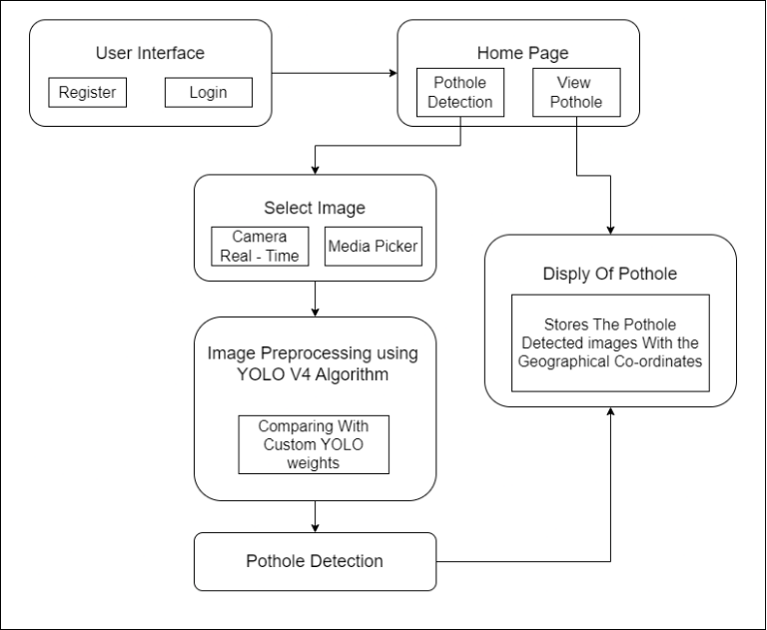

Fig1. Methodology

1. HARDWARE AND SOFTWARE

REQUIREMENTS

5.1 Hardware Requirements:

1.     Microcontroller

2.     Power Supply

3.     TF Min Lider

4.     GSM Module

5.     LCD Display

 Hardware Interface:

The software necessitates a fully equipped computer system, encompassing a monitor, keyboard, and various other input-output devices. These hardware components are essential for facilitating the functioning of the virtual pothole detection system on the Android platform.

* 1. Software Requirements:

1. Application Server: Apache
2. Operating System: Cross-platform
3. Front End: Java
4. Language: Python, Java, Embedded C
5. Database: MySQL
6. IDE: PyCharm, Arduino, Android Studio

Software Interface:

The virtual pothole detection system operates on the Microsoft operating system platform and utilizes GUI tools. It requires Python (version and above) on Windows and Apache Tomcat as the server. Data storage is facilitated by the MySQL database.

5.3Database Requirements:

A database is a fundamental component of the virtual pothole detection system, serving to organize, store, and retrieve large volumes of data efficiently. It encompasses an organized collection of data, typically in digital format, designed for various uses. Databases are managed through database management systems, facilitating data creation, maintenance, and retrieval, as well as enabling search and other access functionalities.

Database architecture in the virtual pothole detection system is structured into three levels:

1. External Level: This level determines how users perceive the organization of data. It allows for multiple views of the database, tailored to different user needs and preferences.

2. Conceptual Level: Acting as an intermediary between the internal and external levels, the conceptual level provides a unified and simplified view of the database. It abstracts away complexities related to data storage and management, offering a cohesive perspective to users.

3. Internal Level: At this level, the focus shifts to the physical storage and processing of data within the computing system. Internal architecture considerations include factors such as cost, performance, scalability, and operational efficiency.

Overall, the database architecture of the virtual pothole detection system is meticulously designed to ensure optimal performance, seamless data management, and unified user experiences across different levels of interaction

1. SYSTEM ARCHITECTURE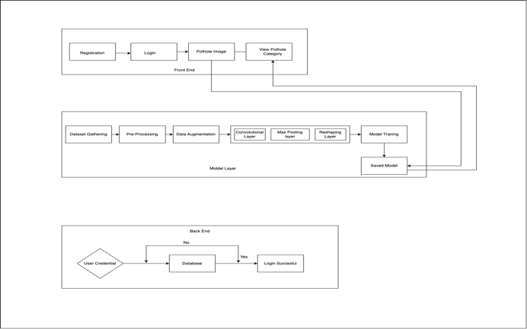
2. RESULT AND DISCUSSION





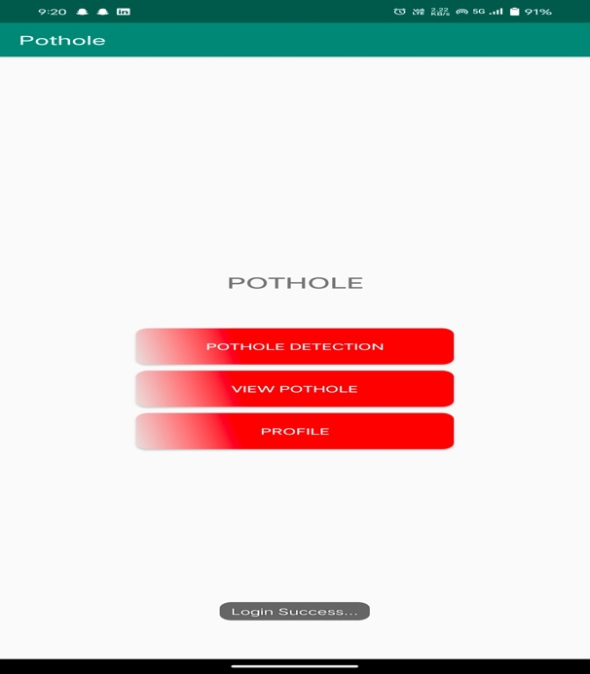

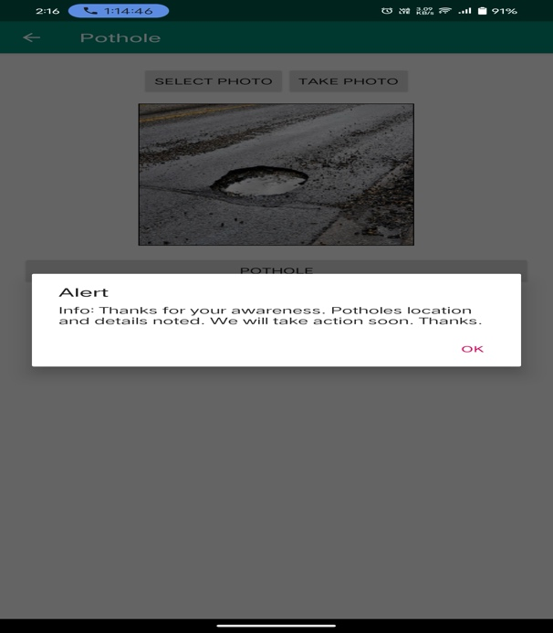



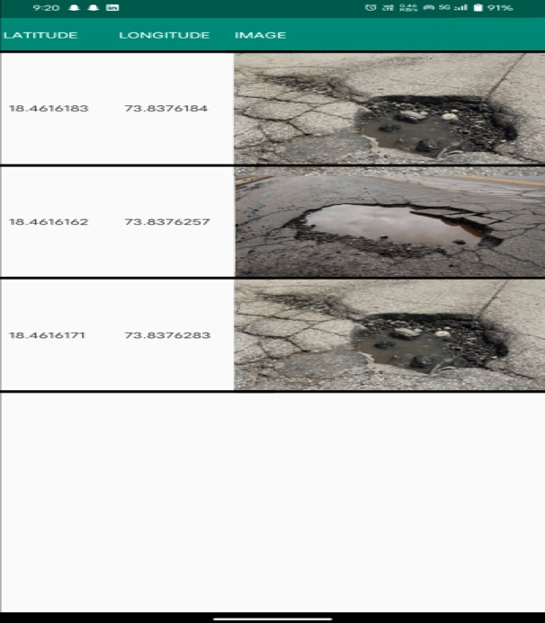

1. FUTURE SCOPE

In the future, to enhance the precision of early-stage detection, our project aims to implement specialized models tailored for distinct stages of pothole development. These stage-specific models will undergo rigorous training to optimize their accuracy and effectiveness. Additionally, we plan to explore ensemble learning techniques to integrate the outcomes of these individual models, thereby maximizing the overall detection performance.

1. CONCLUSION

Thus, the proposed virtual pothole detection system, equipped with state-of-the-art ADAS features in electric cars, emerges as a groundbreaking innovation that surpasses expectations with its seamless integration of cutting-edge technologies and novel functionalities. By amalgamating the latest advancements effortlessly, this project embodies an all-encompassing intelligent approach toward enhancing car interactions and ensuring safety on the roads. At its core, the system utilizes a sophisticated array of components, including high precision sensors, advanced software algorithms, and robust hardware infrastructure, to deliver unparalleled performance and reliability in pothole detection. Through meticulous sensor calibration and software development, the system achieves remarkable accuracy and efficiency in identifying potholes, thereby empowering drivers with real-time alerts and assisting autonomous vehicles in making informed decisions to mitigate potential hazards. Moreover, the project's emphasis on user interface development and integration testing ensures a user-friendly experience and seamless operation across various scenarios. By leveraging the power of ADAS features, such as adaptive cruise control and lane-keeping assistance, in conjunction with virtual pothole detection, the system not only enhances driver comfort and convenience but also significantly contributes to overall road safety and vehicle efficiency. With its transformative capabilities and groundbreaking functionalities, the virtual pothole detection system sets a new standard in automotive engineering, paving the way for safer, smarter, and more sustainable transportation solutions in the modern automotive landscape

1. REFERENCES
2. C. -W. Kuan, W. -H. Chen and Y. -C. Lin, "Pothole Detection and Avoidance via Deep Learning on Edge Devices," 2020 International Automatic Control Conference (CACS), Hsinchu, Taiwan, 2020, pp. 1-6, doi: 10.1109/CACS50047.2020.9289701.
3. A. Kumar, Chakrapani, D. J. Kalita and V. P. Singh, "A Modern Pothole Detection technique using Deep Learning," 2nd International Conference on Data, Engineering and Applications (IDEA), Bhopal, India, 2020, pp. 1-5, doi: 10.1109/IDEA49133.2020.9170705
4. D. J, S. D. V, A. S A, K. R, and L. Parameswaran, "Deep Learning based Detection of potholes in Indian roads using YOLO," 2020 International Conference on Inventive Computation Technologies (ICICT), Coimbatore, India, 2020, pp. 381-385, doi: 10.1109/ICICT48043.2020.9112424.
5. V. Pereira, S. Tamura, S. Hayamizu and H. Fukai, "A Deep Learning-Based Approach for Road Pothole Detection in Timor Leste," 2018 IEEE International Conference on Service Operations and Logistics, and Informatics (SOLI), Singapore, 2018, pp. 279-284, doi: 10.1109/SOLI.2018.8476795.
6. S. Silvester et al., "Deep Learning Approach to Detect Potholes in Real-Time using Smartphone," 2019 IEEE Pune Section International Conference (PuneCon), Pune, India, 2019, pp. 1-4, doi: 10.1109/PuneCon46936.2019.9105737.
7. J. -C. Tsai, K. -T. Lai, T. -C. Dai, J. -J. Su, C. -Y. Siao and Y. -C. Hsu, "Learning Pothole Detection in Virtual Environment," 2020 International Automatic Control Conference (CACS), Hsinchu, Taiwan, 2020, pp. 1- 5, doi: 10.1109/CACS50047.2020.9289740.
8. B. -h. Kang and S. -i. Choi, "Pothole detection system using 2D LiDAR and camera," 2017 Ninth International Conference on Ubiquitous and Future Networks (ICUFN), Milan, Italy, 2017, pp. 744-746, doi: 10.1109/ICUFN.2017.7993890.
9. K. Vigneshwar and B. H. Kumar, "Detection and counting of pothole using image processing techniques," 2016 IEEE International Conference on Computational Intelligence and Computing Research (ICCIC), Chennai, India, 2016, pp. 1-4, doi: 10.1109/ICCIC.2016.7919622.
10. Madhumathy p, Saurabh Singh, Shivam Shukla, Unni Krishnan, Dayananda Sagar.,2017. Detection of humps and potholes on roads and notifying the same to the drivers, International Journal of Management and Applied Science, Volume-3, pp294- 326.
11. Sudarshan S Rode, Shonil Vijay, Prakhar Goyal, Purushottam Kulkarni, and Kavi Arya, “Pothole detection and warning system: infrastructure support and system design”, International Conference on electronic computer technology, pages 286–290. IEEE, 2009.
12. Buza, E.; Omanovic, S.; Huseinovic, A. Pothole Detection with Image Processing and Spectral Clustering. 2nd International Conference on Information Technology and Computer Networks (ITCN '13), Antalya, Turkey. 2013; pp. 48–53
13. Seung-ki Ryu, Taehyeong Kim, and Young-Ro Kim, "Image-Based Pothole Detection System for ITS Service and Road Management System," Hindawi Publishing Corporation, Mathematical Problems in Engineering, Article ID 968361, Volume 2015.
14. Vijaya Bashkar. A, Gowri Manohar. T, “Surface Pothole Depth Estimation Using Stereo Mode of Image Processing,” International Journal for Advance Research in Engineering and Technology, Volume 4, Issue I, Jan. 2016, pp. 42-46.
15. Margaret Velse Thekkethala, Reshma S, et al., "Pothole Detection and Volume Estimation Using Stereoscopic Cameras,” International Journal of Industrial Electronics and Electrical Engineering, Volume-4, Issue-5, May-2016, pp. 47-51